

Customer Retention

Submitted by: Kshitij Chawla

# ACKNOWLEDGMENT

In this project different libraries and methods are used that are available in python which helped in completion of the project:

[https://scikit-](https://scikit-learn.org/stable/modules/generated/sklearn.ensemble.RandomForestClassifier.html) [learn.org/stable/modules/generated/sklearn.ensemble.RandomForestCla](https://scikit-learn.org/stable/modules/generated/sklearn.ensemble.RandomForestClassifier.html) [ssifier.html](https://scikit-learn.org/stable/modules/generated/sklearn.ensemble.RandomForestClassifier.html)

[http://scikit-](http://scikit-learn.org/stable/modules/generated/sklearn.preprocessing.PowerTransformer.html) [learn.org/stable/modules/generated/sklearn.preprocessing.PowerTransf](http://scikit-learn.org/stable/modules/generated/sklearn.preprocessing.PowerTransformer.html) [ormer.html](http://scikit-learn.org/stable/modules/generated/sklearn.preprocessing.PowerTransformer.html)

[http://scikit-](http://scikit-learn.org/stable/modules/generated/sklearn.tree.DecisionTreeClassifier.html) [learn.org/stable/modules/generated/sklearn.tree.DecisionTreeClassifier.](http://scikit-learn.org/stable/modules/generated/sklearn.tree.DecisionTreeClassifier.html) [html](http://scikit-learn.org/stable/modules/generated/sklearn.tree.DecisionTreeClassifier.html)

[http://scikit-](http://scikit-learn.org/stable/modules/generated/sklearn.model_selection.train_test_split.html) [learn.org/stable/modules/generated/sklearn.model_selection.train_test_](http://scikit-learn.org/stable/modules/generated/sklearn.model_selection.train_test_split.html) [split.html](http://scikit-learn.org/stable/modules/generated/sklearn.model_selection.train_test_split.html)

<http://scikit-learn.org/stable/modules/model_evaluation.html>

[http://scikit-](http://scikit-learn.org/stable/auto_examples/classification/plot_classifier_comparison.html) [learn.org/stable/auto_examples/classification/plot_classifier_comparison](http://scikit-learn.org/stable/auto_examples/classification/plot_classifier_comparison.html)

[.html](http://scikit-learn.org/stable/auto_examples/classification/plot_classifier_comparison.html)

[http://scikit-](http://scikit-learn.org/stable/auto_examples/classification/plot_classifier_comparison.html) [learn.org/stable/auto_examples/classification/plot_classifier_comparison](http://scikit-learn.org/stable/auto_examples/classification/plot_classifier_comparison.html)

[.html](http://scikit-learn.org/stable/auto_examples/classification/plot_classifier_comparison.html) <https://seaborn.pydata.org/generated/seaborn.countplot.html>

[https://www.analyticsvidhya.com/blog/2020/06/auc-roc-curve-machine-](https://www.analyticsvidhya.com/blog/2020/06/auc-roc-curve-machine-learning/) [learning/](https://www.analyticsvidhya.com/blog/2020/06/auc-roc-curve-machine-learning/)

[https://www.analyticsvidhya.com/blog/2020/10/how-to-choose-](https://www.analyticsvidhya.com/blog/2020/10/how-to-choose-evaluation-metrics-for-classification-model/) [evaluation-metrics-for-classification-model/](https://www.analyticsvidhya.com/blog/2020/10/how-to-choose-evaluation-metrics-for-classification-model/)

[https://machinelearningmastery.com/smote-oversampling-for-](https://machinelearningmastery.com/smote-oversampling-for-imbalanced-classification/) [imbalanced-classification/](https://machinelearningmastery.com/smote-oversampling-for-imbalanced-classification/)

# INTRODUCTION

## Business Problem Framing

[E-retail factors for customer activation and retention: A case study from Indian e-commerce customers](https://www.researchgate.net/publication/346412647_E-retail_factors_for_customer_activation_and_retention_An_empirical_study_from_Indian_e-commerce_customers)

Customer satisfaction has emerged as one of the most important factors that guarantee the success of online store; it has been posited as a key stimulant of purchase, repurchase intentions and customer loyalty. A comprehensive review of the literature, theories and models have been carried out to propose the models for customer activation and customer retention. Five major factors that contributed to the success of an e-commerce store have been identified as: service quality, system quality, information quality, trust and net benefit. The research furthermore investigated the factors that influence the online customers repeat purchase intention. The combination of both utilitarian value and hedonistic values are needed to affect the repeat purchase intention (loyalty) positively. The data is collected from the Indian online shoppers. Results indicate the e-retail success factors, which are very much critical for customer satisfaction.

## Conceptual Background of the Domain Problem

The project will require knowledge and practice in building Graphs

/plots and analysing them to get the relationship between dataset, Knowledge of Different Learning Models to build and predict the required output. Basic Data science concepts to increase the quality of the dataset and Python Knowledge (Coding Language) which will be used to solve the complete Micro Credit Defaulter project.

Understanding of calculating F2 score, accuracy, skewness and basic mathematics/statistical approaches will help to build an accurate model for this project.

## Review of Literature

Customer retention refers to a company’s ability to turn customers into repeat buyers and prevent them from switching to a competitor. It indicates whether your product and the quality of your service please your existing customers. It’s also the lifeblood of most subscription-based companies and service providers.

Customer retention strategies are the processes and initiatives businesses put in place to build customer loyalty and improve customer lifetime value.

Customer retention is different from customer acquisition or lead generation. It focuses on customers who have already signed up for a service or purchased a product from you.

But retaining customers is about more than just transactions—it’s about relationships. Research shows that customers view their relationships with brands similarly to their [relationships with friends](https://www.campaignlive.co.uk/article/consumers-expect-brands-friends-study-finds/1461335). Customers like brands that are reliable, authentic, and aware of what matters to them.

Focus on buyer relationships with your existing customers to boost their [brand loyalty](https://www.zendesk.com/blog/improve-customer-loyalty-and-retention/). These shoppers will continue to choose your brand even when presented with other options. With this loyal base, your brand will be more likely to weather volatile markets.

Why is customer retention important?

Keeping your current customers happy is generally more cost-effective than acquiring first-time customers. According to the Harvard Business Review, acquiring a new customer can be [five to 25 times](https://hbr.org/2014/10/the-value-of-keeping-the-right-customers) more expensive than holding on to an existing one.

## Motivation for the Problem Undertaken

I wanted to solve the real-life problem using the Technical skills gathered during the course of being a Data Analyst and improving the skill set.

# Analytical Problem Framing

## Mathematical/ Analytical Modelling of the Problem----

Classification Models->

Classification is a process in which an algorithm is used to analyse an existing data set of known points. The understanding achieved through that analysis is then leveraged as a means of appropriately classifying the data. Classification is a form of machine learning that can be particularly helpful in analysing very large, complex sets of data to help make more accurate predictions.

“Classification models are a form of supervised machine learning

which is often used when the analyst needs to understand how

they got to a certain point,”

Some of the most common classification models include decision trees, random forests, nearest neighbour, and Naive Bayes.

Decision Tree –

It is a decision-making tool that uses a flowchart-like tree structure or is a model of decisions and all of their possible results, including outcomes, input costs and utility.

Decision-tree algorithm falls under the category of supervised learning algorithms. It works for both continuous as well as categorical output variables.

The branches/edges represent the result of the node and the nodes have either:

Conditions [Decision Nodes] Result [End Nodes]

The branches/edges represent the truth/falsity of the statement and takes makes a decision based on that in the example below which shows a decision tree that evaluates the smallest of three

numbers:

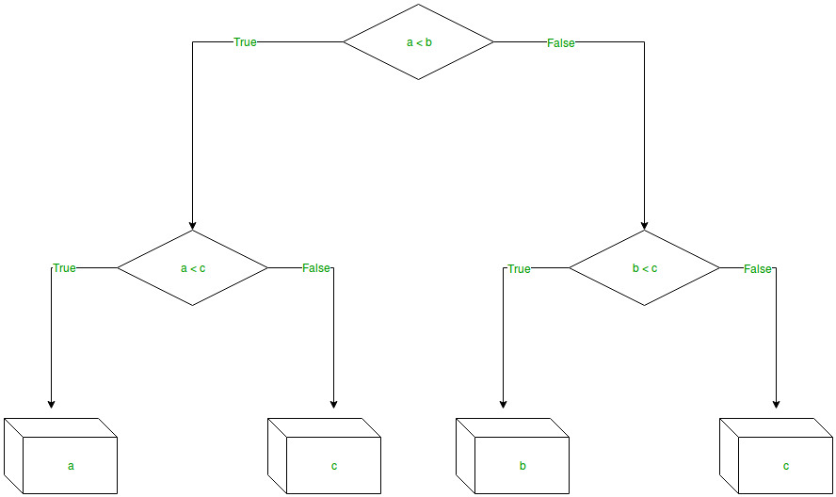

Random Forest –

Random forest is a supervised learning algorithm which is used for both classification as well as regression. But however, it is mainly used for classification problems. As we know that a forest is made up of trees and more trees means more robust forest. Similarly, random forest algorithm creates decision trees on data samples and then gets the prediction from each of them and finally selects the best solution by means of voting. It is an ensemble method which is better than a single decision tree because it reduces the over-fitting by averaging the result.

Naive Bayes –

Naive Bayes classifiers are a collection of classification algorithms based on Bayes’ Theorem. It is not a single algorithm but a family of algorithms where all of them share a common principle, i.e. every pair of features being classified is independent of each other.

Logistic Regression –

Logistic regression is a supervised learning classification algorithm used to predict the probability of a target variable. The nature of target or dependent variable is dichotomous, which means there would be only two possible classes.

In simple words, the dependent variable is binary in nature having data coded as either 1 (stands for success/yes) or 0 (stands for failure/no).

Mathematically, a logistic regression model predicts P(Y=1) as a function of X. It is one of the simplest ML algorithms that can be used for various classification problems such as spam detection, Diabetes prediction, cancer detection etc.

SVM –

Supervised Machine Learning Algorithm used for classification and/or regression. It is more preferred for classification but is sometimes very useful for regression as well. Basically, SVM finds a hyper-plane that creates a boundary between the types of data. In 2-dimensional space, this hyper-plane is nothing but a line.

We used different Plots/ graphs to perform EDA on the dataset->

1. Box Plot**:** It is a type of chart that depicts a group of numerical data through their quartiles. It is a simple way to visualize the shape of our data. It makes comparing characteristics of data between categories very easy.
2. Count Plot: IT is kind of like a histogram or a bar graph for some categorical area. It simply shows the number of occurrences of an item based on a certain type of category
3. Heat Map: It contains values representing various shades of the same colour for each value to be plotted. Usually the darker shades of the chart represent higher values than the lighter shade. For a very different value a completely different colour can also be used.
4. Scatter Plot: A scatter plot is a diagram where each value in the data set is represented by a dot. The Matplotlib module has a method for drawing scatter plots

## Data Sources and their formats

Below are the fields present in our dataset

|  |
| --- |
| 1Gender of respondent |
| 2 How old are you? |
| 3 Which city do you shop online from? |
| 4 What is the Pin Code of where you shop online from? |
| 5 Since How Long You are Shopping Online ? |
| 6 How many times you have made an online purchase in the past 1 year? |
| 7 How do you access the internet while shopping on-line? |
| 8 Which device do you use to access the online shopping? |
| 9 What is the screen size of your mobile device? |
| 10 What is the operating system (OS) of your device? |
| 11 What browser do you run on your device to access the website? |
| 12 Which channel did you follow to arrive at your favorite online store for the first time? |
| 13 After first visit how do you reach the online retail store? |
| 14 How much time do you explore the e- retail store before making a purchase decision? |
| 15 What is your preferred payment Option? |
| 16 How frequently do you abandon (selecting an items and leaving without making payment) your shopping cart? |
| 17 Why did you abandon the “Bag” “Shopping Cart”? |
| 18 The content on the website must be easy to read and understand |
| 19 Information on similar product to the one highlighted is important for product comparison |
| 20 Complete information on listed seller and product being offered is important for purchase decision. |
| 21 All relevant information on listed products must be stated clearly |
| 22 Ease of navigation in website 23 Loading and processing speed |
| 24 User friendly Interface of the website |
| 25 Convenient Payment methods |
| 26 Trust that the online retail store will fulfill its part of the transaction at the stipulated time |
| 27 Empathy (readiness to assist with queries) towards the customers |
| 28 Being able to guarantee the privacy of the customer |
| 29 Responsiveness availability of several communication channels (email online rep twitter phone etc.) |
| 30 Online shopping gives monetary benefit and discounts |
| 31 Enjoyment is derived from shopping online |
| 32 Shopping online is convenient and flexible |
| 33 Return and replacement policy of the e-tailer is important for purchase decision |
| 34 Gaining access to loyalty programs is a benefit of shopping online |
| 35 Displaying quality Information on the website improves satisfaction of customers |
| 36 User derive satisfaction while shopping on a good quality website or application |
| 37 Net Benefit derived from shopping online can lead to users satisfaction |
| 38 User satisfaction cannot exist without trust |
| 39 Offering a wide variety of listed product in several category |
| 40 Provision of complete and relevant product information |
| 41 Monetary savings |
| 42 The Convenience of patronizing the online retailer |
| 43 Shopping on the website gives you the sense of adventure |
| 44 Shopping on your preferred e-tailer enhances your social status |
| 45 You feel gratification shopping on your favorite e-tailer |
| 46 Shopping on the website helps you fulfill certain roles |
| 47 Getting value for money spent |
| From the following tick any (or all) of the online retailers you have shopped from; |
| Easy to use website or application |
| Visual appealing web-page layout Wild variety of product on offer |
| Complete relevant description information of products |
| Fast loading website speed of website and application |
| Reliability of the website or application |
| Quickness to complete purchase |
| Availability of several payment options Speedy order delivery |
| Privacy of customers’ information |
| Security of customer financial information |
| Perceived Trustworthiness |
| Presence of online assistance through multi-channel |
| Longer time to get logged in (promotion sales period) |
| Longer time in displaying graphics and photos (promotion sales period) |
| Late declaration of price (promotion sales period) |
| Longer page loading time (promotion sales period) |
| Limited mode of payment on most products (promotion sales period) |
| Longer delivery period Change in website/Application design |
| Frequent disruption when moving from one page to another |
| Website is as efficient as before |
| Which of the Indian online retailer would you recommend to a friend? |

Data types of the fields:

Below is the information of all the attributes with their respective datatypes:

|  |
| --- |
| 1Gender of respondent- object |
| 2 How old are you?--object |
| 3 Which city do you shop online from? object |
| 4 What is the Pin Code of where you shop online from?- int64 |
| 5 Since How Long You are Shopping Online ?- object |
| 6 How many times you have made an online purchase in the past 1 year? object |
| 7 How do you access the internet while shopping on-line?- object |
| 8 Which device do you use to access the online shopping?- object |
| 9 What is the screen size of your mobile device?\t\t\t\t\t\t object |
| 10 What is the operating system (OS) of your device?\t\t\t\t object |
| 11 What browser do you run on your device to access the website?\t\t\t object |
| 12 Which channel did you follow to arrive at your favorite online store for the first time? object |
| 13 After first visit, how do you reach the online retail store?\t\t\t\t object |
| 14 How much time do you explore the e- retail store before making a purchase decision?- object |
| 15 What is your preferred payment Option?\t\t\t\t\t--object |
| 16 How frequently do you abandon (selecting an items and leaving without making payment) your shopping cart?\t\t\t\t\t\t\t- object |
| 17 Why did you abandon the “Bag”, “Shopping Cart”?\t\t\t\t\t object |
| 18 The content on the website must be easy to read and understand- object |
| 19 Information on similar product to the one highlighted is important for product comparison object |
| 20 Complete information on listed seller and product being offered is important for purchase decision. object |
| 21 All relevant information on listed products must be stated clearly object |
| 22 Ease of navigation in website- object |
| 23 Loading and processing speed- object |
| 24 User friendly Interface of the website- object |
| 25 Convenient Payment methods--object |
| 26 Trust that the online retail store will fulfill its part of the transaction at the stipulated time-object |
| 27 Empathy (readiness to assist with queries) towards the customers- object |
| 28 Being able to guarantee the privacy of the customer- object |
| 29 Responsiveness, availability of several communication channels (email, online rep, twitter, phone etc.)--object |
| 30 Online shopping gives monetary benefit and discounts-object |
| 31 Enjoyment is derived from shopping online-object |
| 32 Shopping online is convenient and flexible- object |
| 33 Return and replacement policy of the e-tailer is important for purchase decisionobject |
| 34 Gaining access to loyalty programs is a benefit of shopping online object |
| 35 Displaying quality Information on the website improves satisfaction of customersobject |
| 36 User derive satisfaction while shopping on a good quality website or applicationobject |
| 37 Net Benefit derived from shopping online can lead to users satisfaction- object |
| 38 User satisfaction cannot exist without trust object |
| 39 Offering a wide variety of listed product in several category- object |
| 40 Provision of complete and relevant product information-object |
| 41 Monetary savings- object |
| 42 The Convenience of patronizing the online retailer- object |
| 43 Shopping on the website gives you the sense of adventure object |
| 44 Shopping on your preferred e-tailer enhances your social status-object |
| 45 You feel gratification shopping on your favorite e-tailer object |
| 46 Shopping on the website helps you fulfill certain roles object |
| 47 Getting value for money spent- object |
| From the following, tick any (or all) of the online retailers you have shopped from;--object |
| Easy to use website or application- object |
| Visual appealing web-page layout- object |
| Wild variety of product on offer- object |
| Complete, relevant description information of products- object |
| Fast loading website speed of website and application- object |
| Reliability of the website or application- object |
| Quickness to complete purchase- object |
| Availability of several payment optionsobject |
| Speedy order delivery- object |
| Privacy of customers’ information-object |
| Security of customer financial information- object |
| Perceived Trustworthiness object |
| Presence of online assistance through multi-channel--object |
| Longer time to get logged in (promotion, sales period)- object |
| Longer time in displaying graphics and photos (promotion, sales period) object |
| Late declaration of price (promotion, sales period)--object |
| Longer page loading time (promotion, sales period)object |
| Limited mode of payment on most products (promotion, sales period)-object |
| Longer delivery period-object |
| Change in website/Application design object |
| Frequent disruption when moving from one page to another- object |
| Website is as efficient as before-object |
| Which of the Indian online retailer would you recommend to a friend?-objec |

## Data Pre-processing Done

* 1. First we checked the data set dimensions



* 1. Then we checked whether there is any null data available

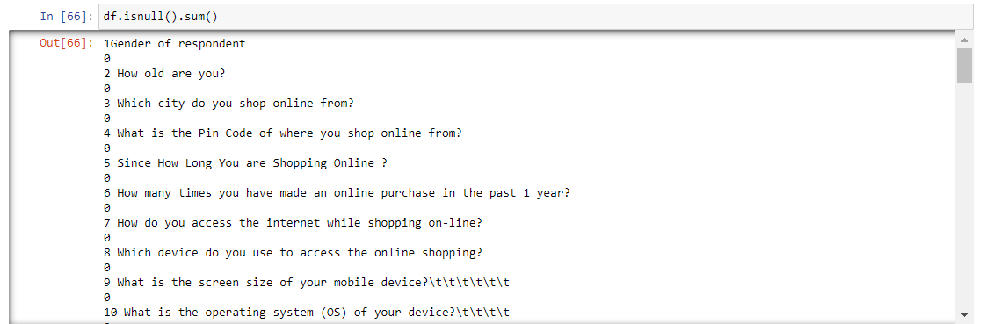

## Hardware and Software Requirements and Tools Used

1. Software: Jupyter Notebook - To code and build the project in python
2. Libraries:
   1. numpy - To perform basic math operations
   2. pandas - To perform basic File operations
   3. Matplotlib - To plot Different Graphs/ Plots
   4. Seaborn - Advance library to enhance the quality of graphs/plots
   5. warnings - To ignore the unwanted warnings raised while interpreting the code
   6. sklearn - To build the Prediction models
   7. imblearn - To balance our dataset distribution

## Visualizations

## 

## 

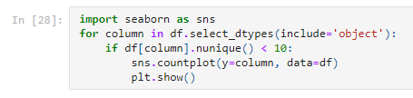  
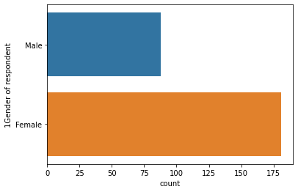

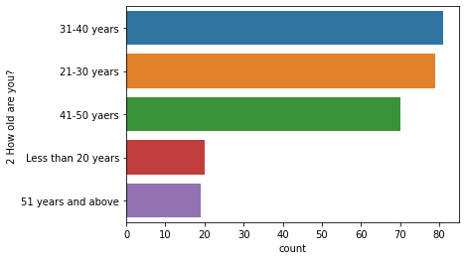

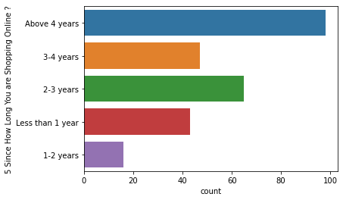

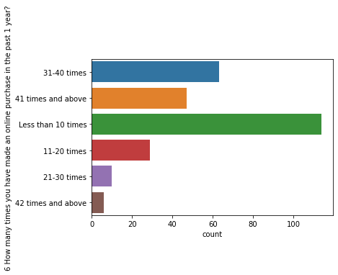

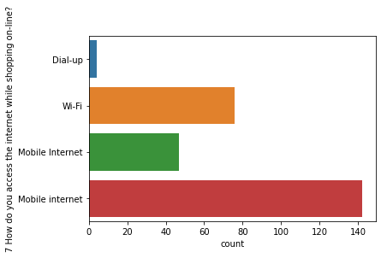

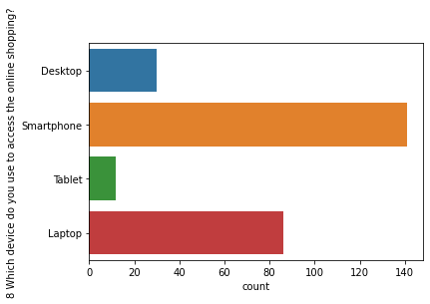

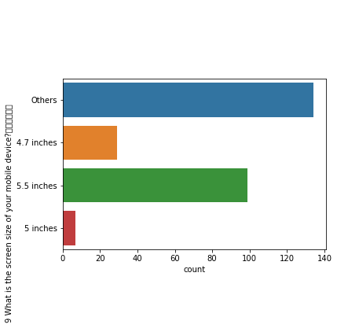

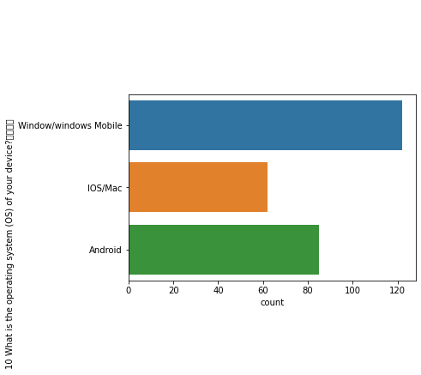

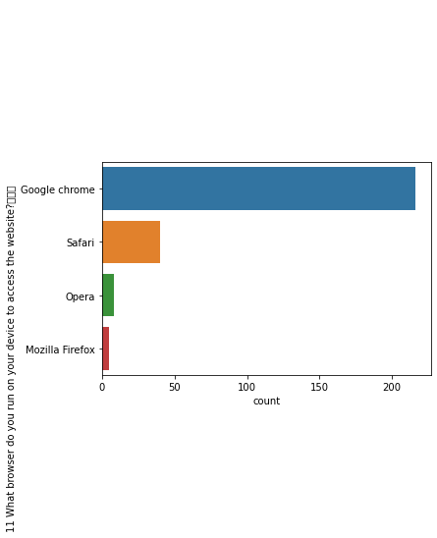

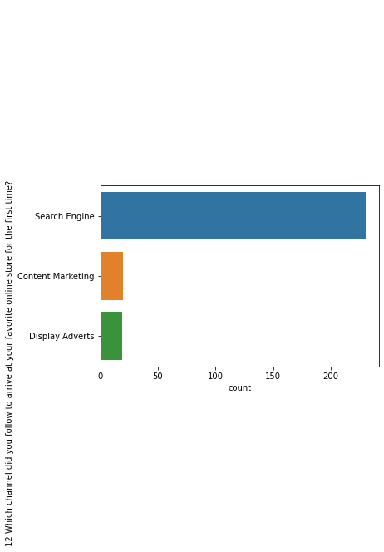

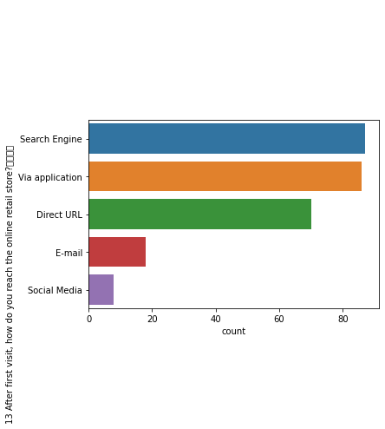

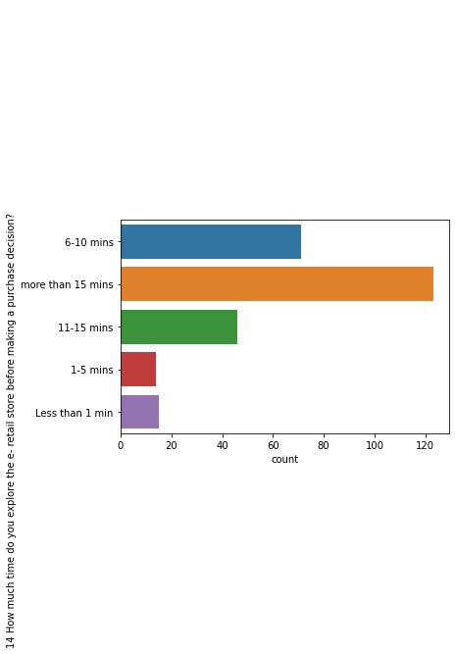

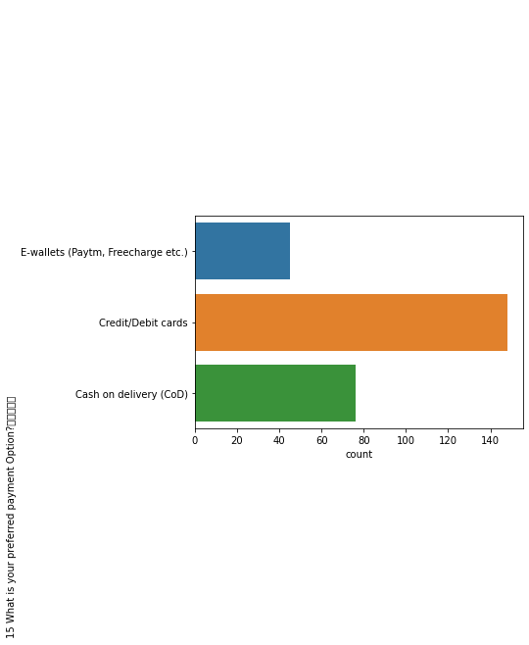

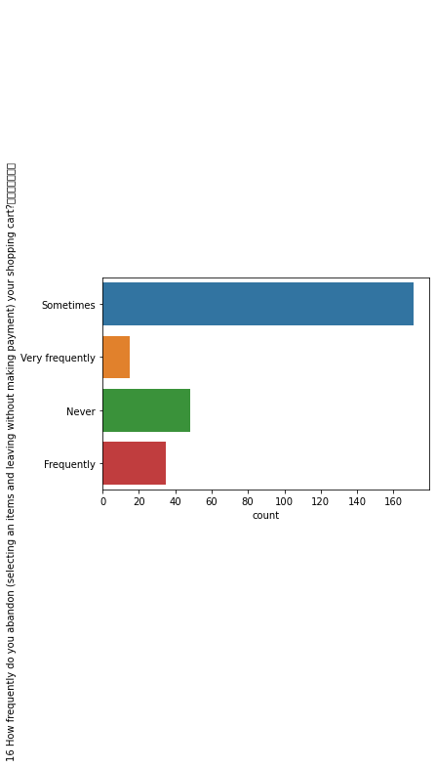

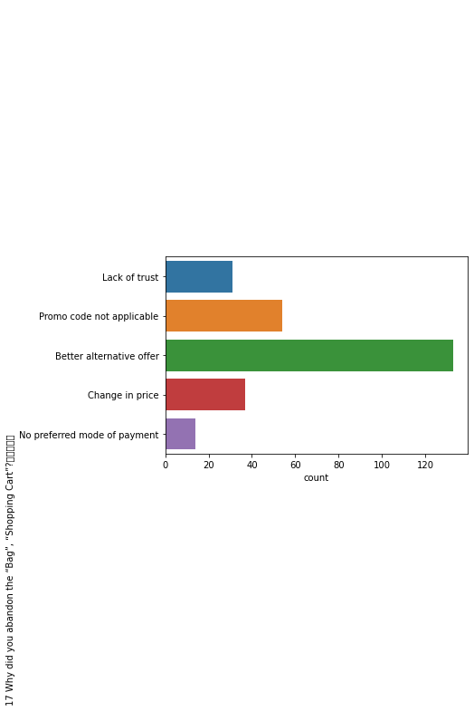

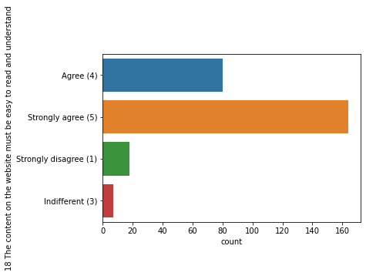

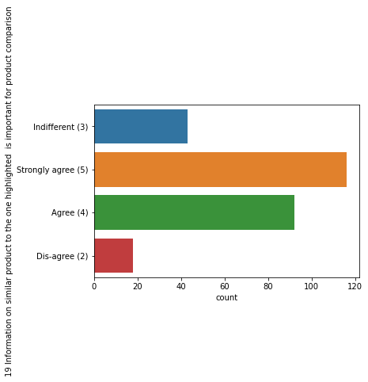

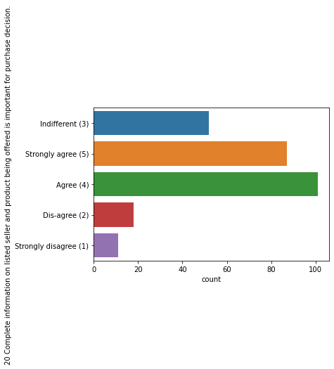

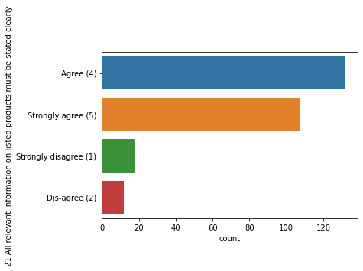

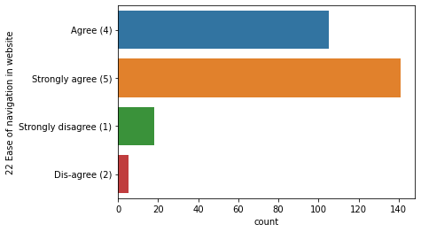

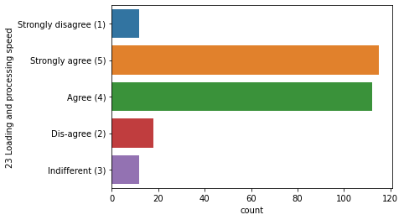

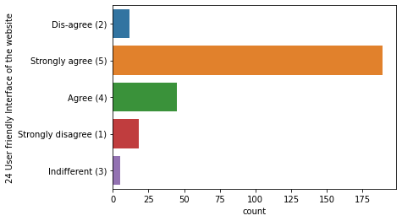

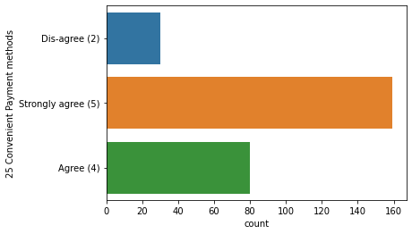

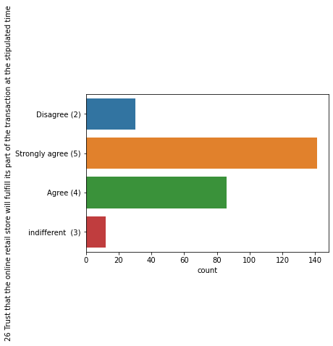

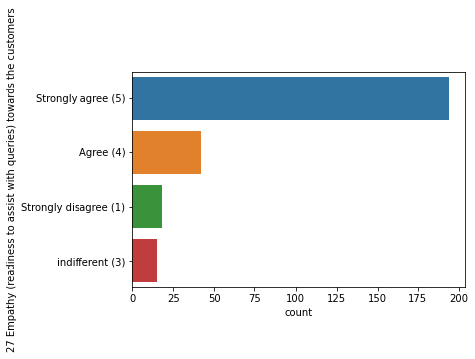

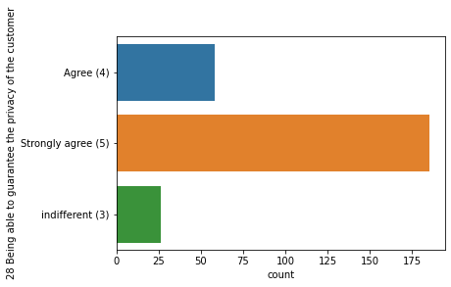

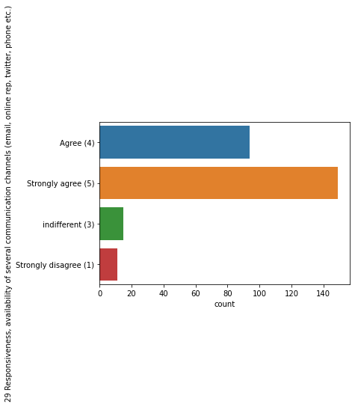

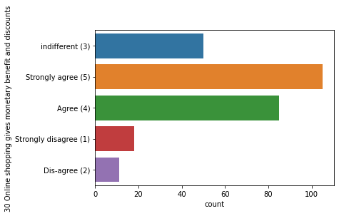

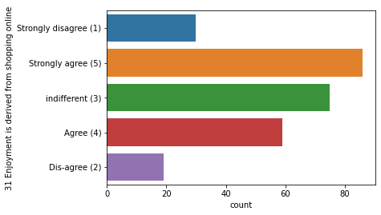

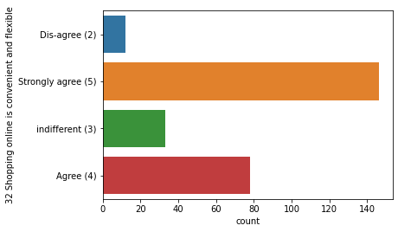

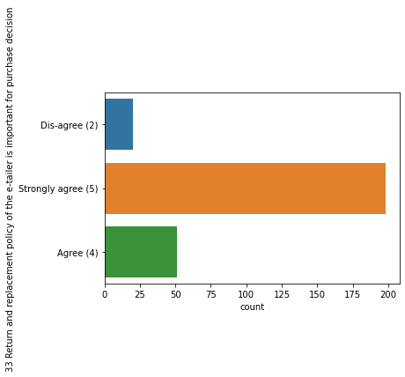

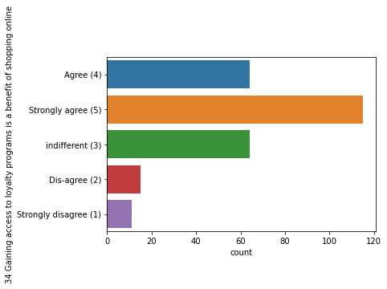

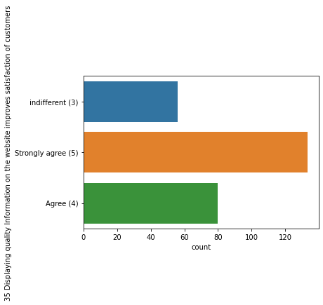

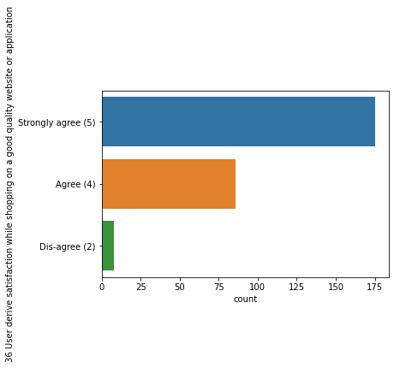

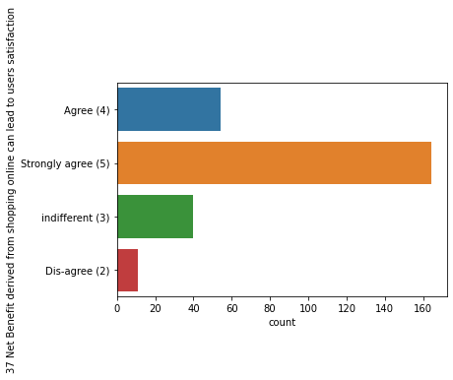

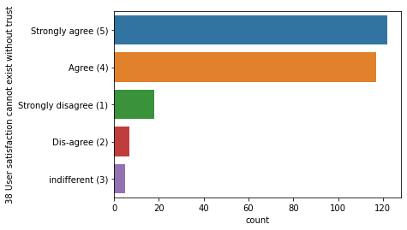

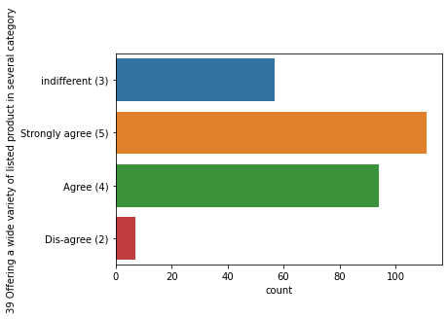

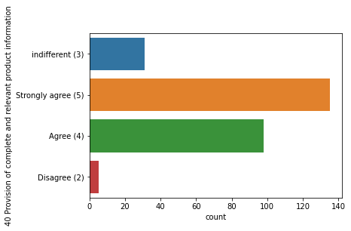

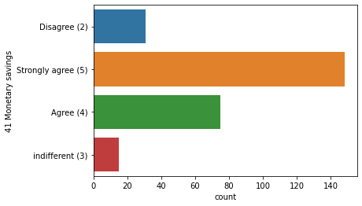

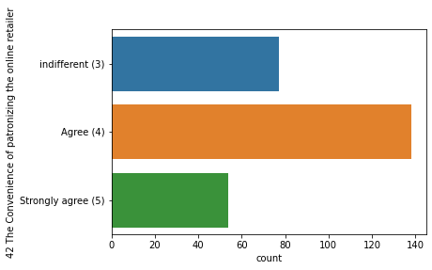

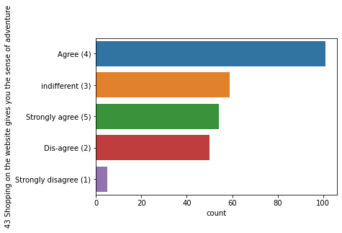

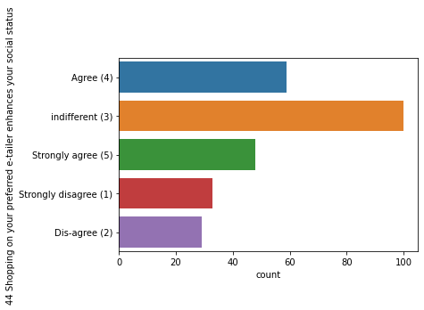

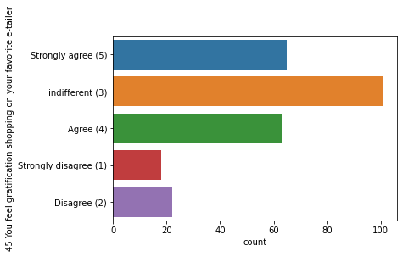

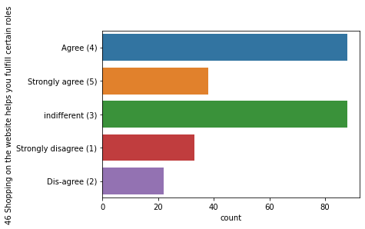

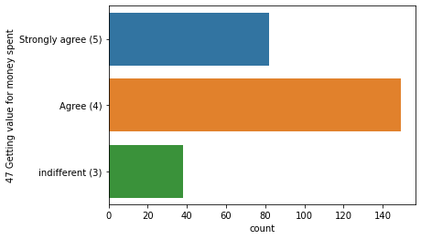

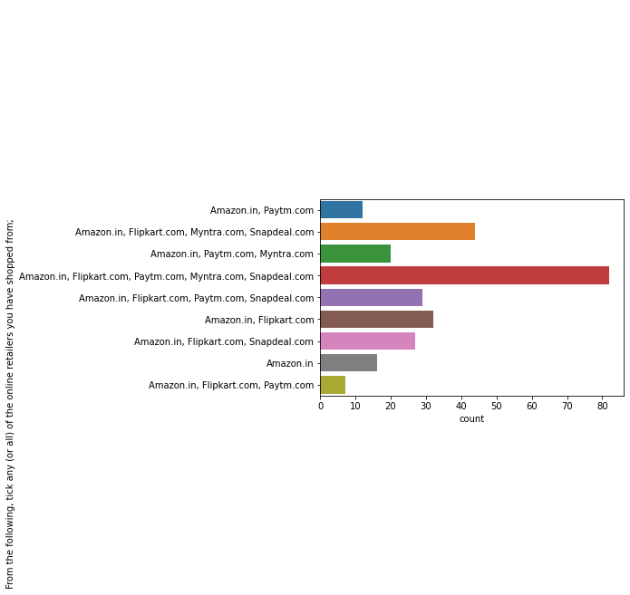

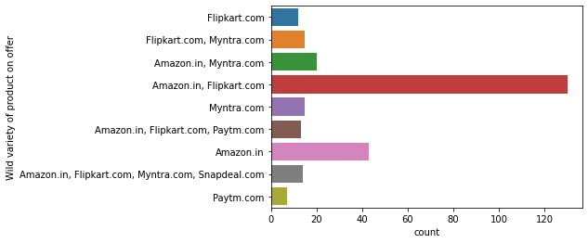

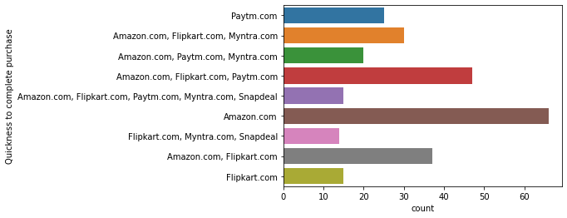

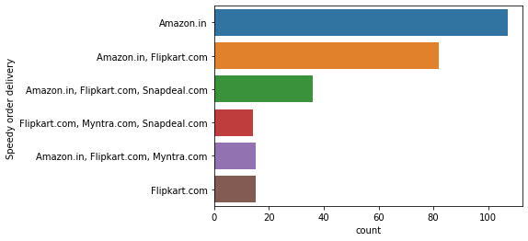

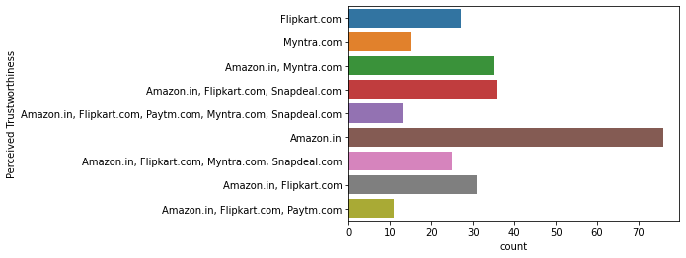

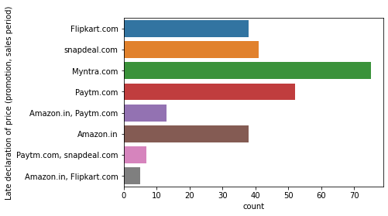

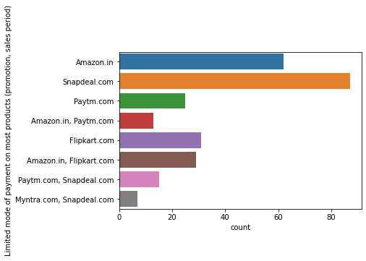

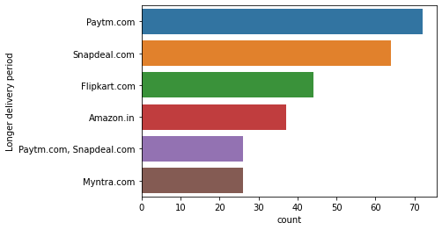

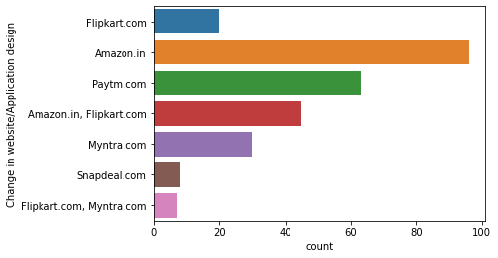

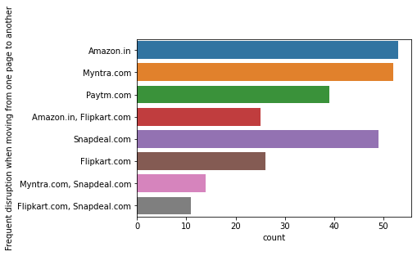

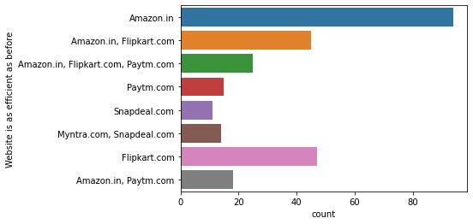

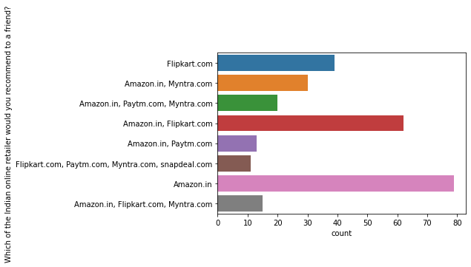

Key Observation:

Most of the surveys are from Female

In data set we have majority of people in 31-40years age group

Most of the people are shopping online for above 4 years

Most of the people had less than 10 times purchase online for past 1 year

Most of the users use Mobile Internet

Most of the users use Smartphone to order online

Most of the users use Google Chrome Web browser for ordering

Most of the users explore for more than 15 min before making purchase

Preferred payment option for most users is Credit/Debit cards

Most preferred portal is Amazon and flipkart

## 

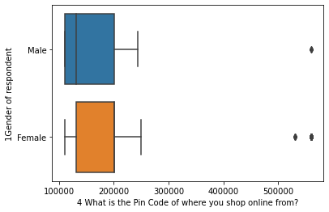

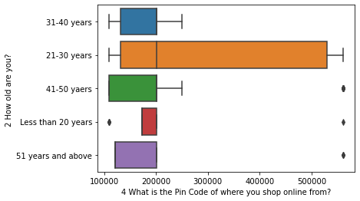

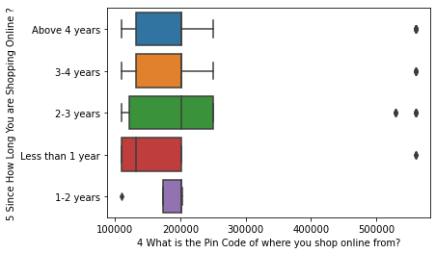

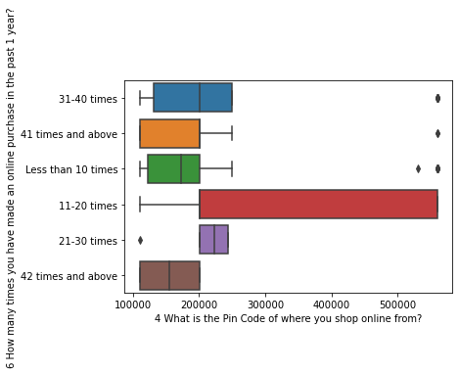

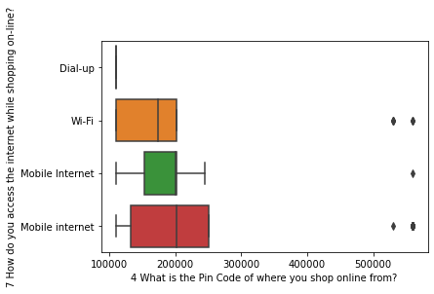

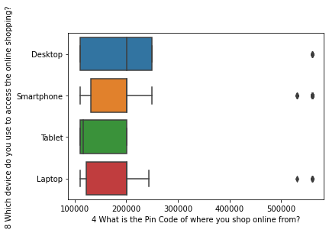

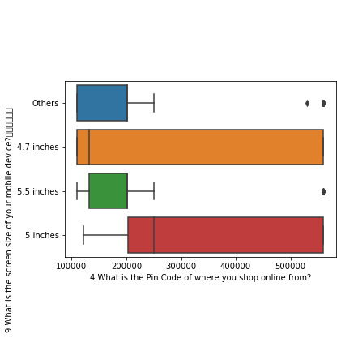

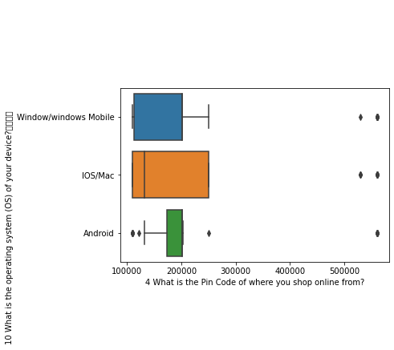

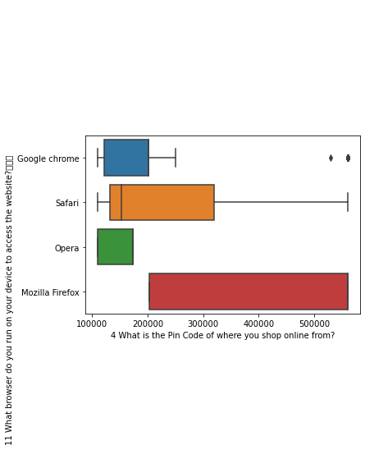

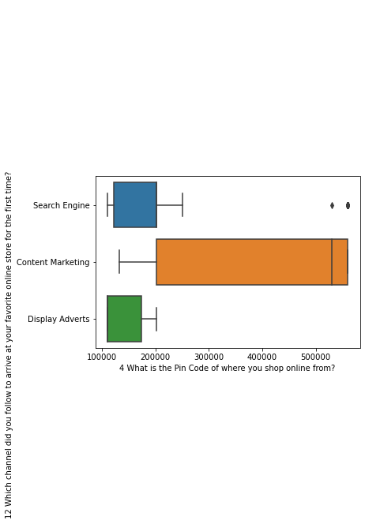

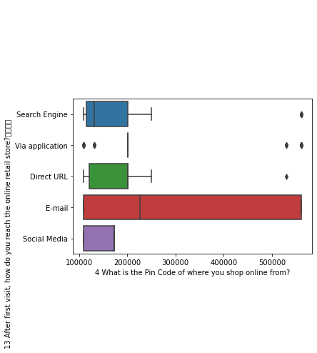

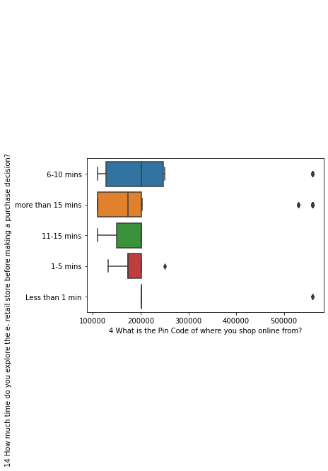

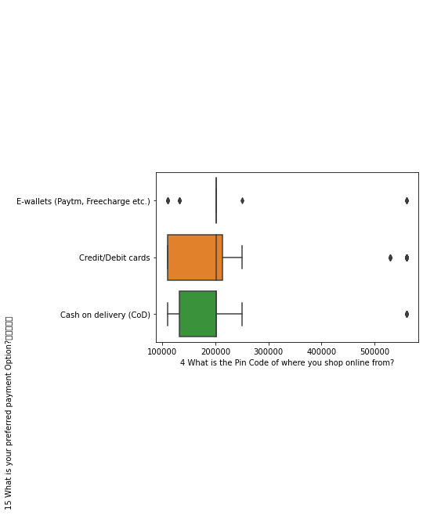

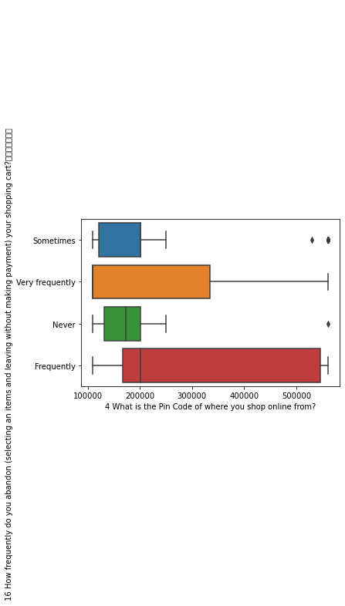

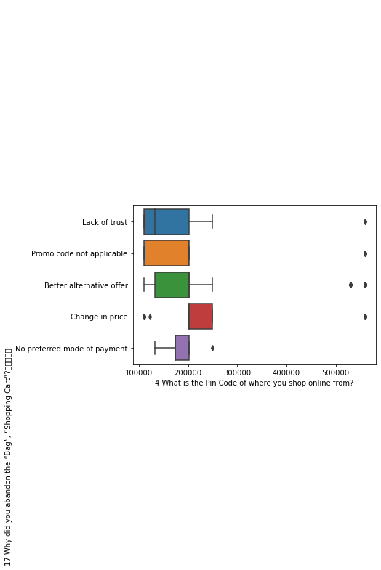

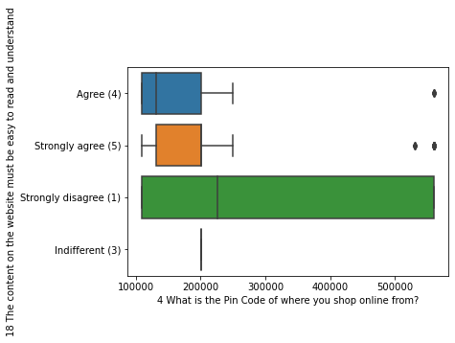

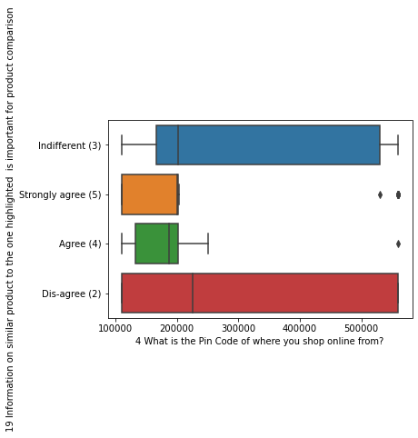

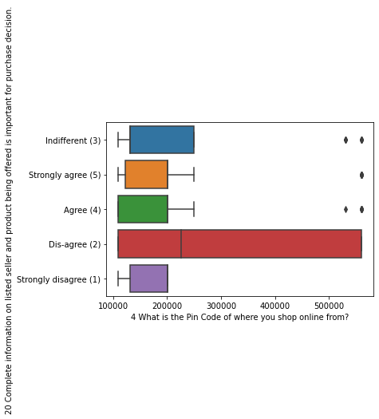

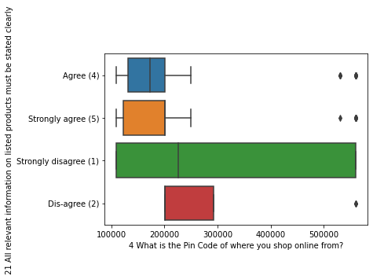

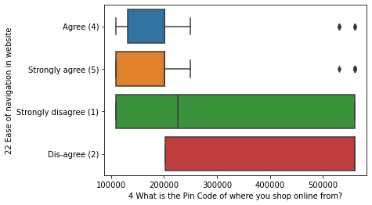

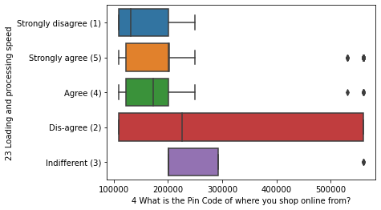

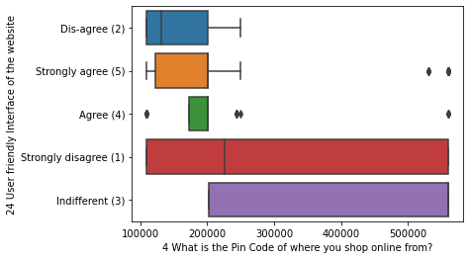

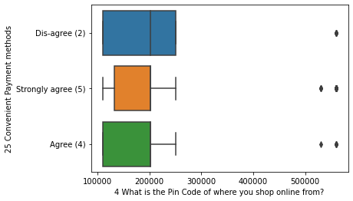

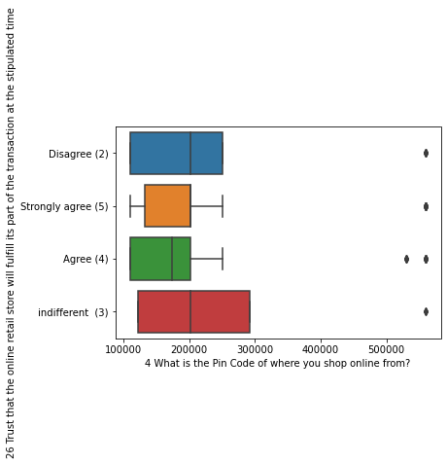

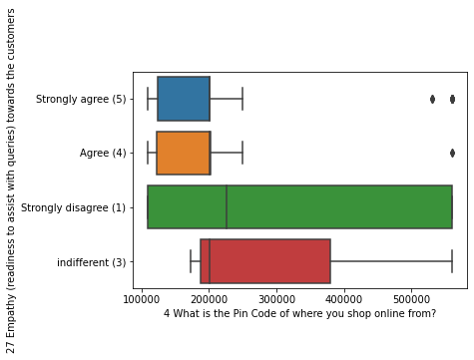

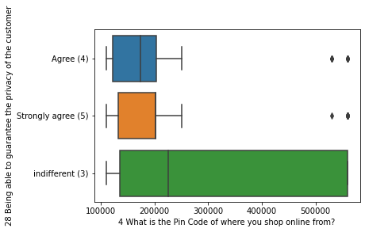

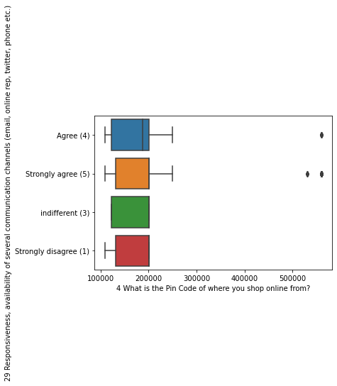

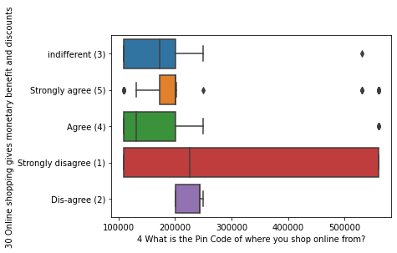

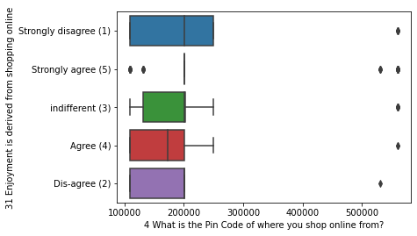

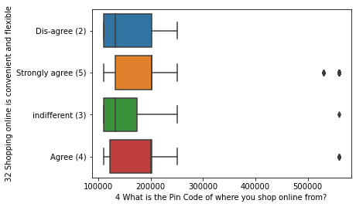

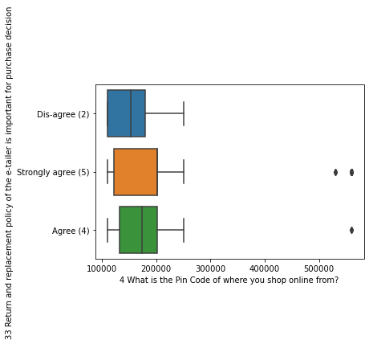

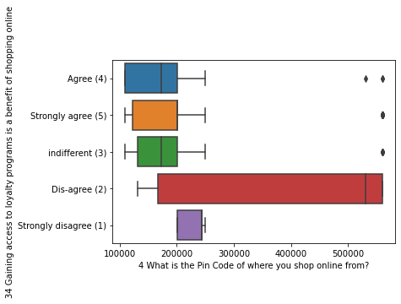

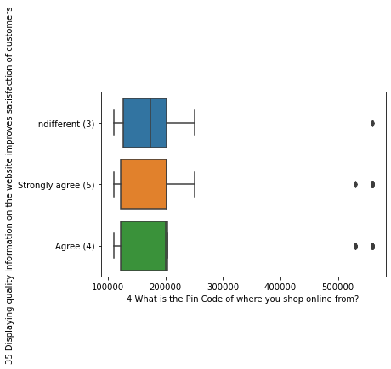

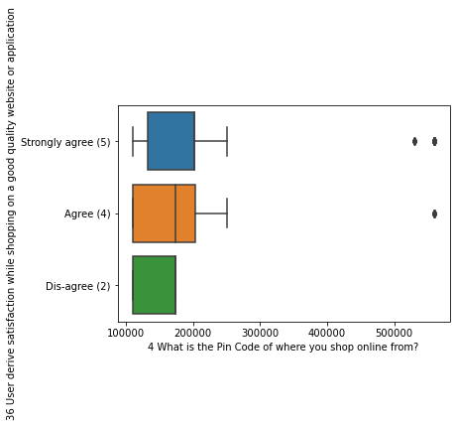

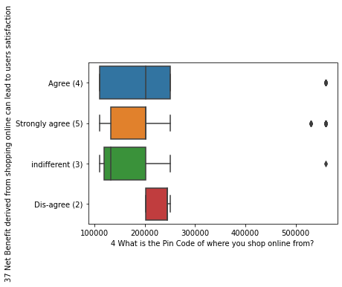

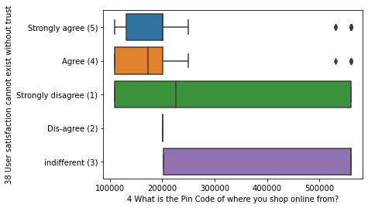

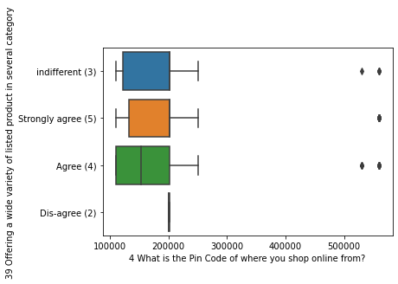

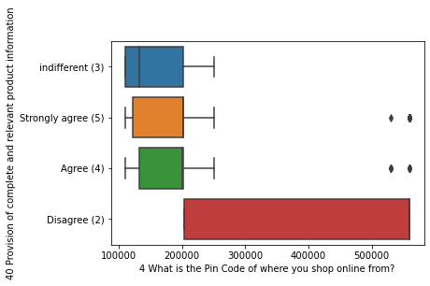

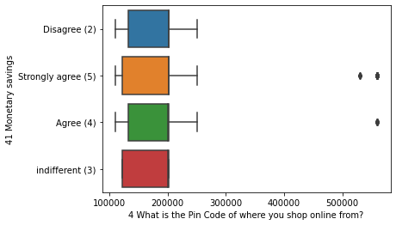

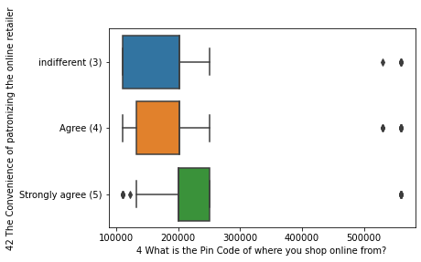

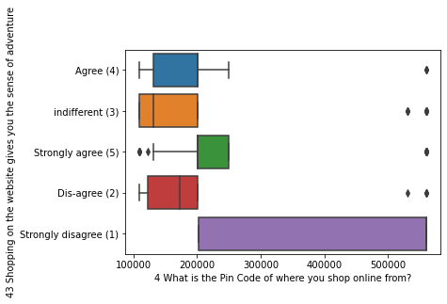

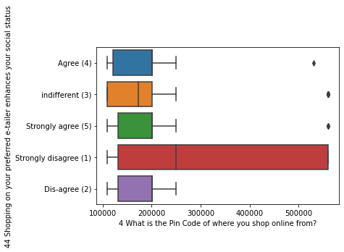

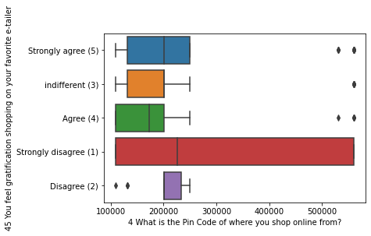

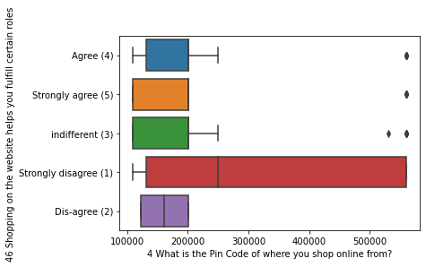

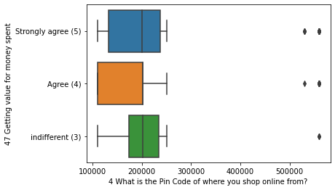

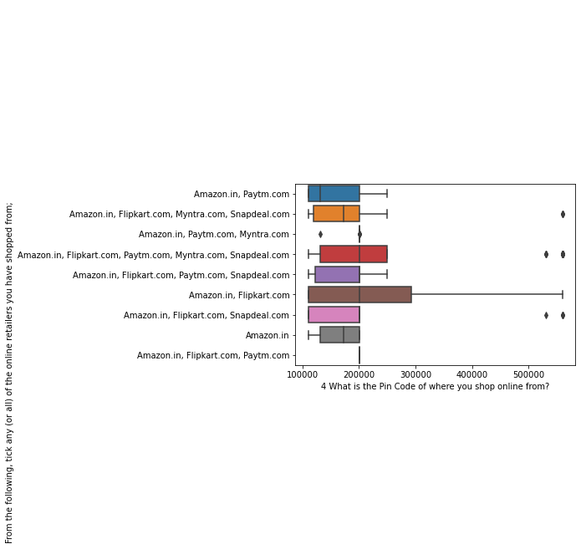

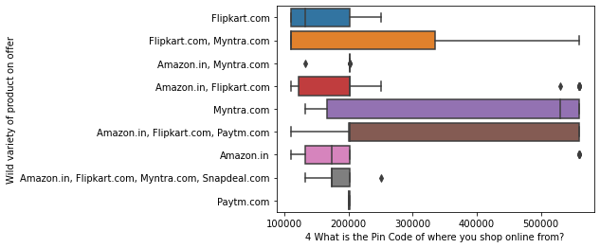

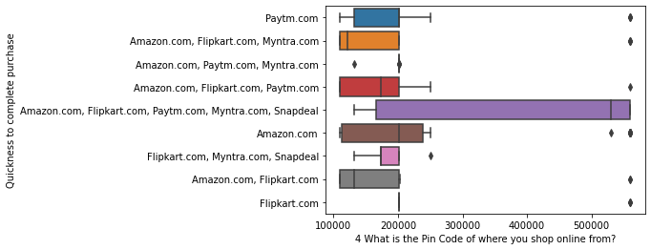

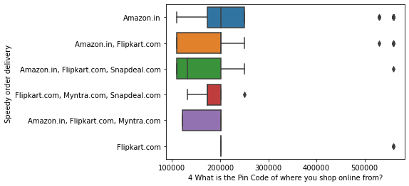

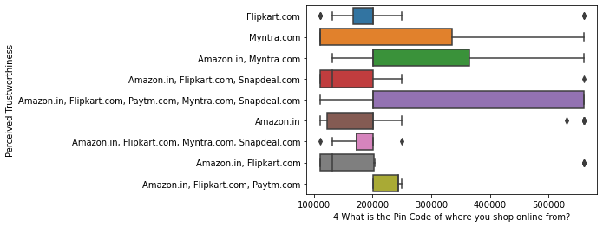

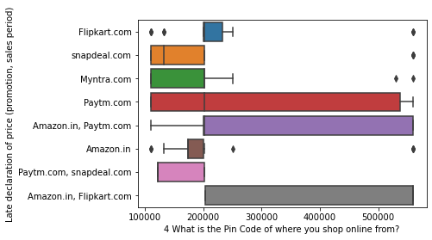

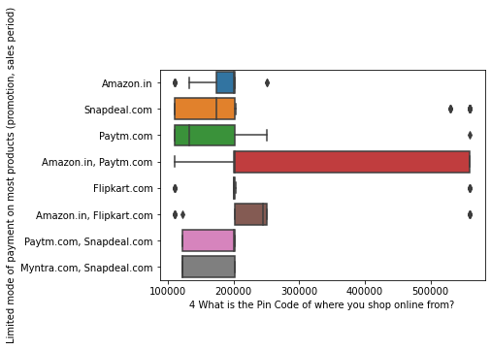

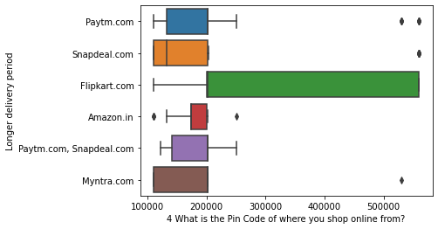

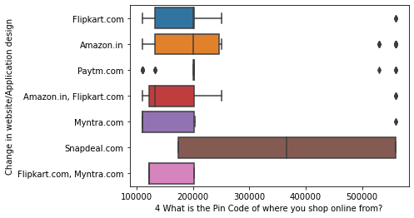

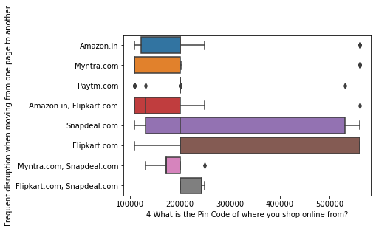

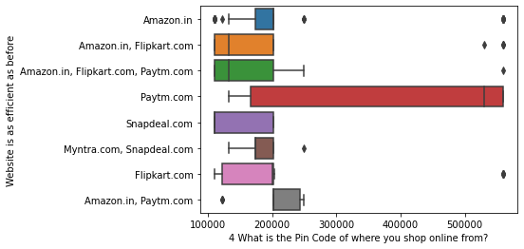

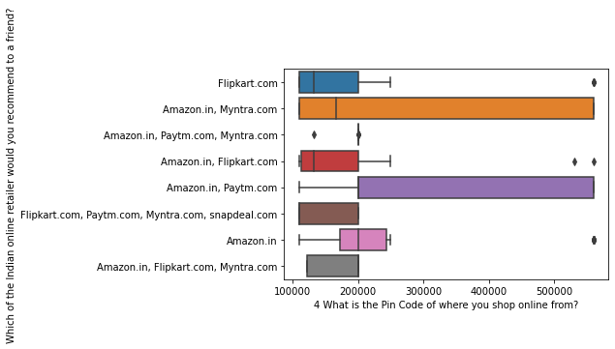

## Outliers are present in Pin code variable

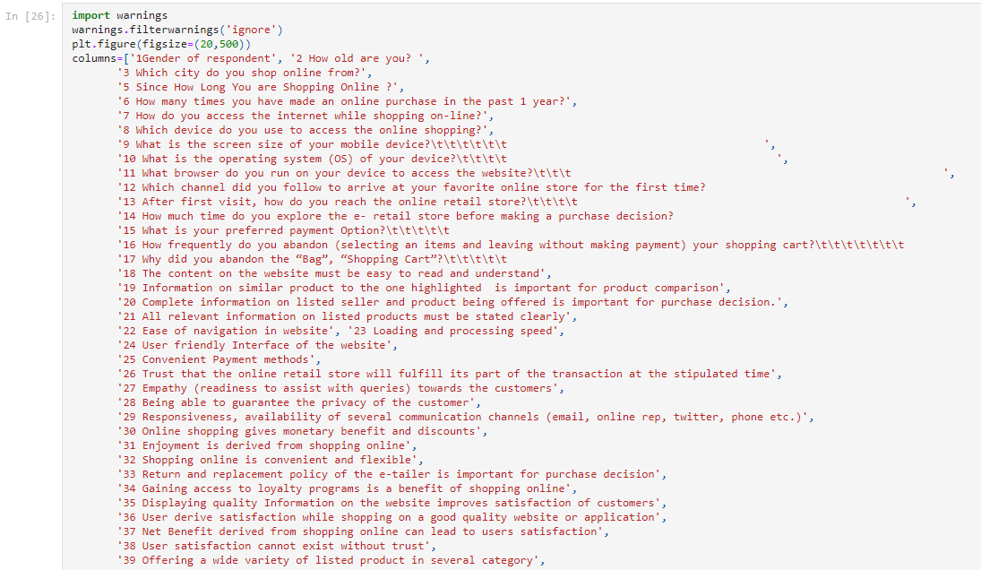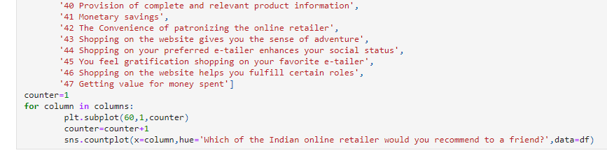

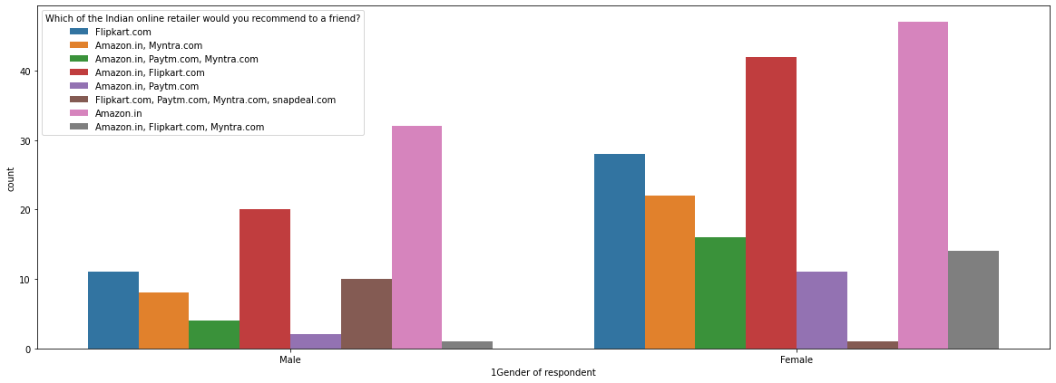

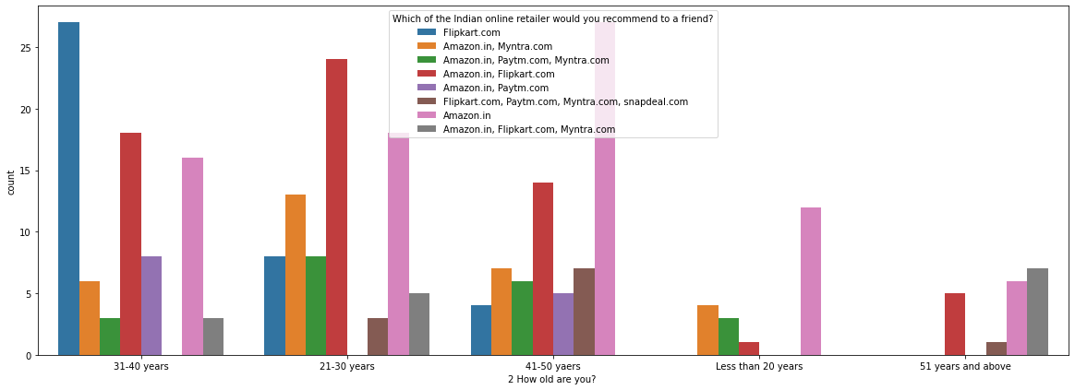

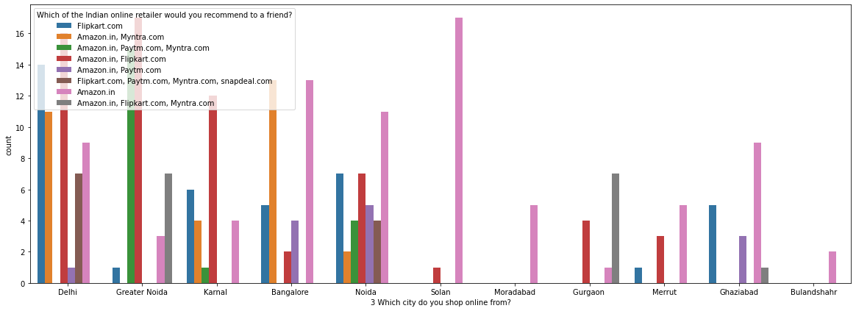

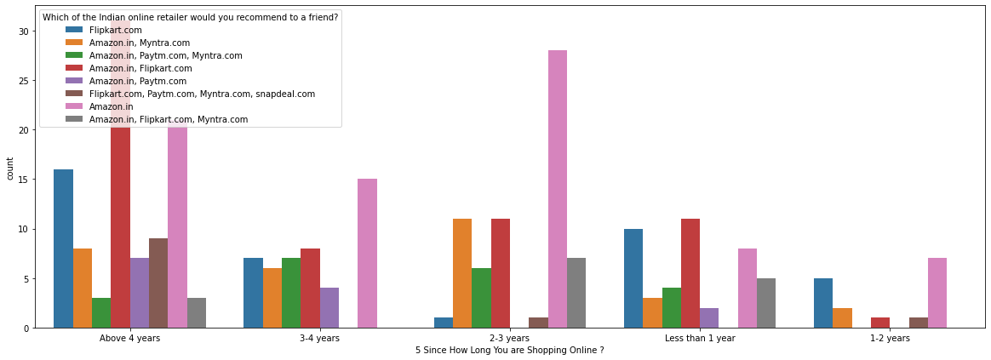

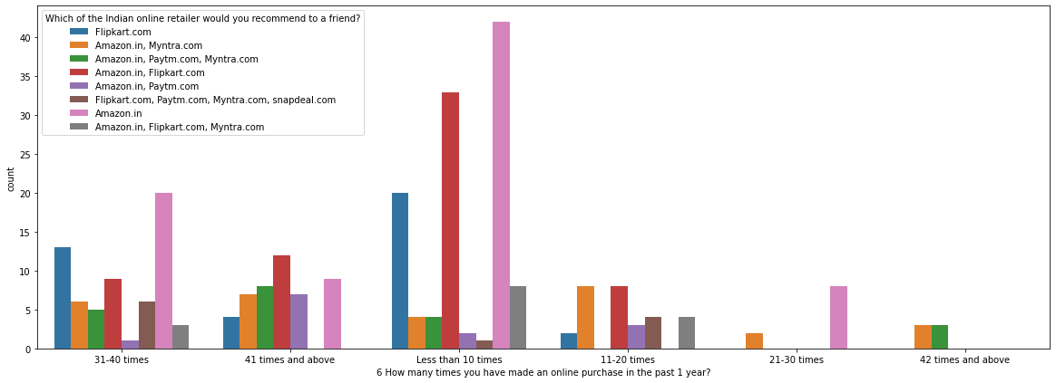

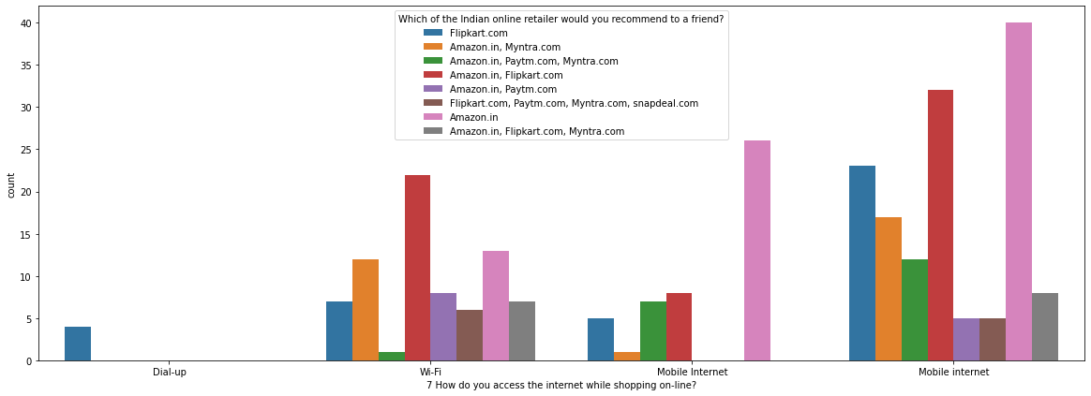

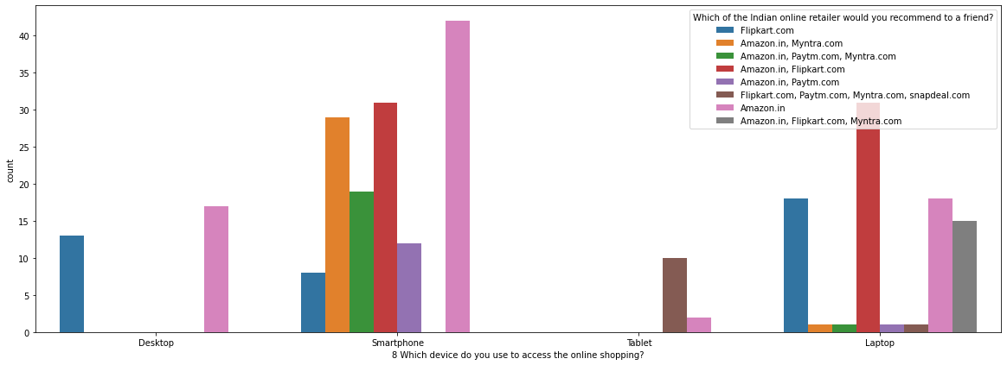

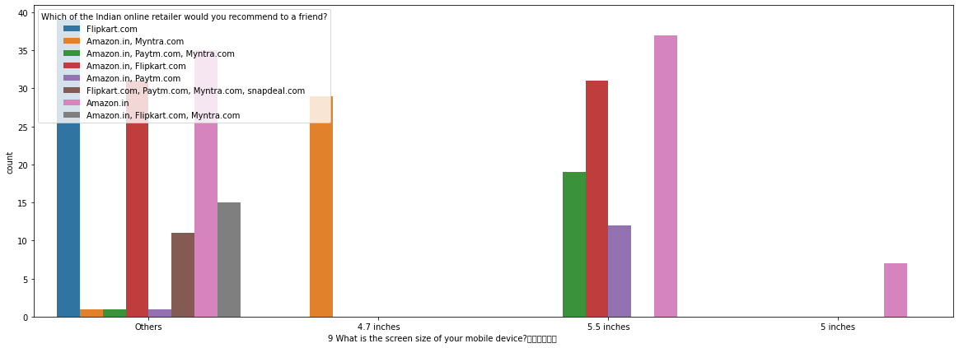

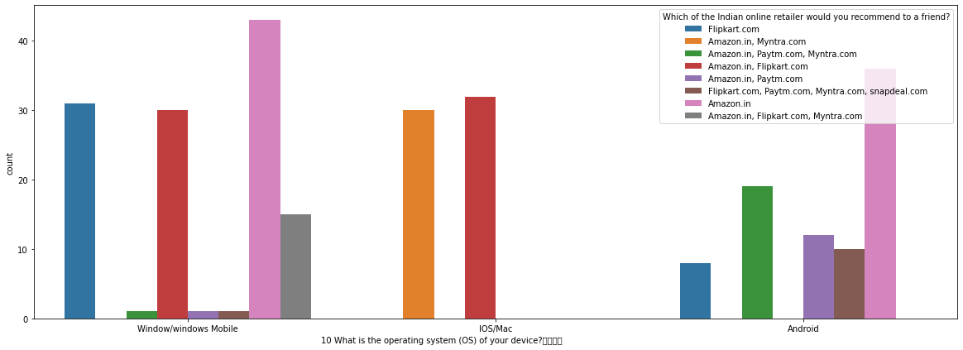

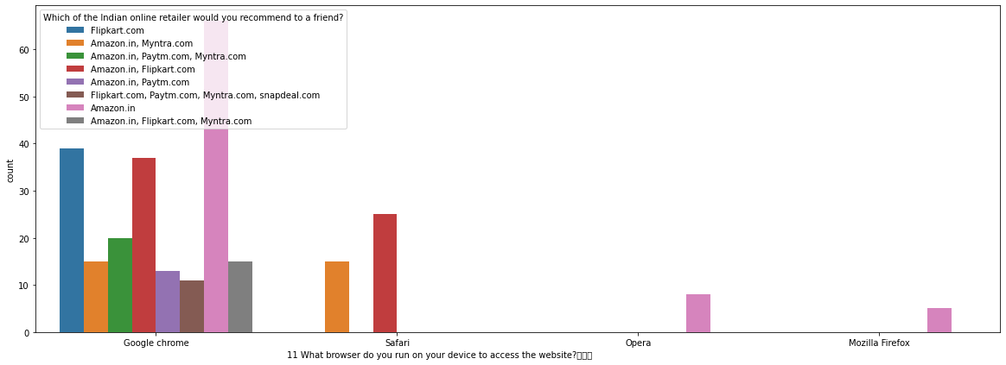

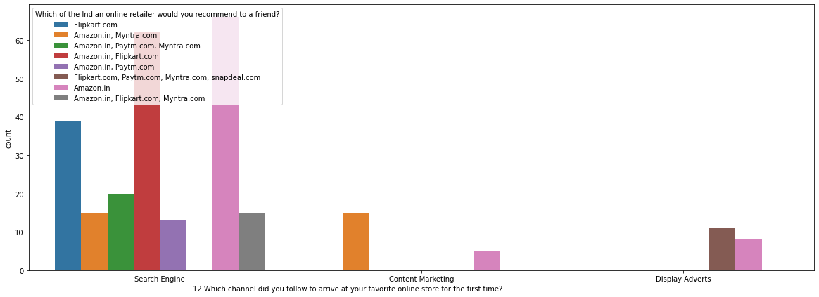

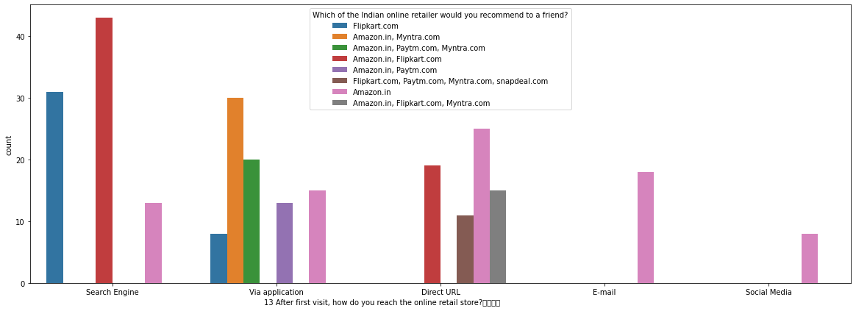

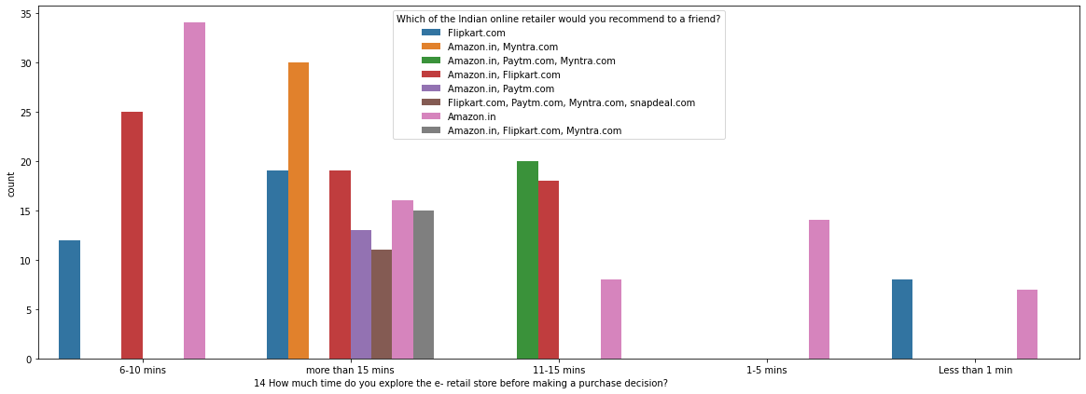

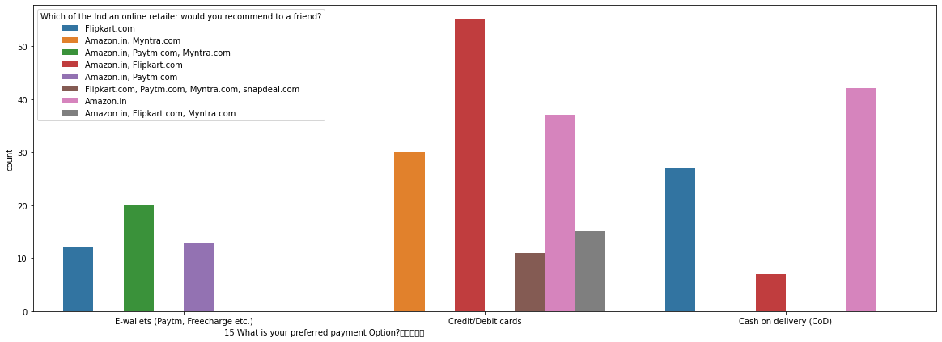

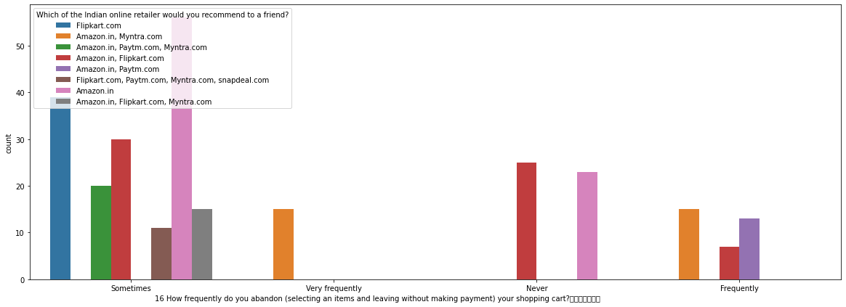

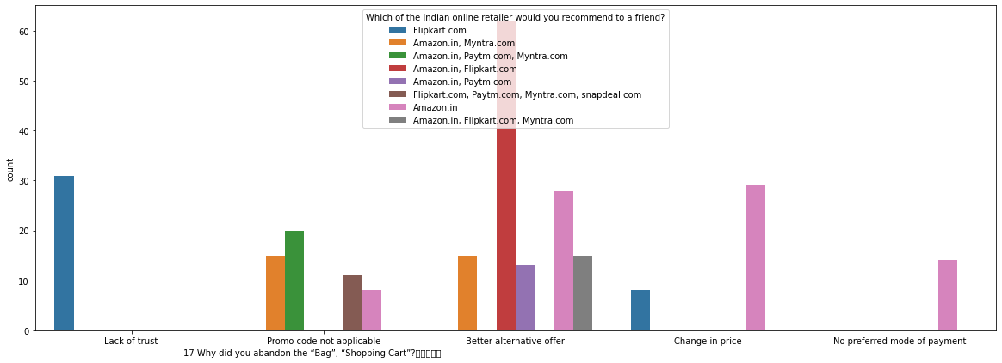

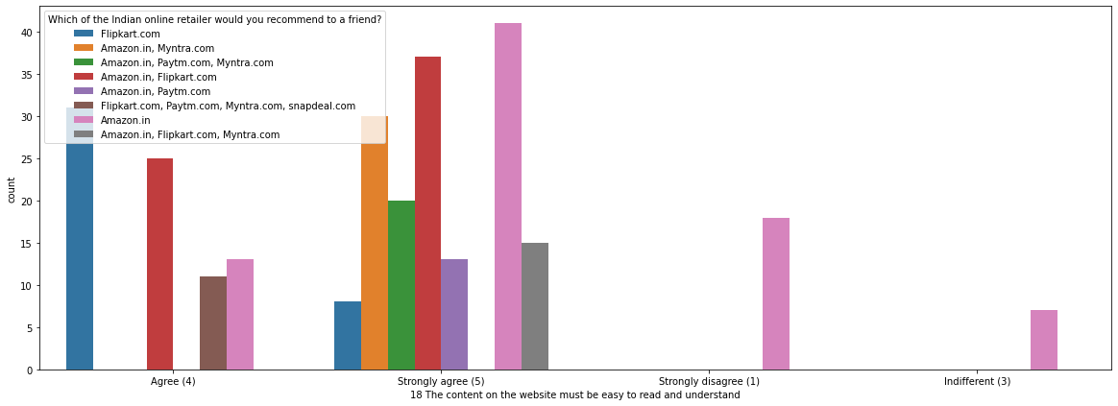

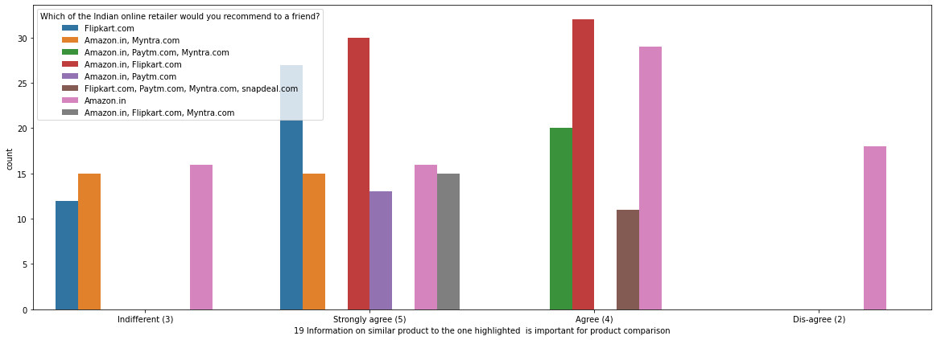

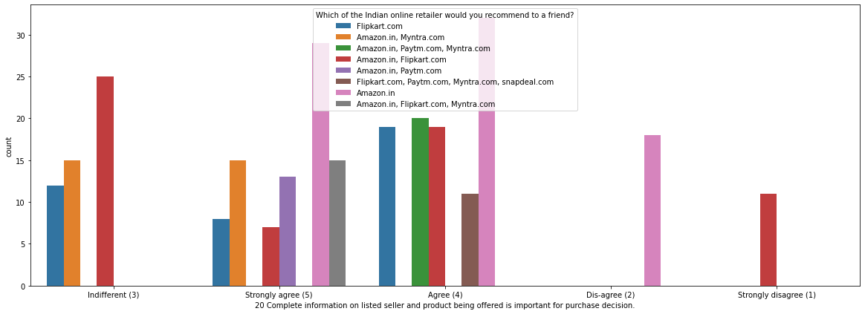

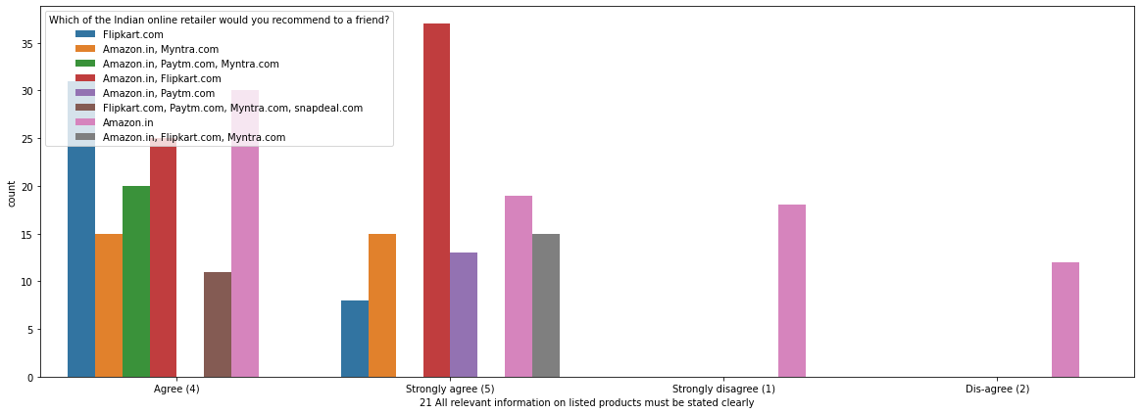

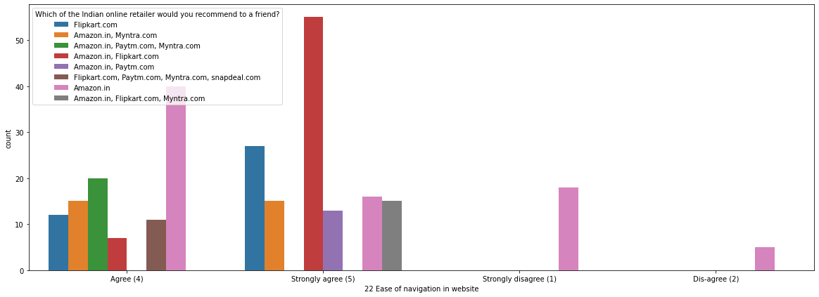

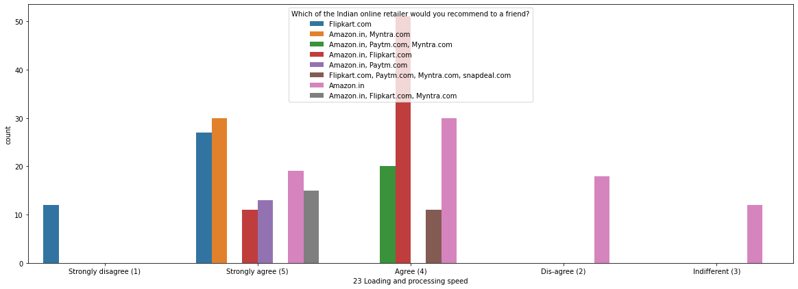

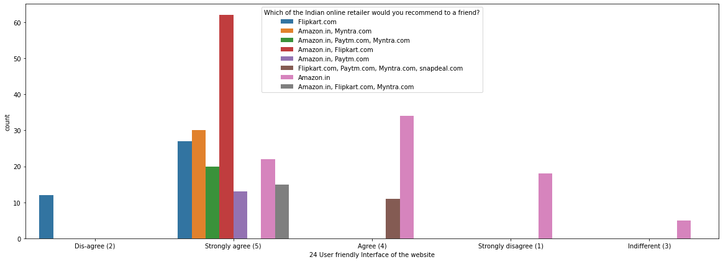

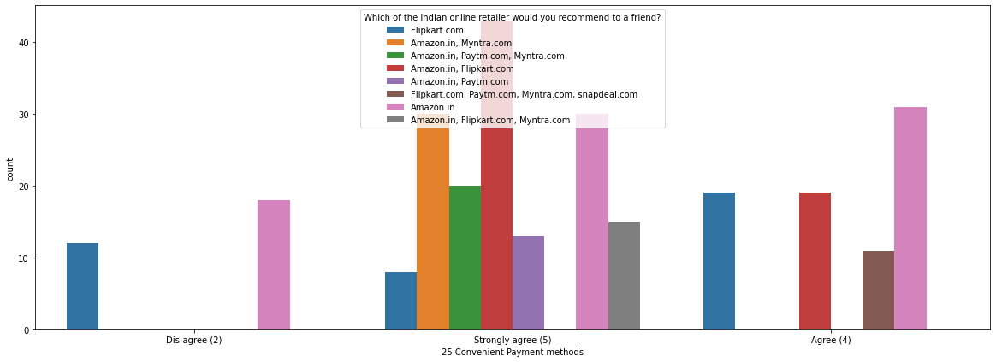

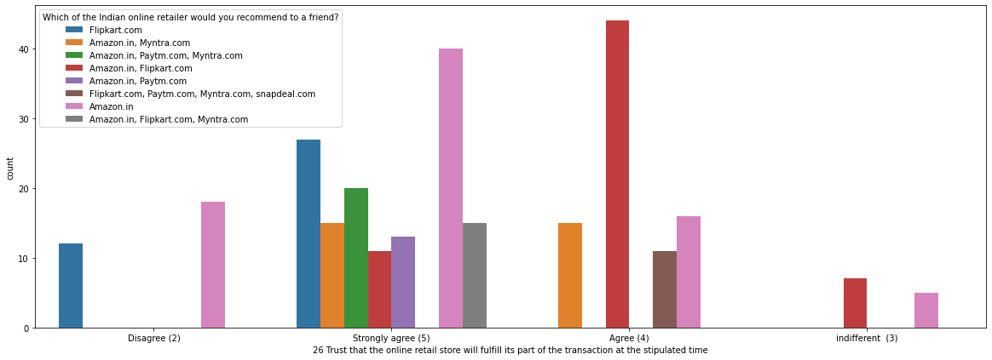

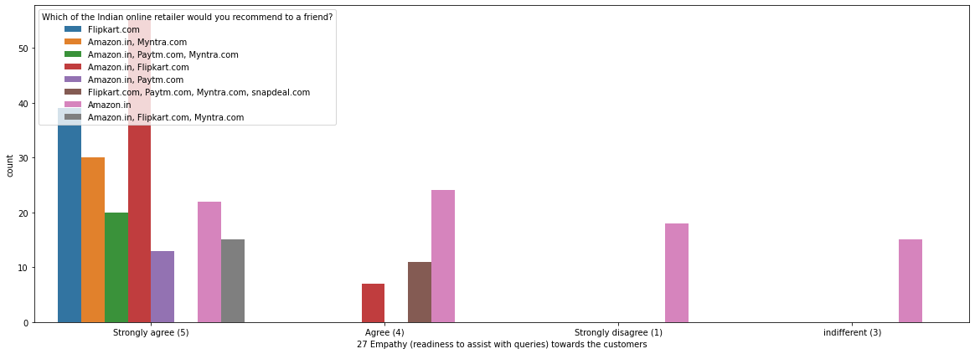

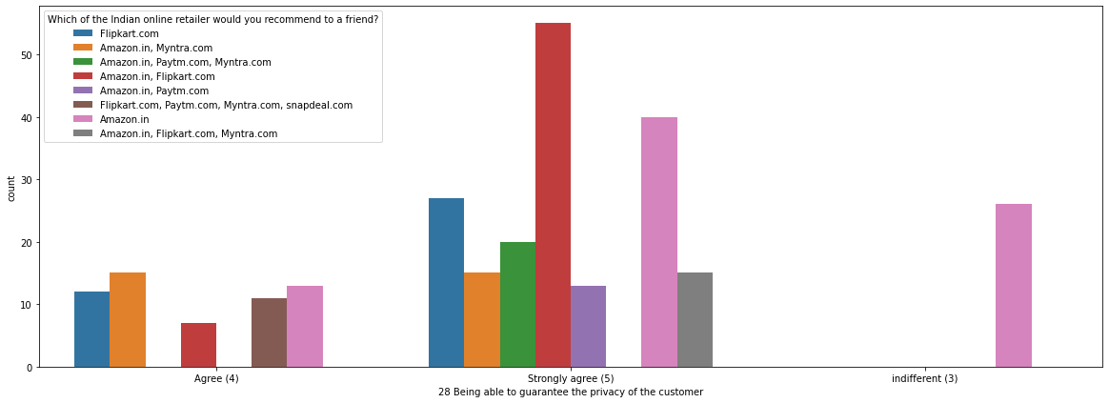

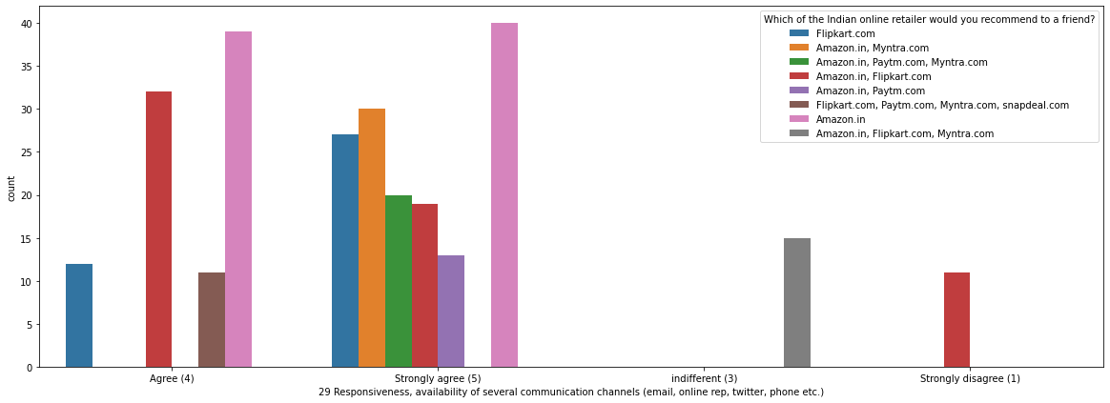

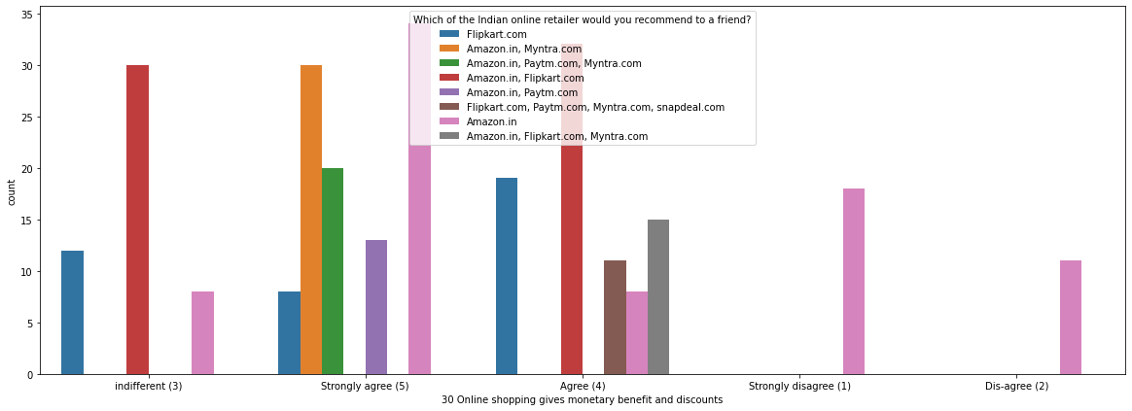

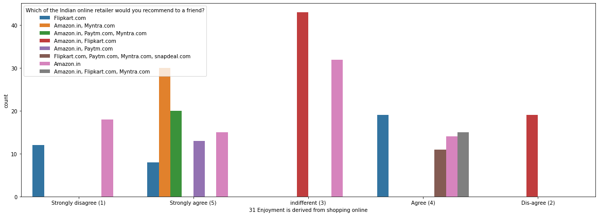

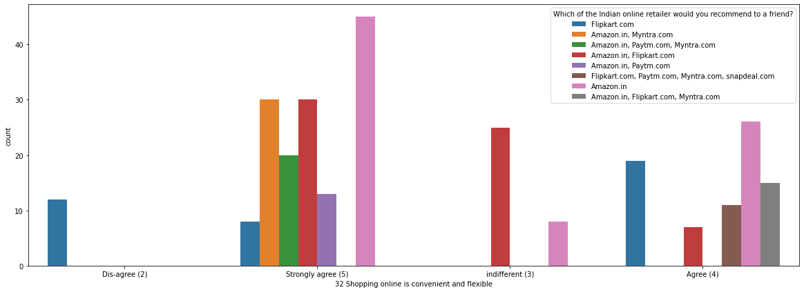

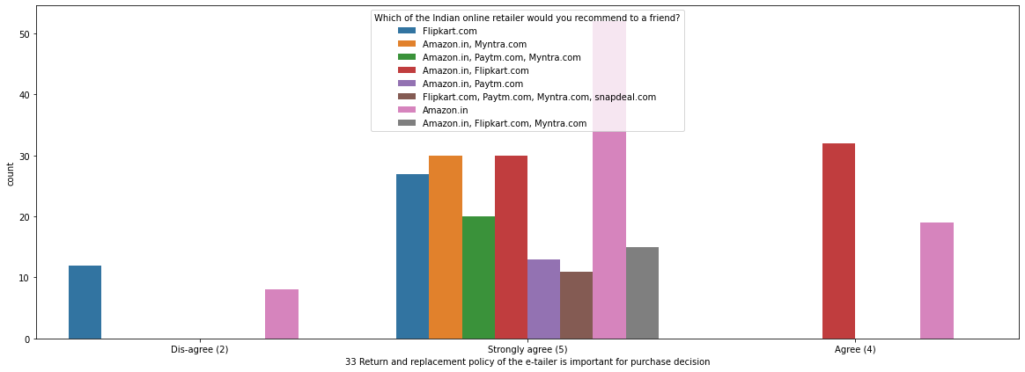

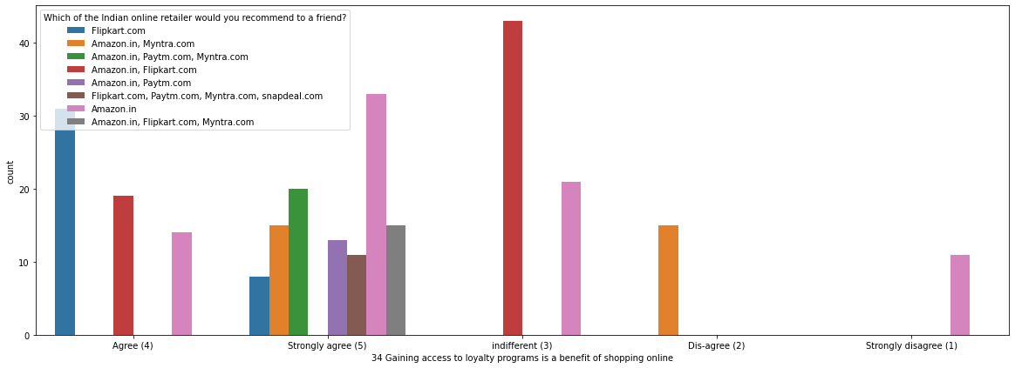

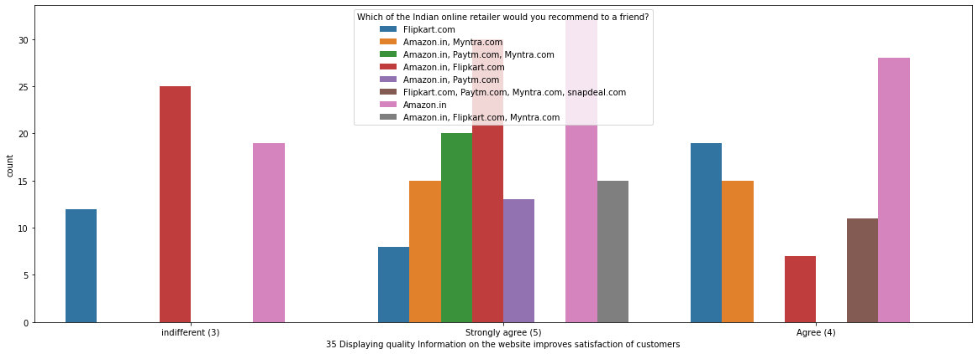

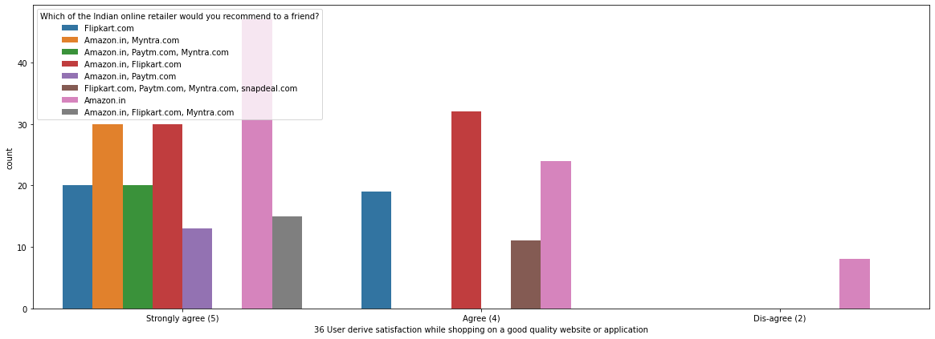

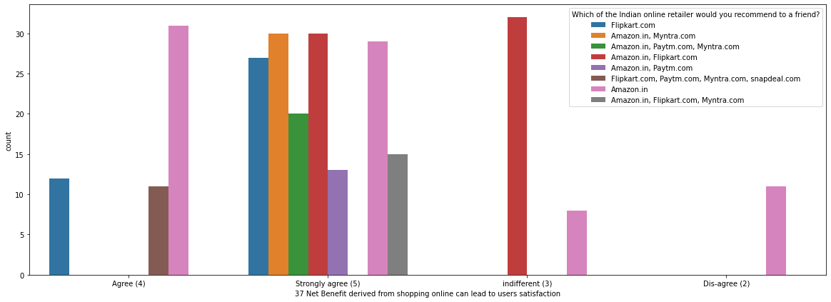

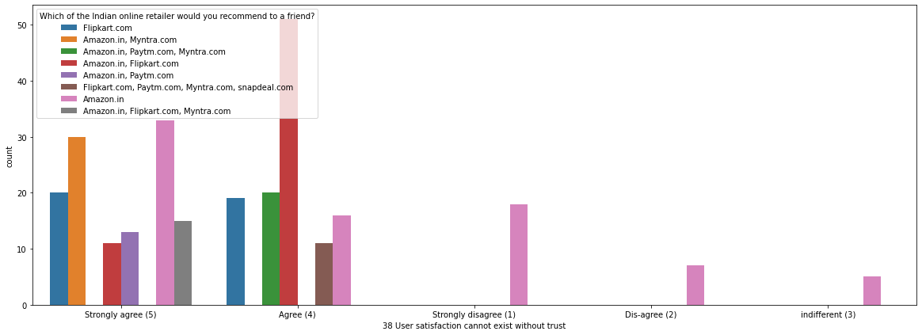

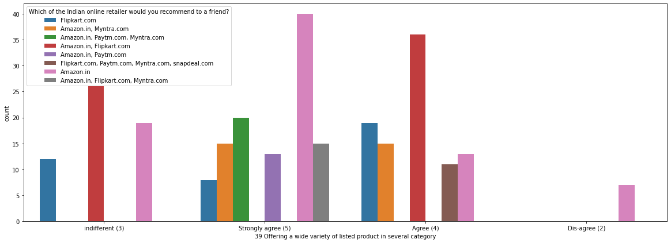

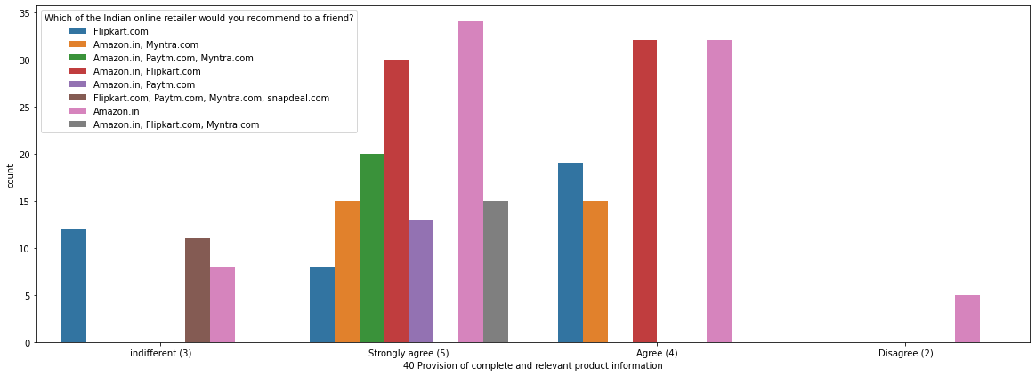

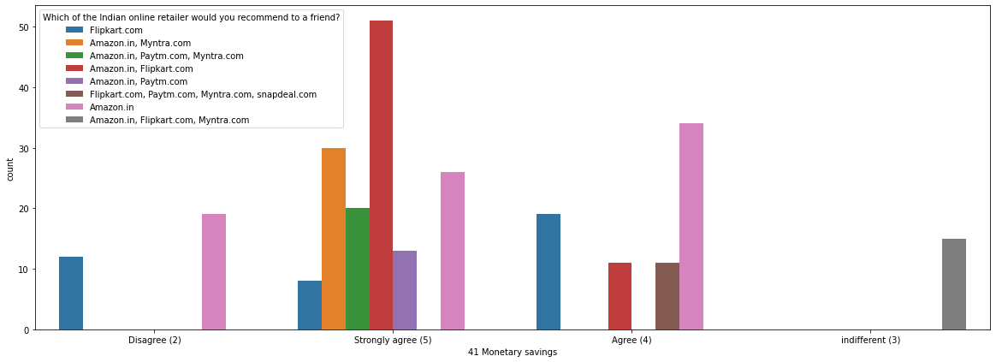

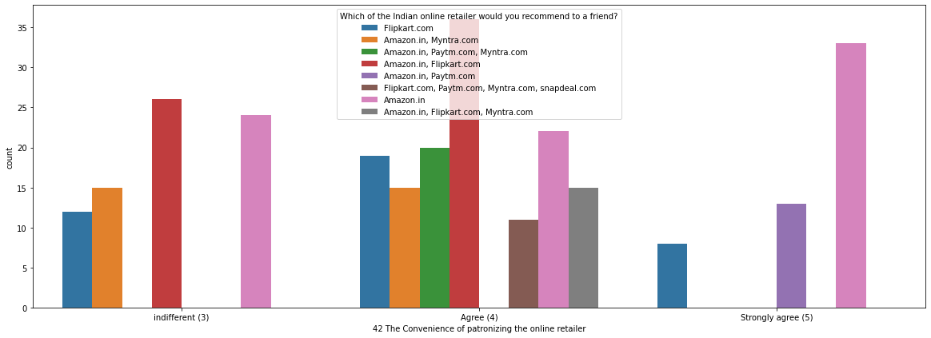

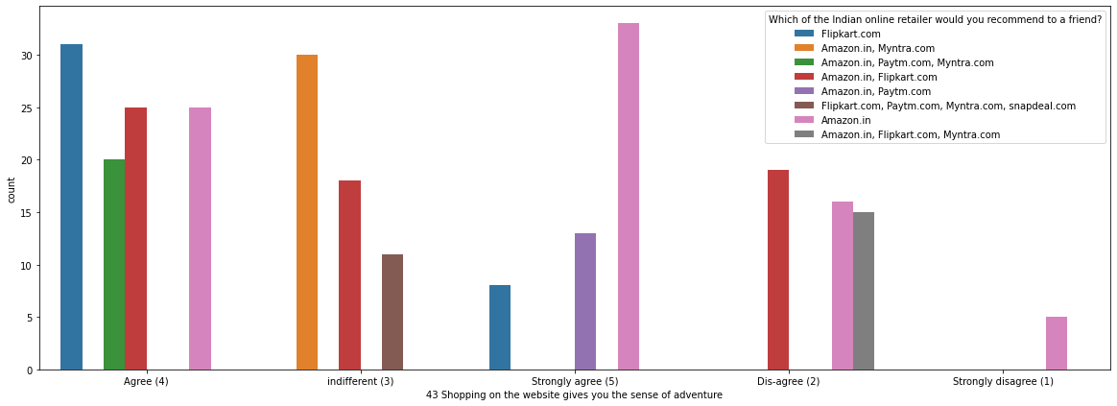

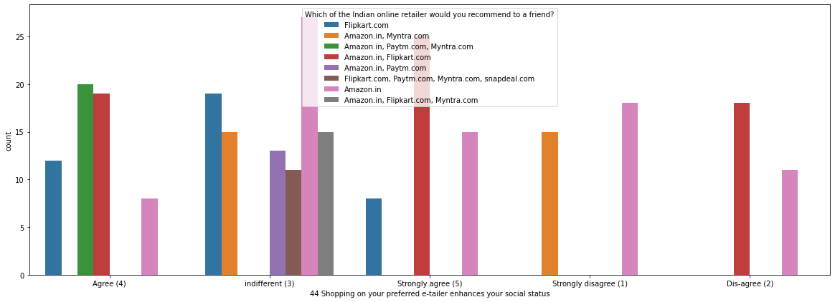

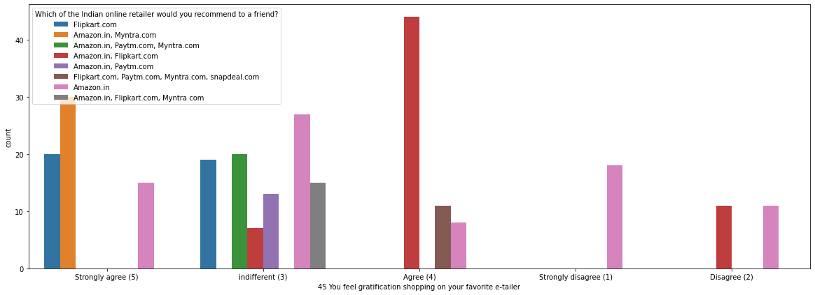

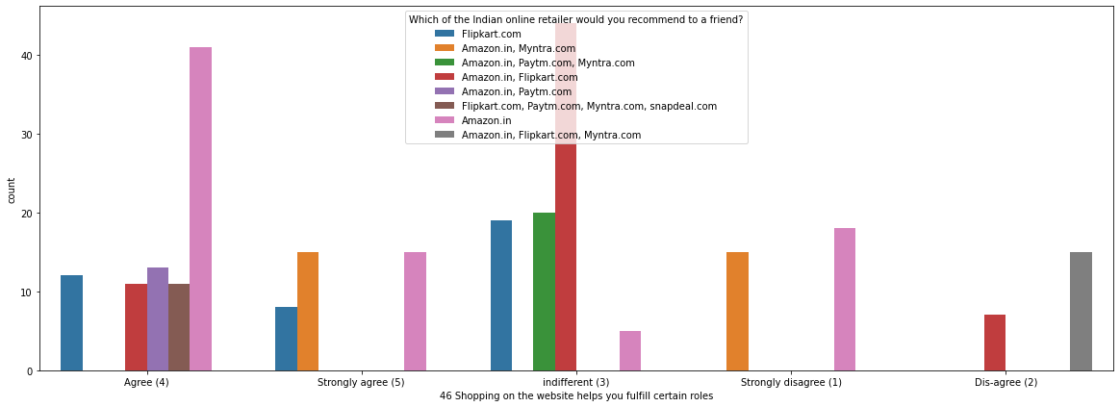

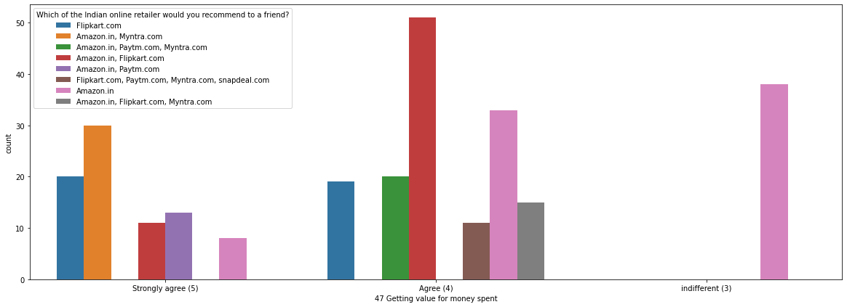

Basic Observations:

Most of the Females uses Amazon for online shopping and recommend the same

Most of the people from 31-40 age group uses Flipkart and recommend the same

Users uses Amazon and flipkart to frequently order and recommend the same

Most of the Amazon Users uses Smartphone to order items and recommend the same

Majorly Payments done on Amazon and Flipkart are using Credt/Debit Card and recommend the same

Majorly users are satisfied with shopping quality from Amazon and recommend the same

Users who believe in consumer trust and privacy/ Account details confidentiality uses Amazon and Flipkart and recommend the same

Users who believe in value for money also uses Amazon and Flipkart and recommend the same

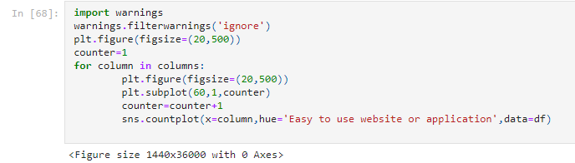

>

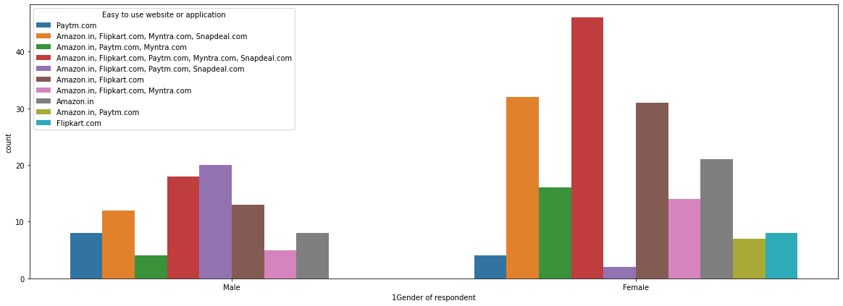

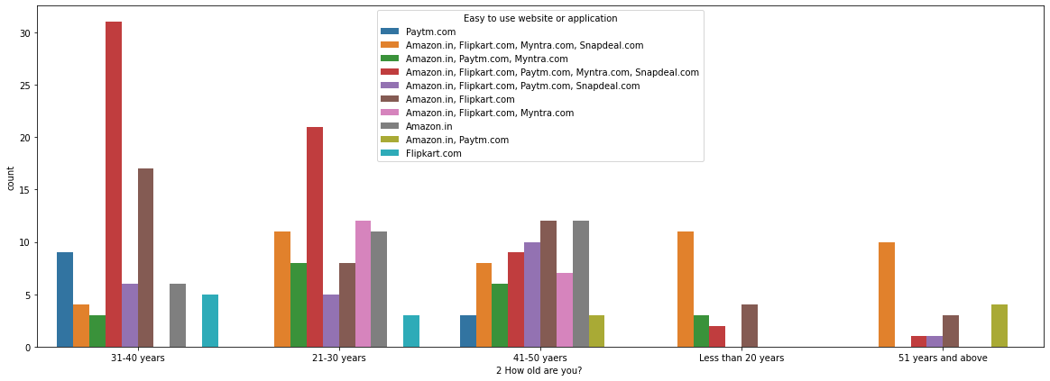

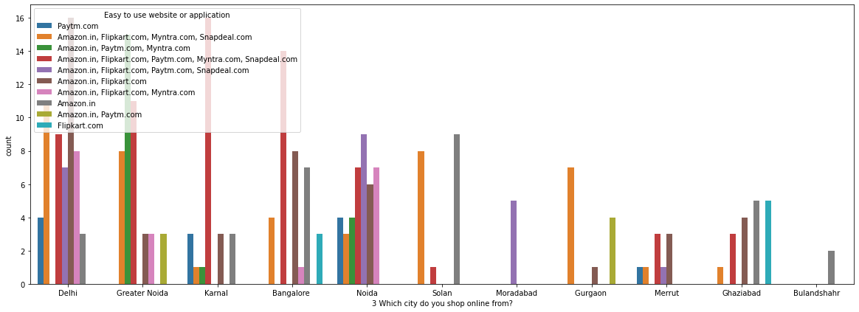

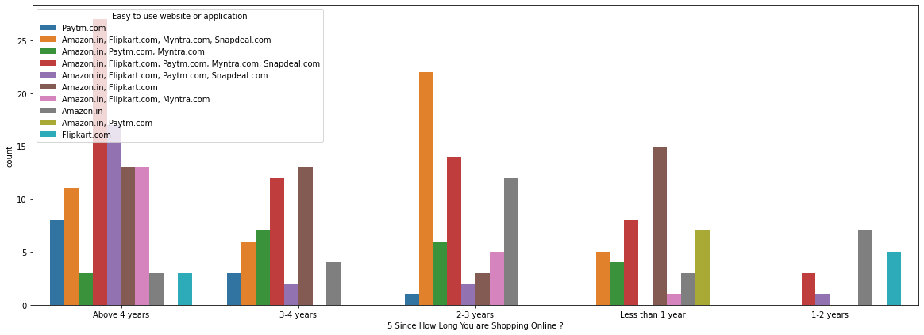

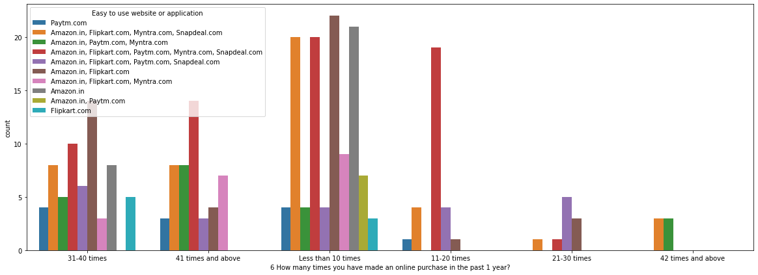

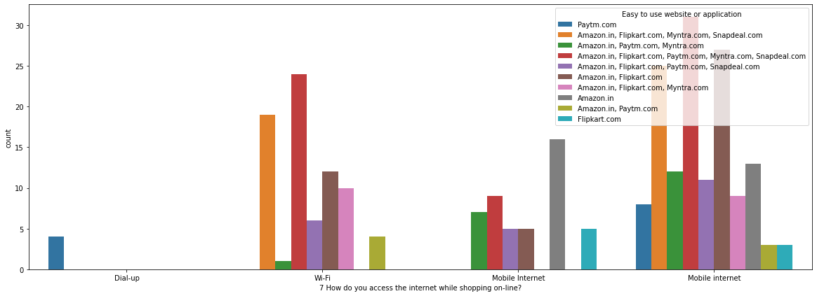

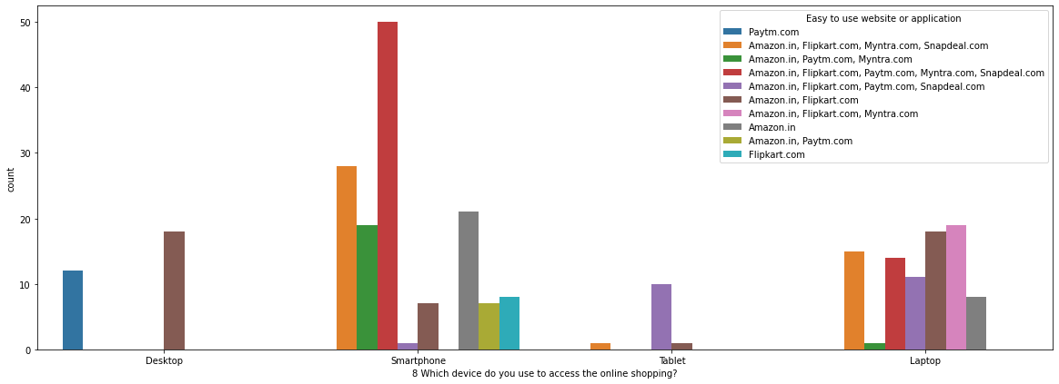

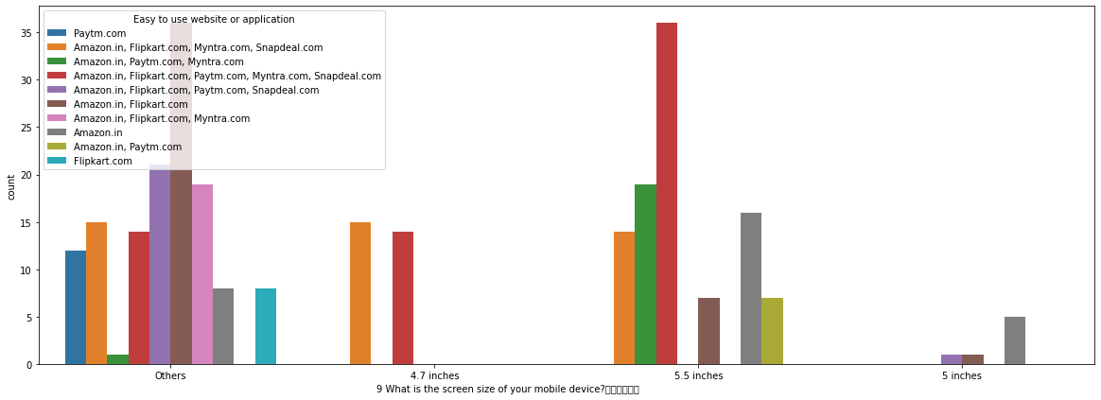

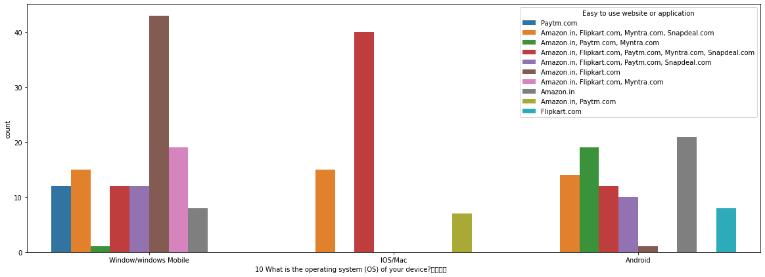

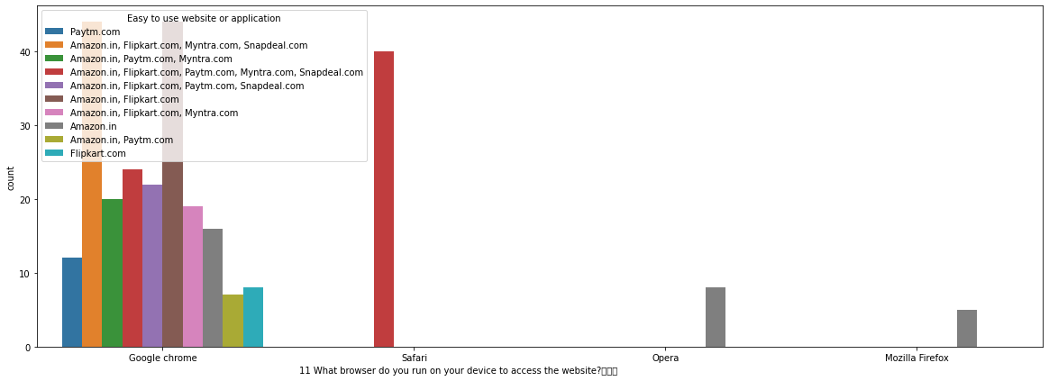

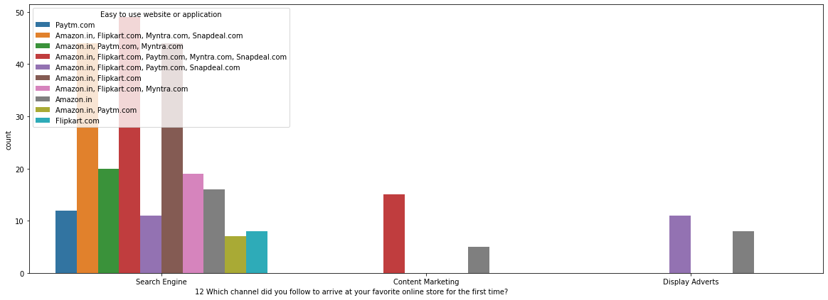

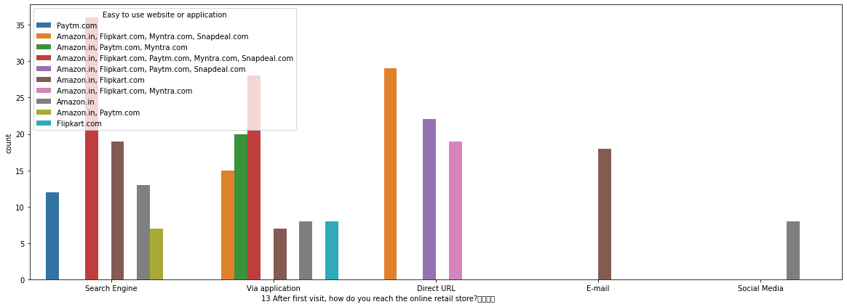

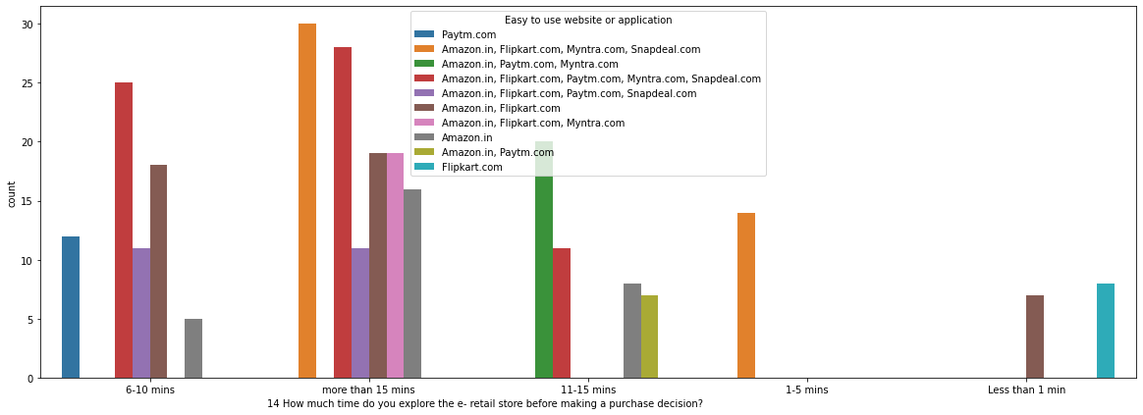

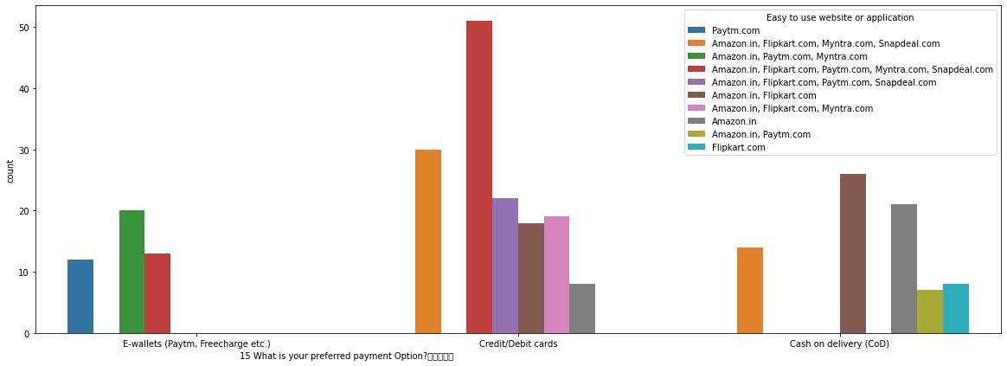

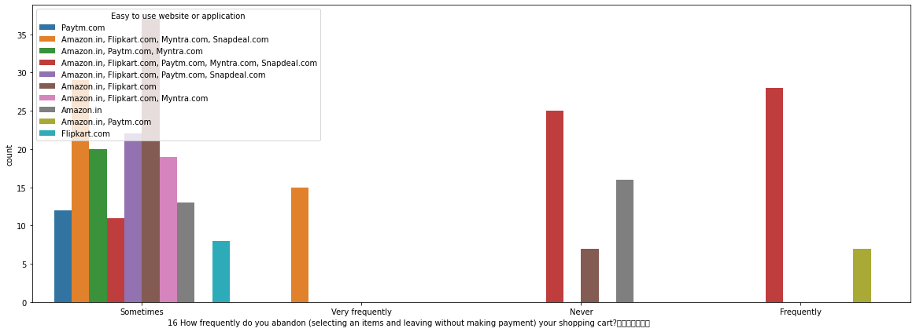

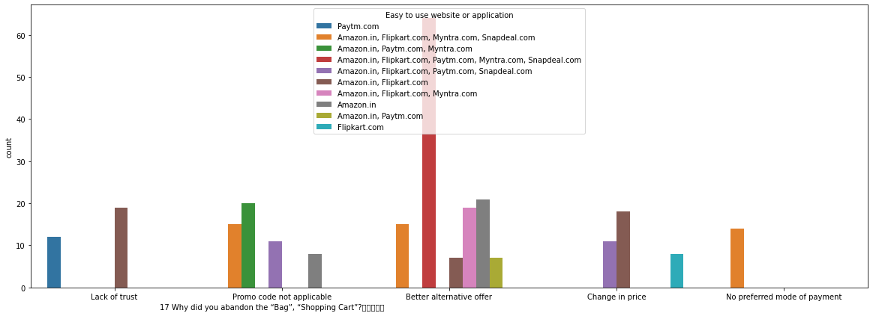

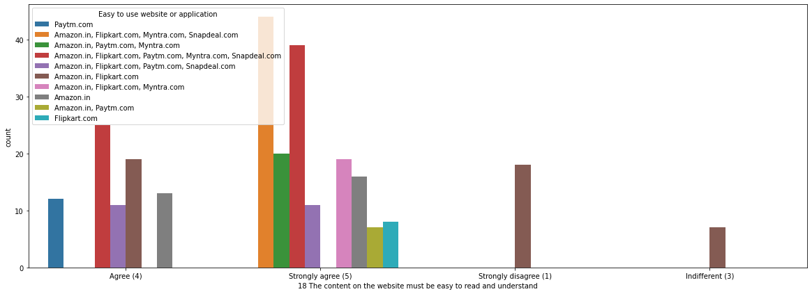

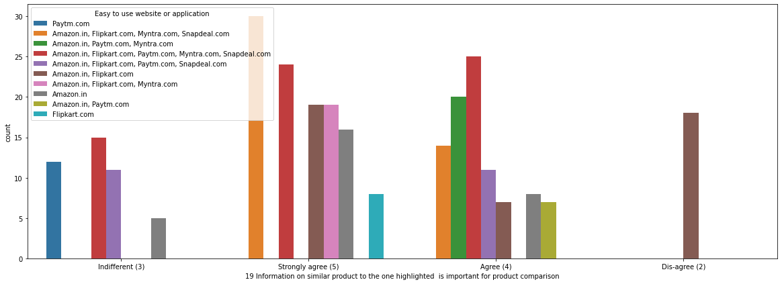

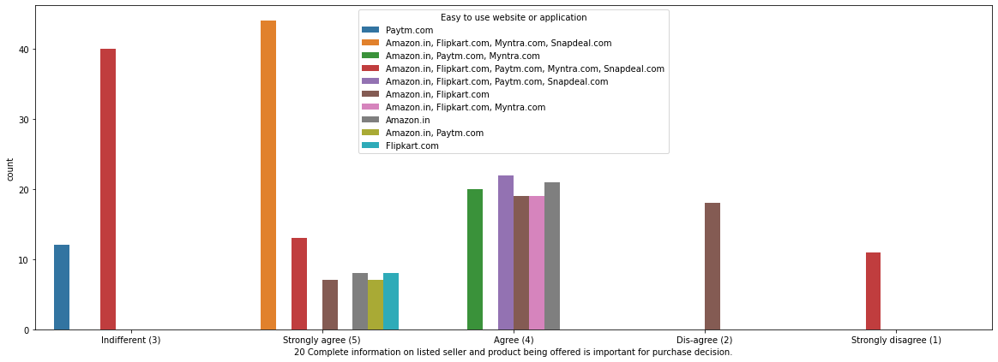

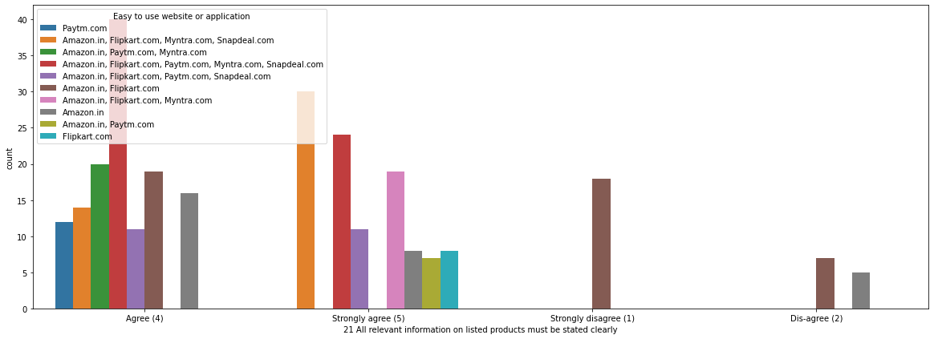

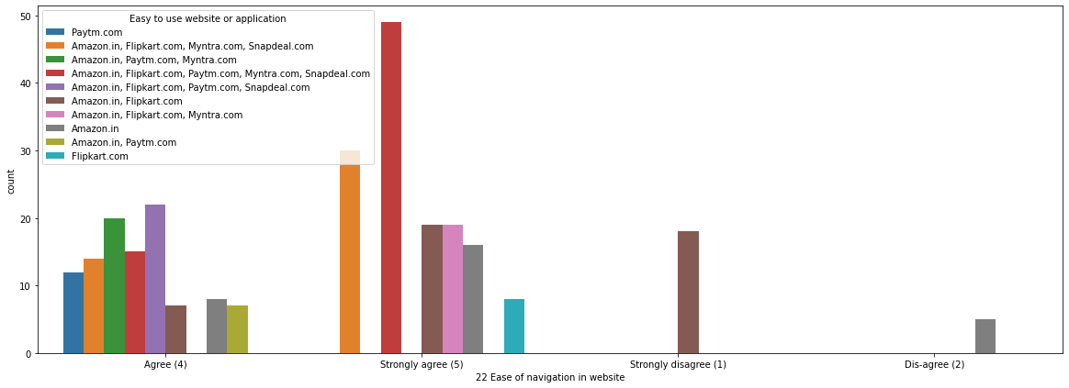

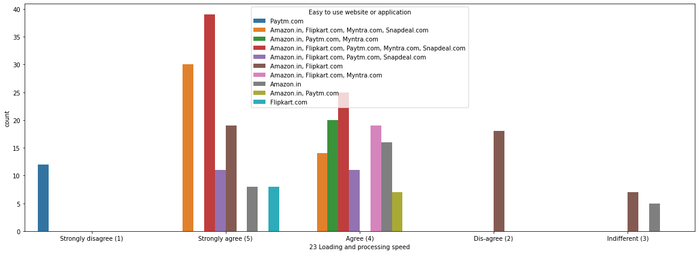

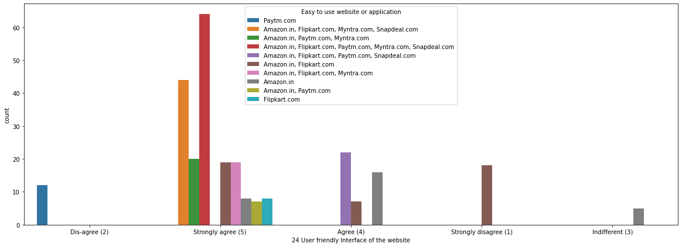

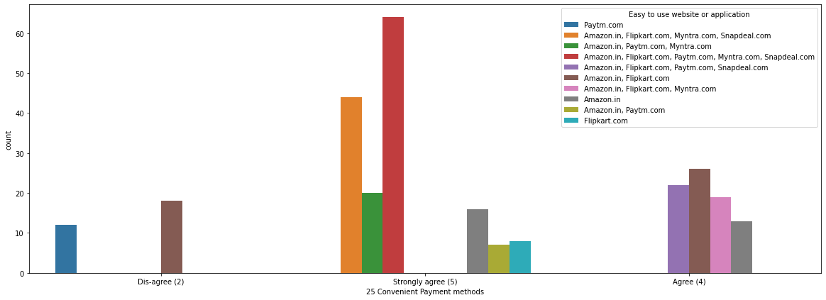

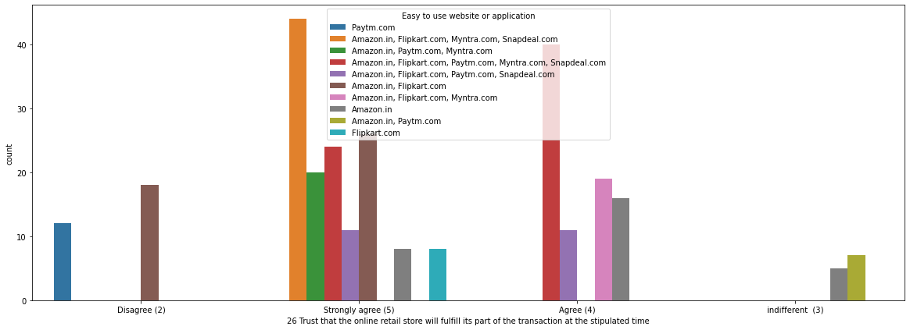

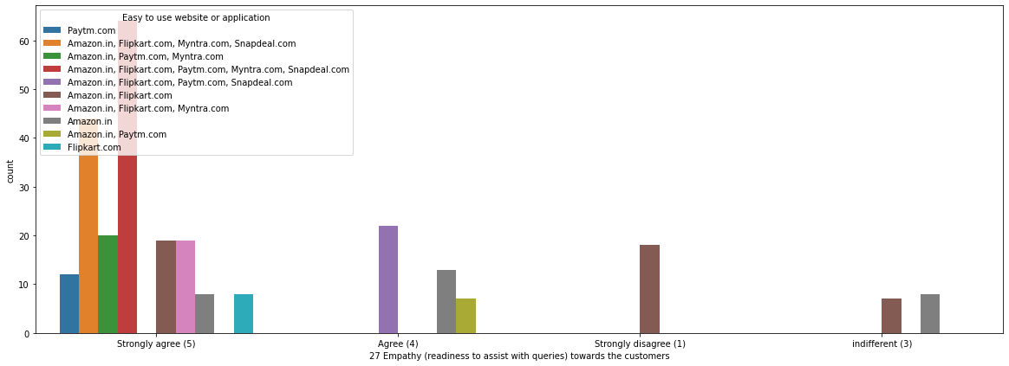

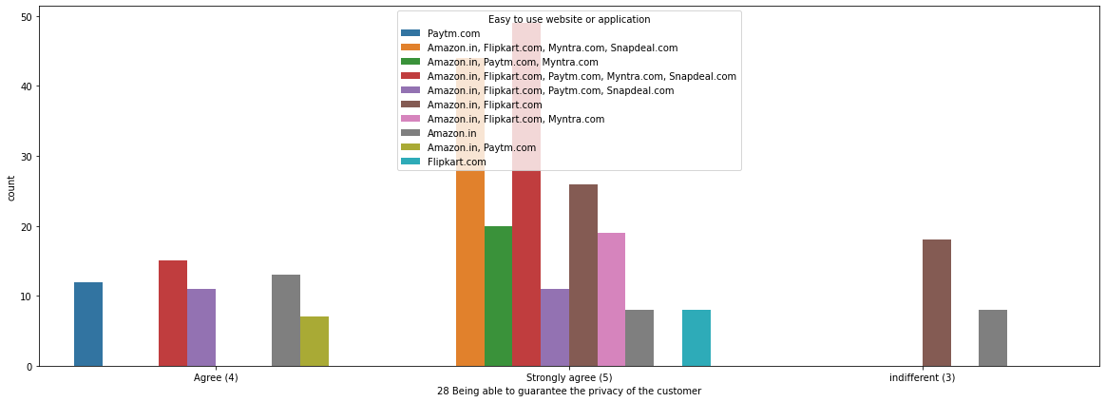

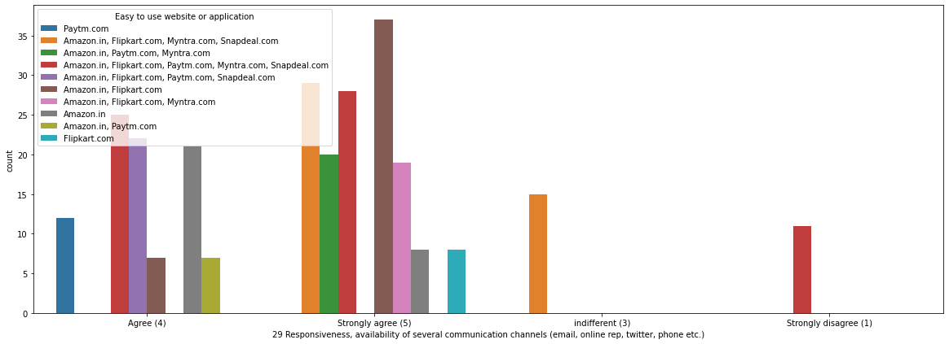

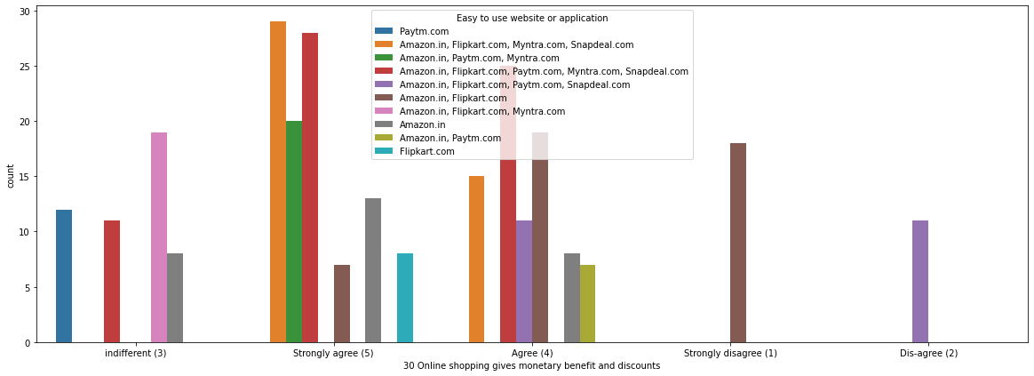

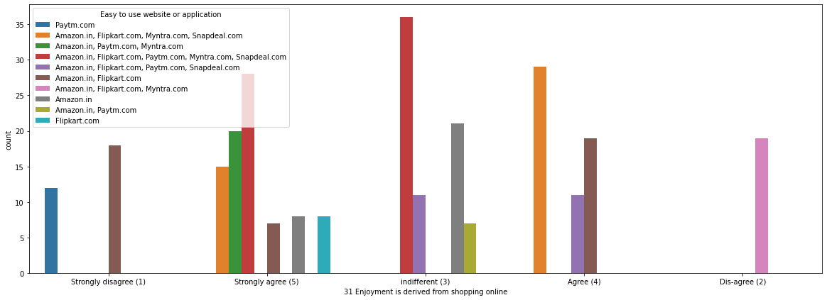

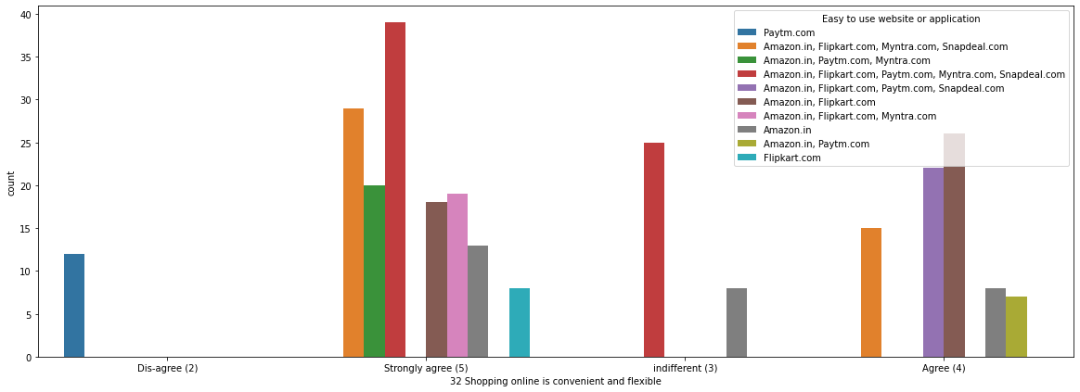

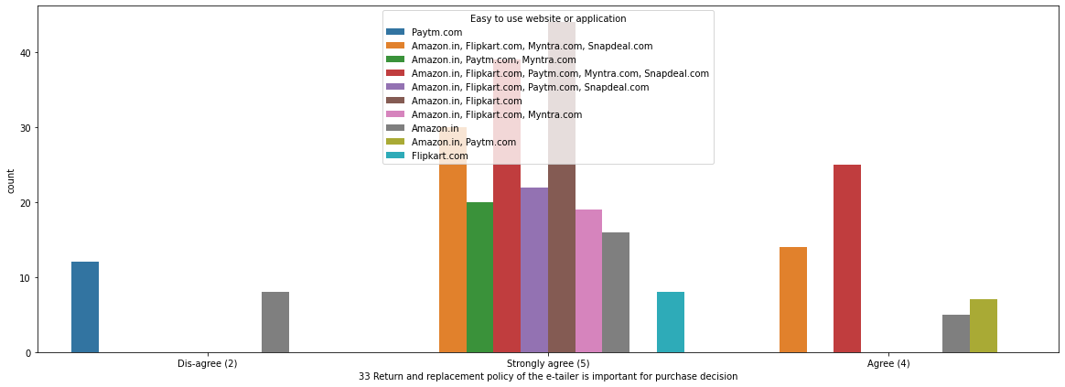

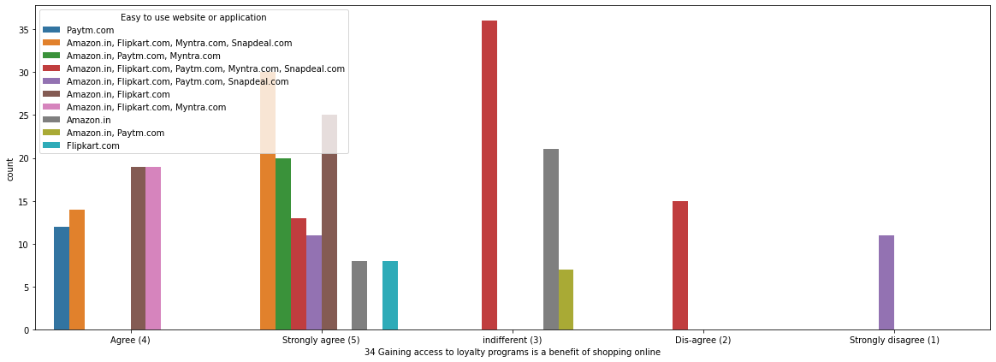

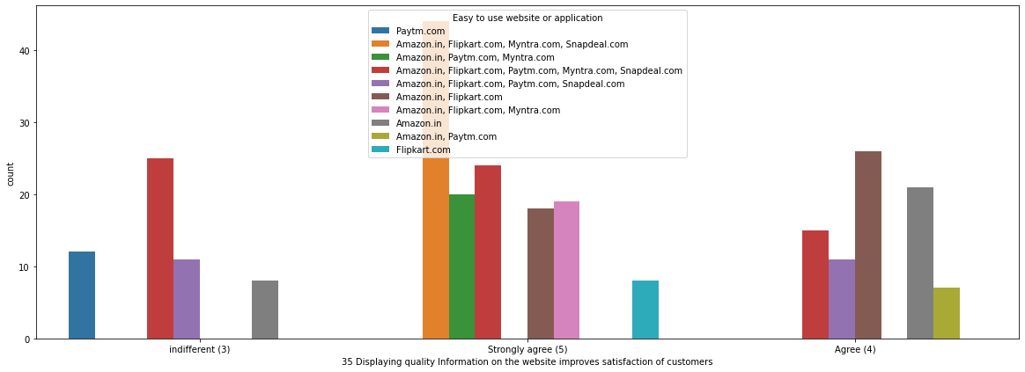

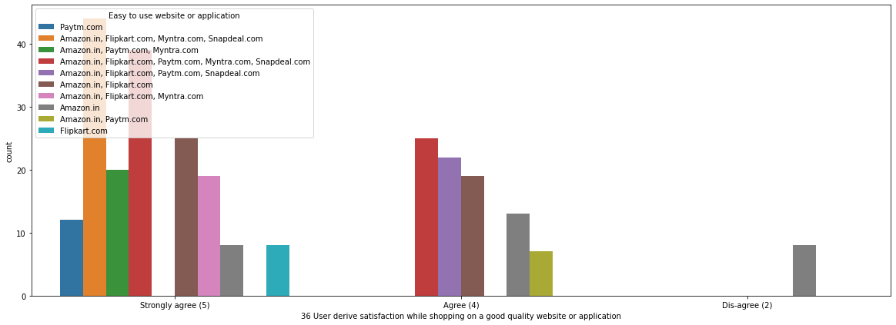

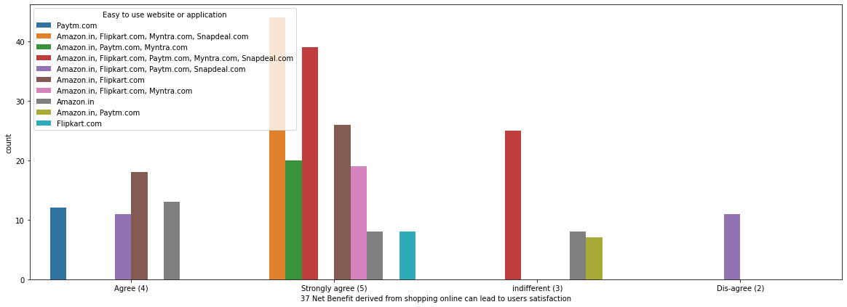

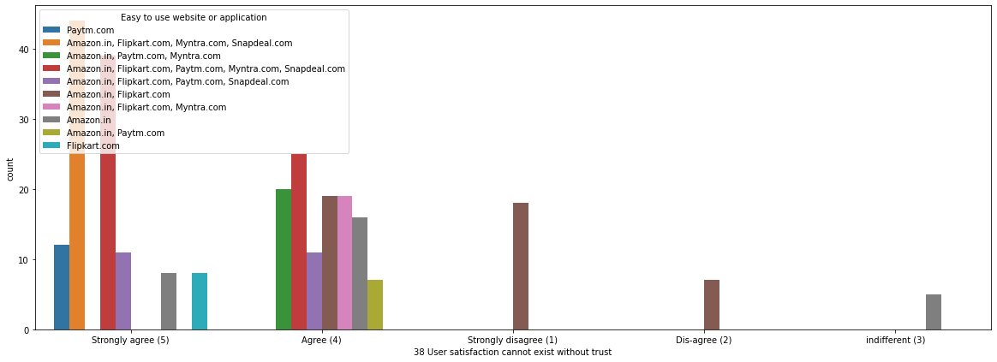

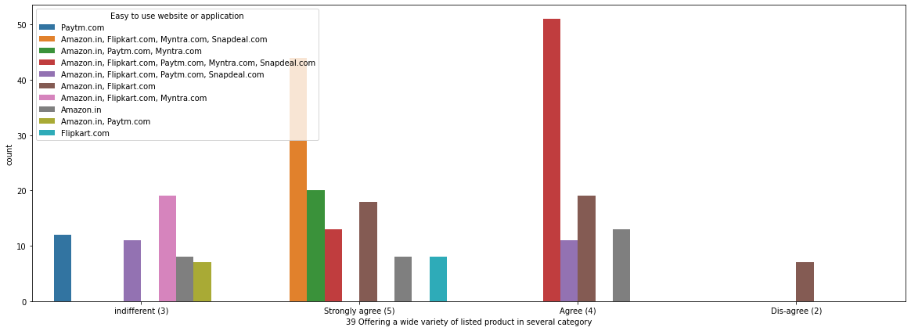

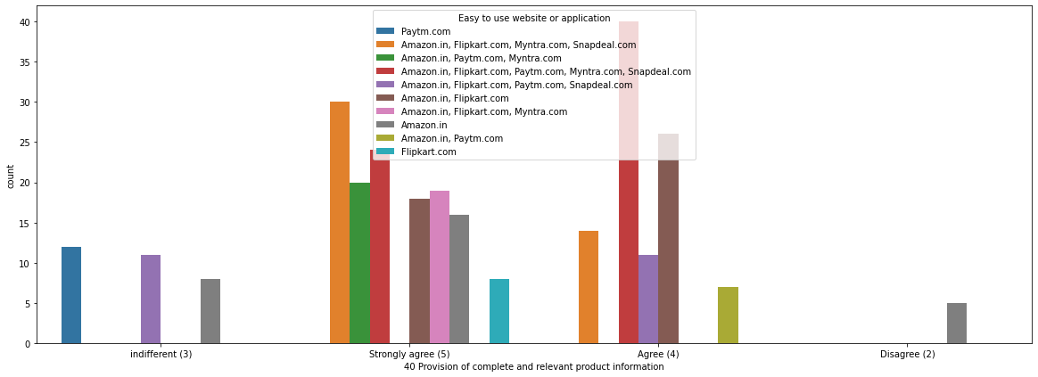

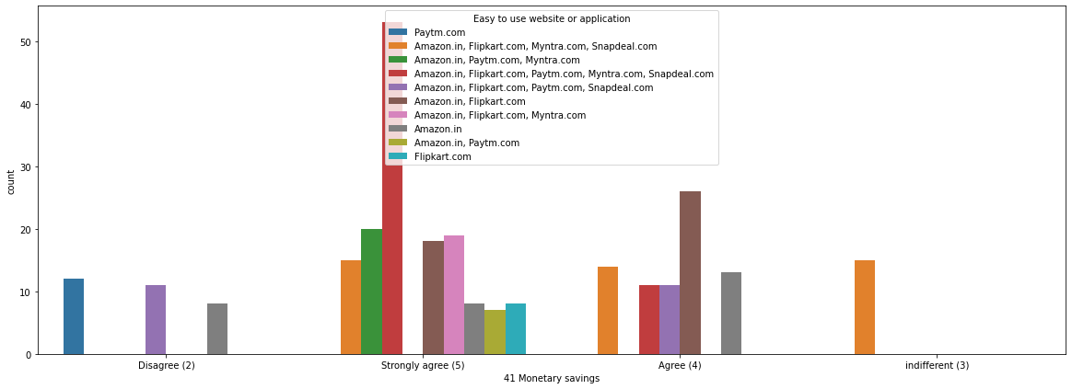

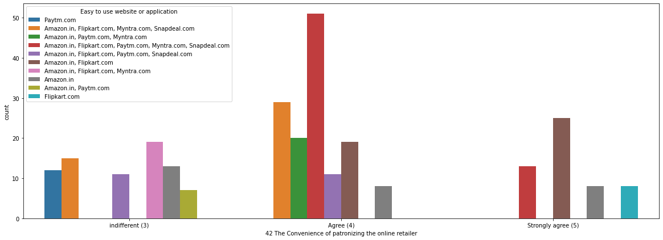

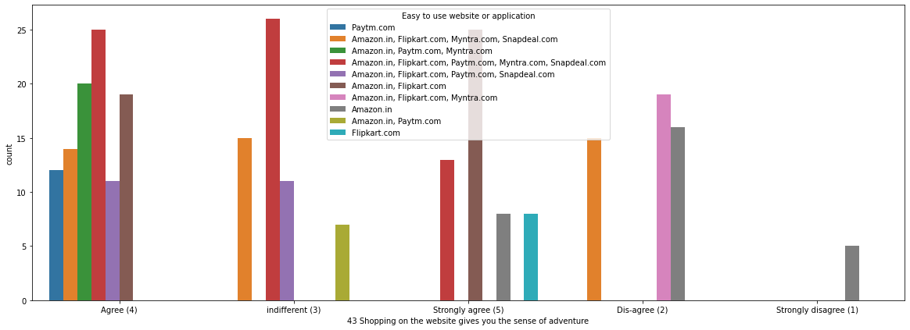

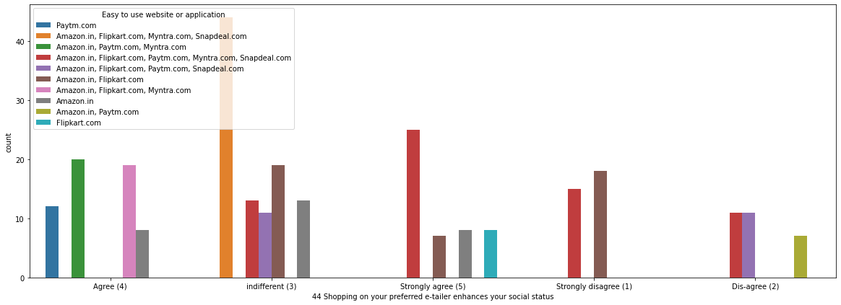

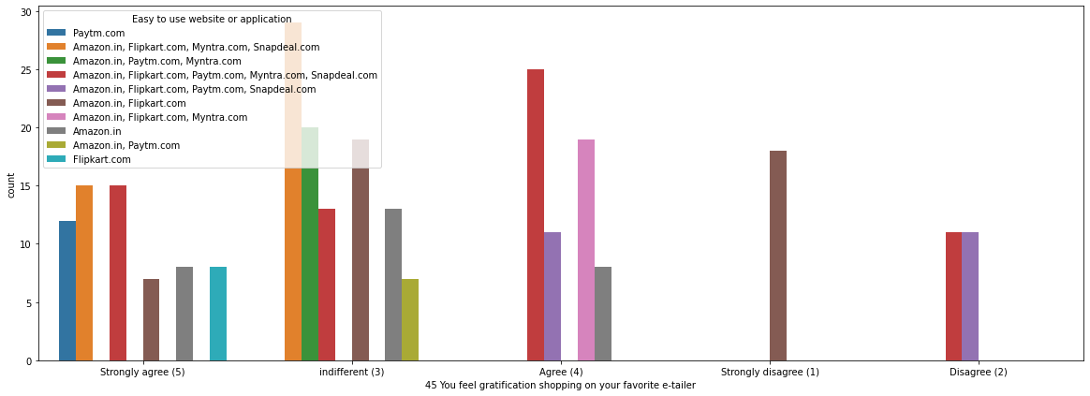

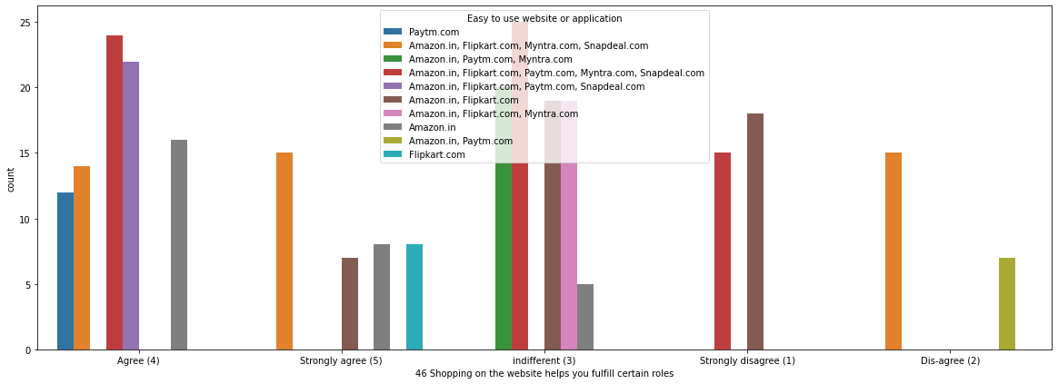

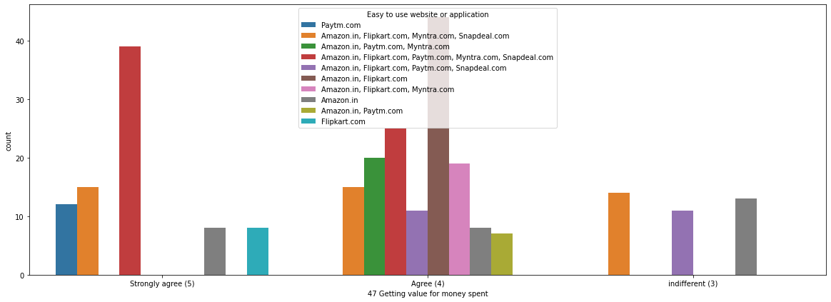

Basic Observations:

Most of the Females finds amazon/flipkart/paytm/myntra easier to use

31-40 age groups people find it more easire to use website

Users who find Amazon/Flipart/Myntra easier to use are doing shopping online for past 2-3 years

Smartphone user find it easire to use amazon/flipkart/paytm/myntra

User who found Amazon/Flipkart easier to use suggests friends to use the same portals for e-shopping

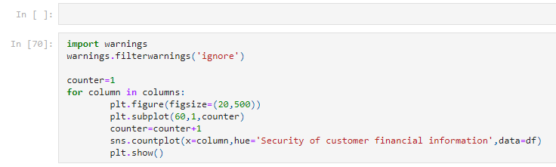

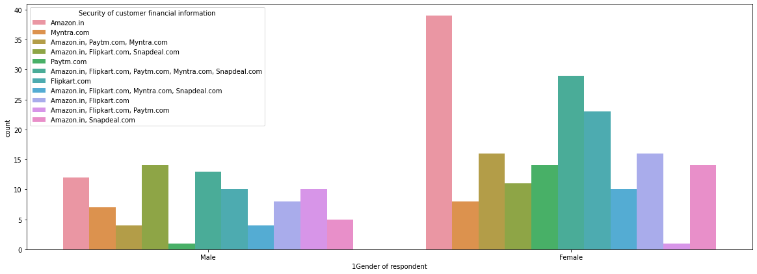

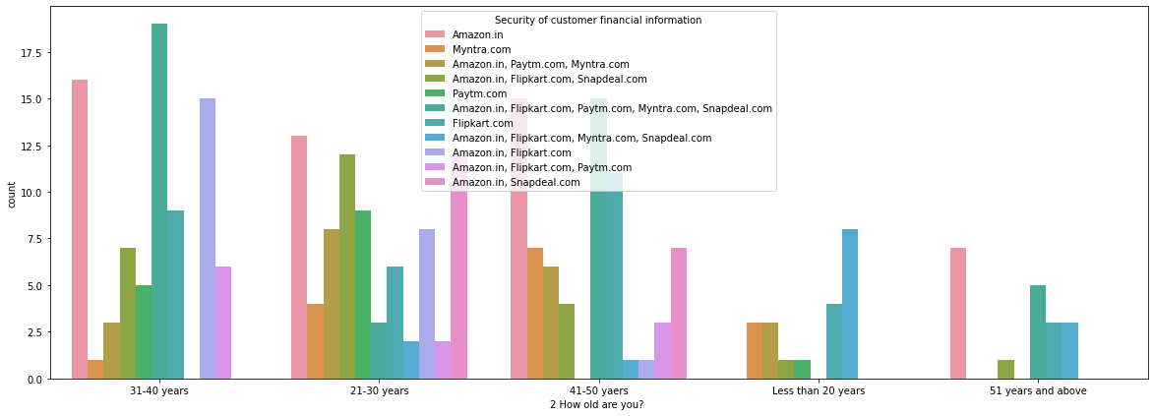

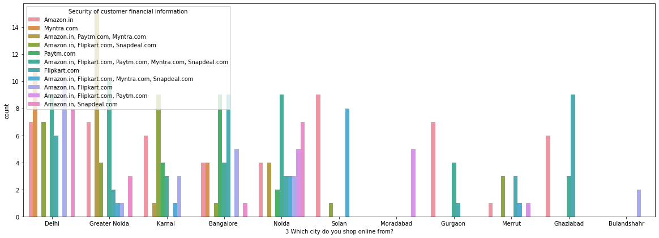

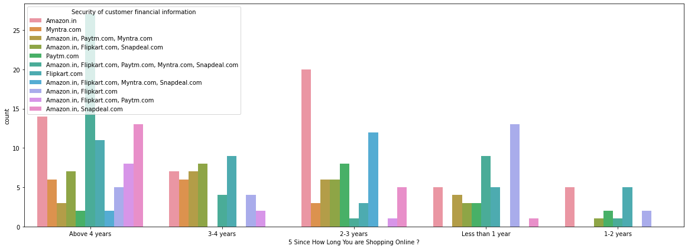

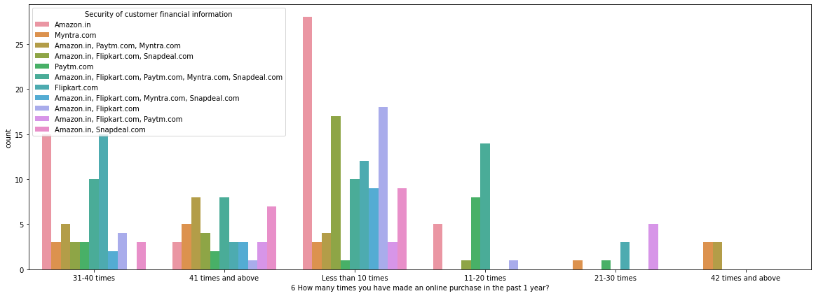

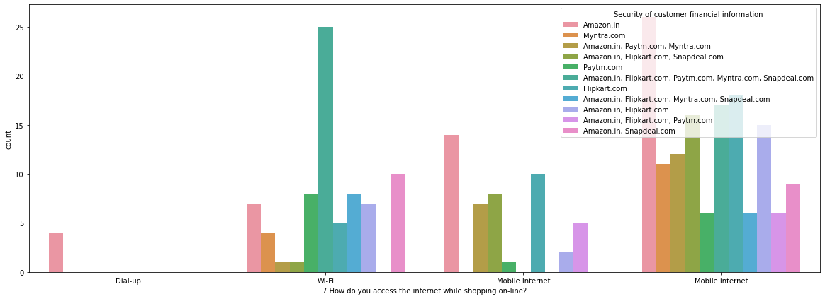

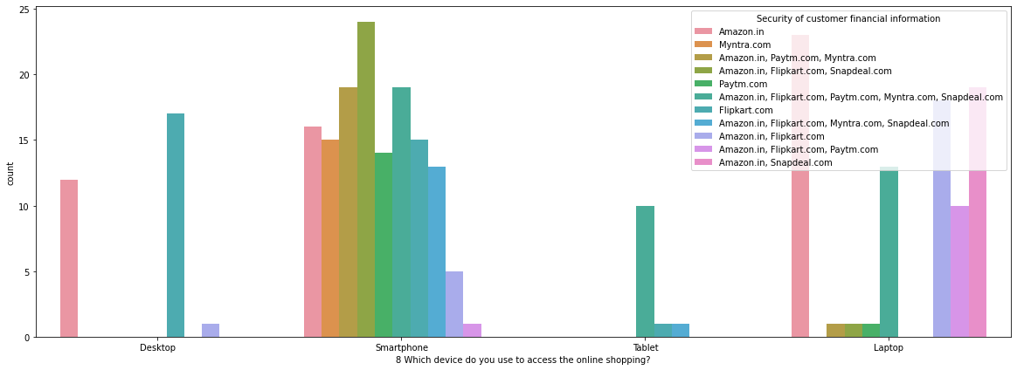

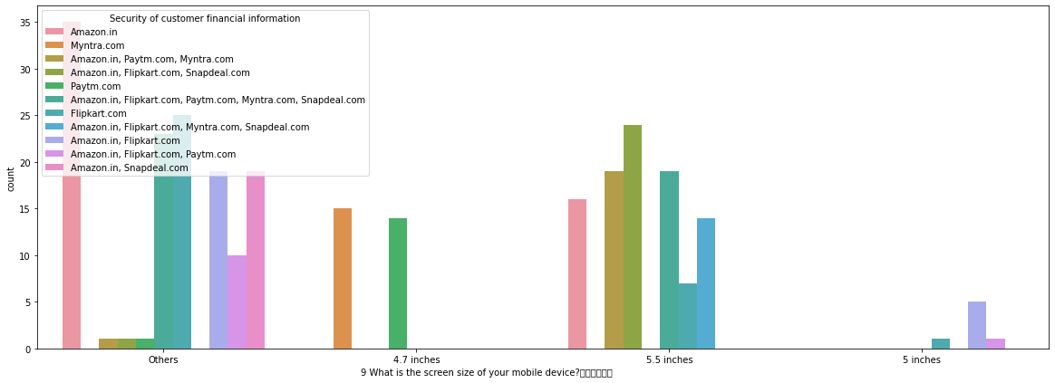

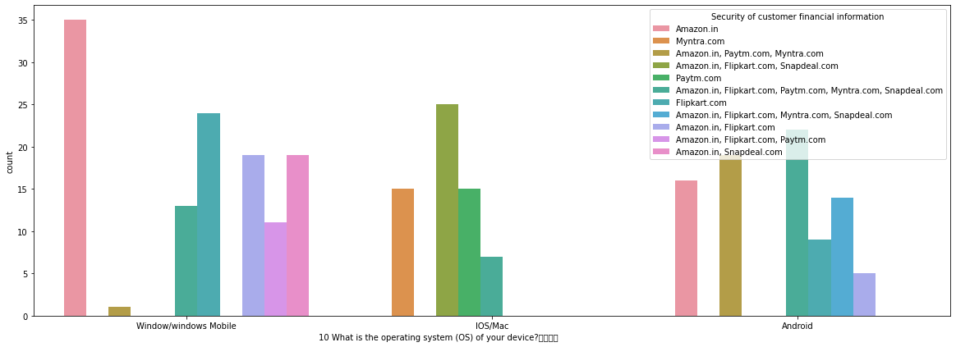

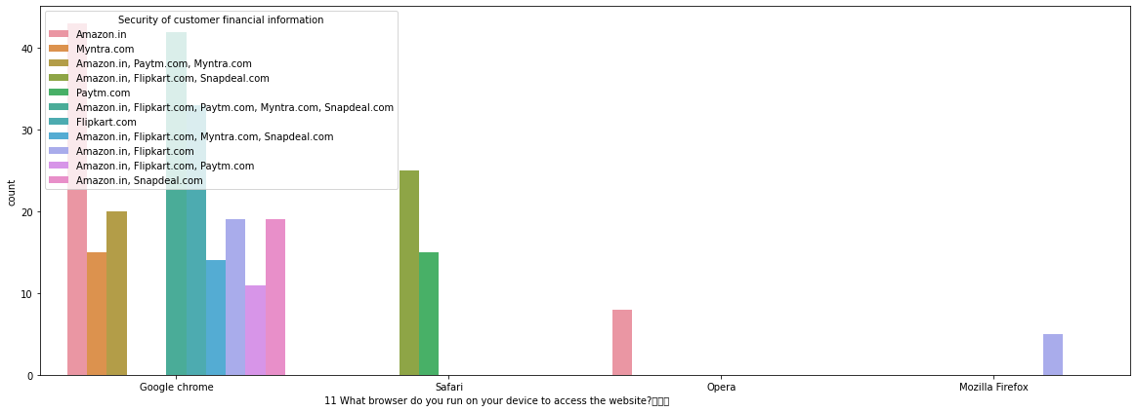

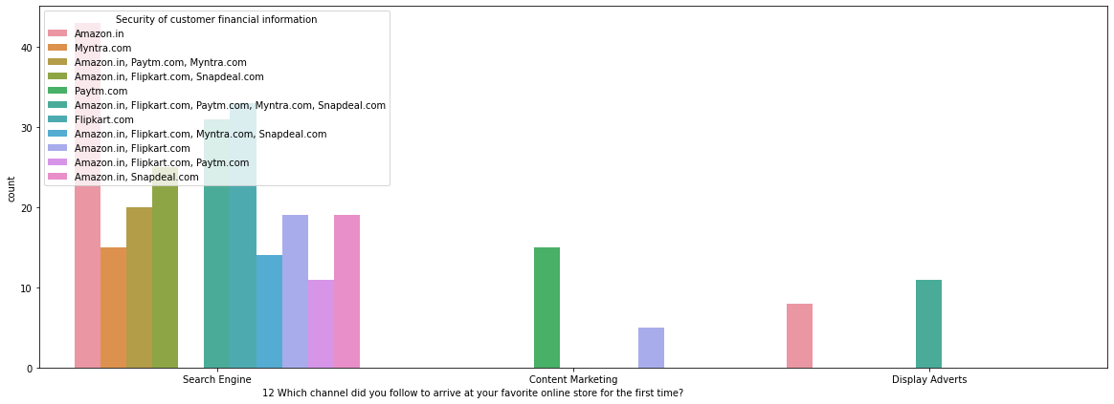

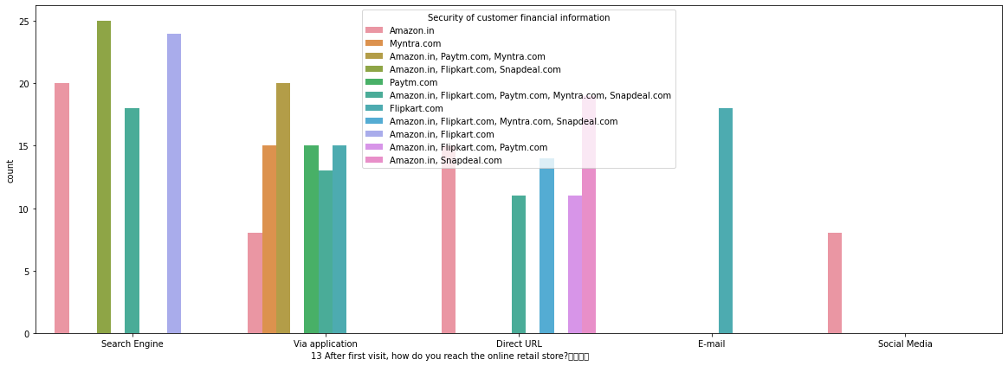

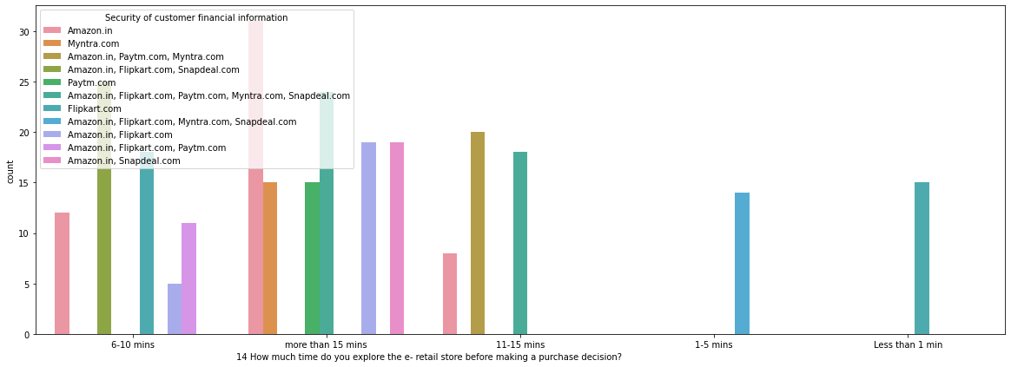

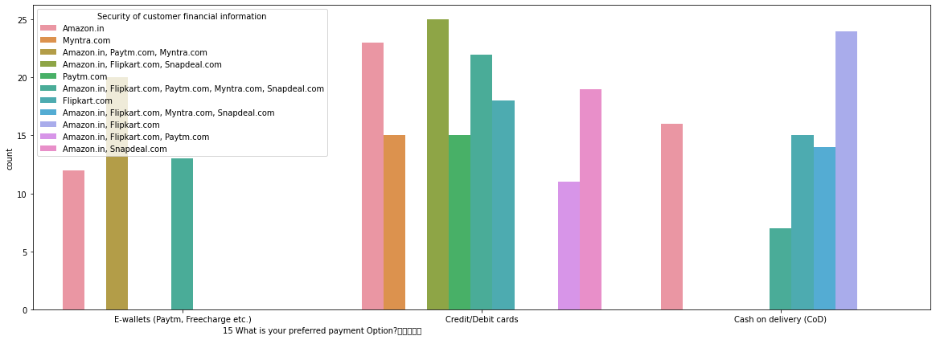

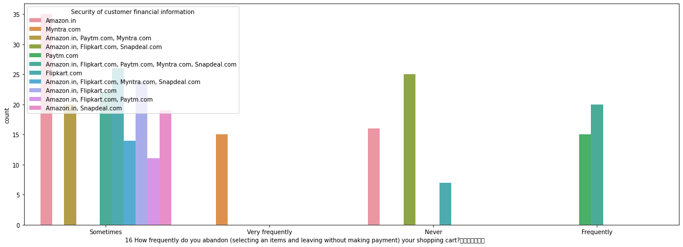

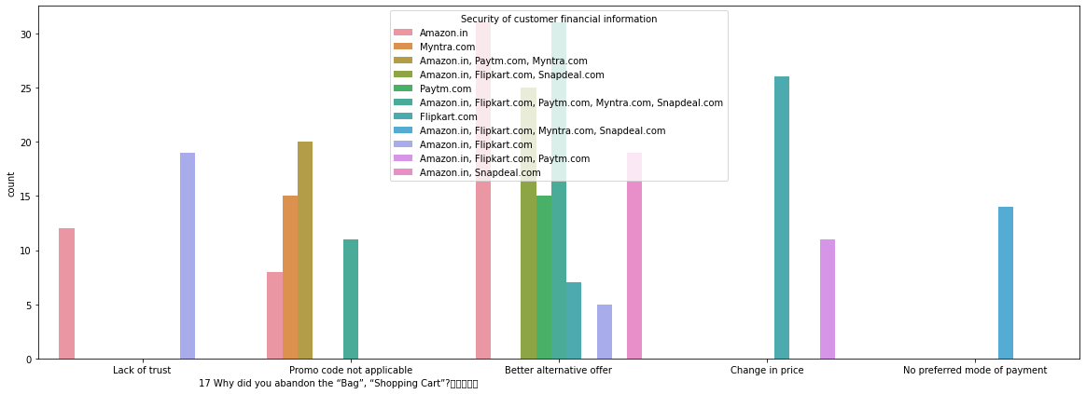

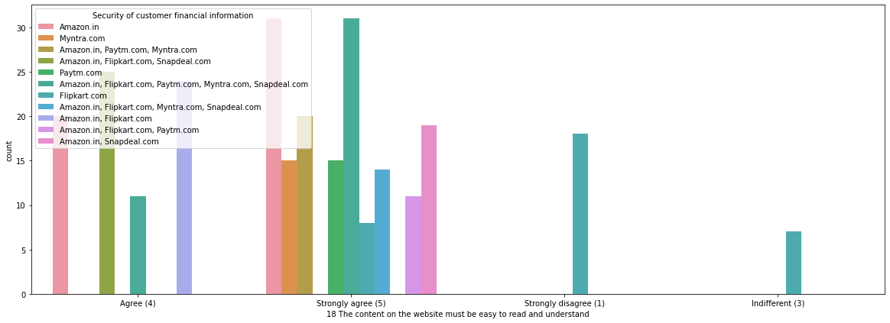

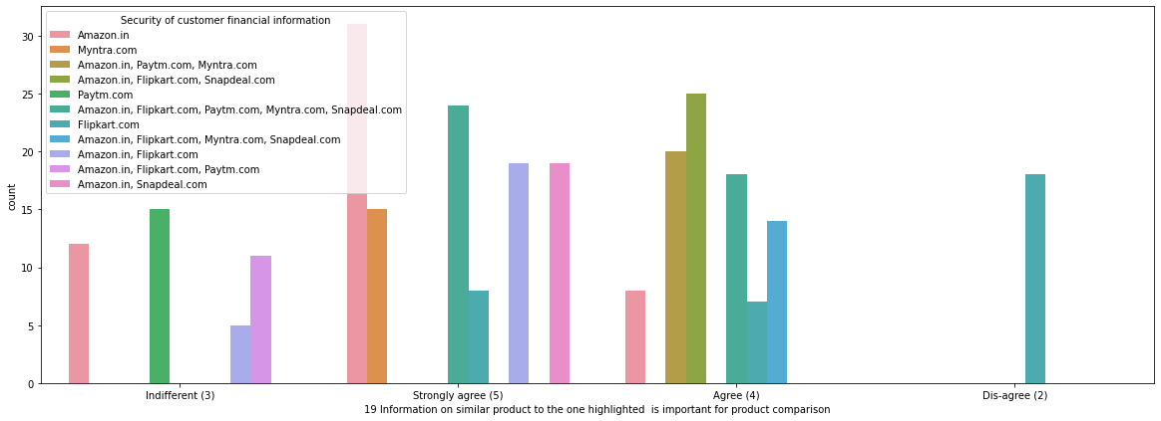

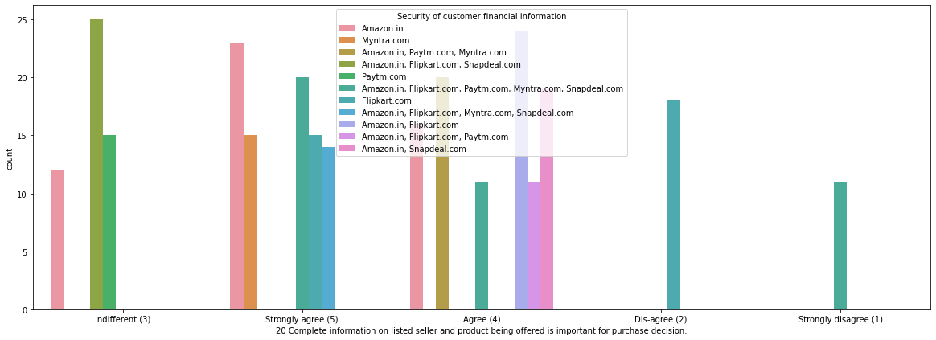

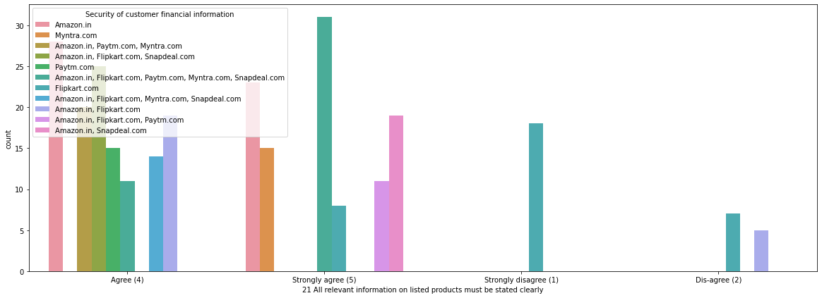

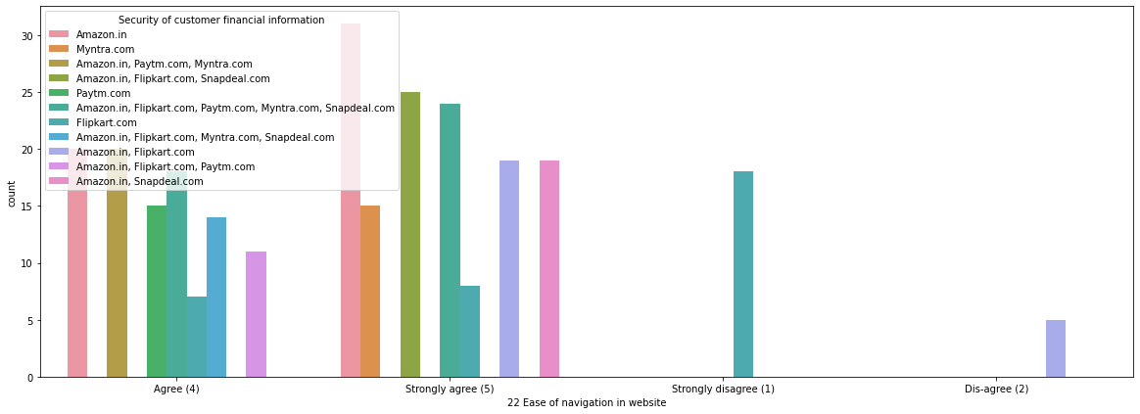

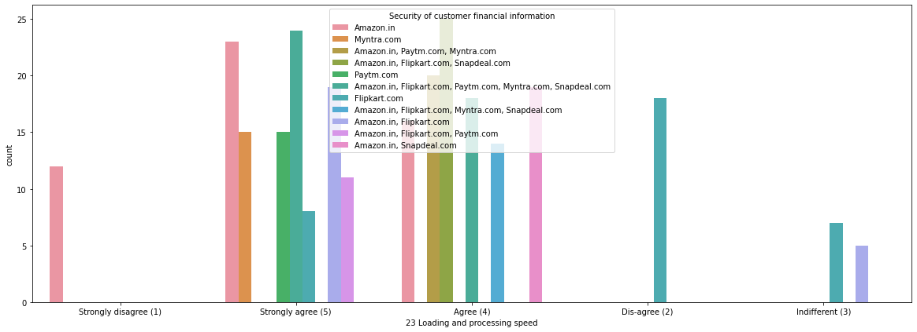

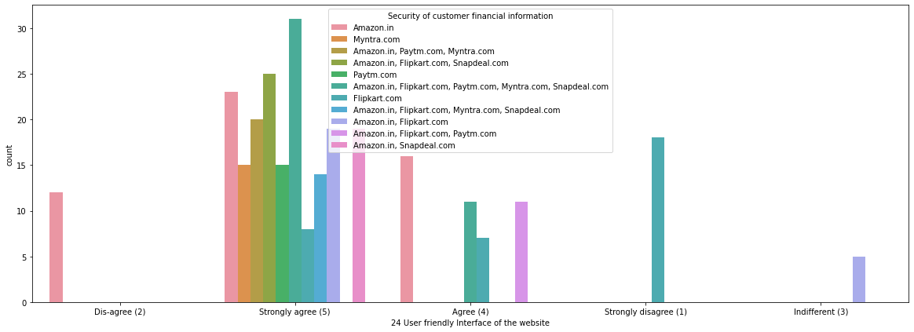

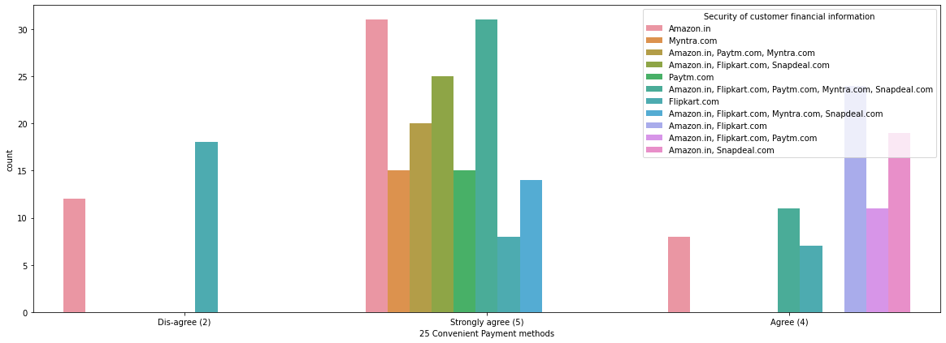

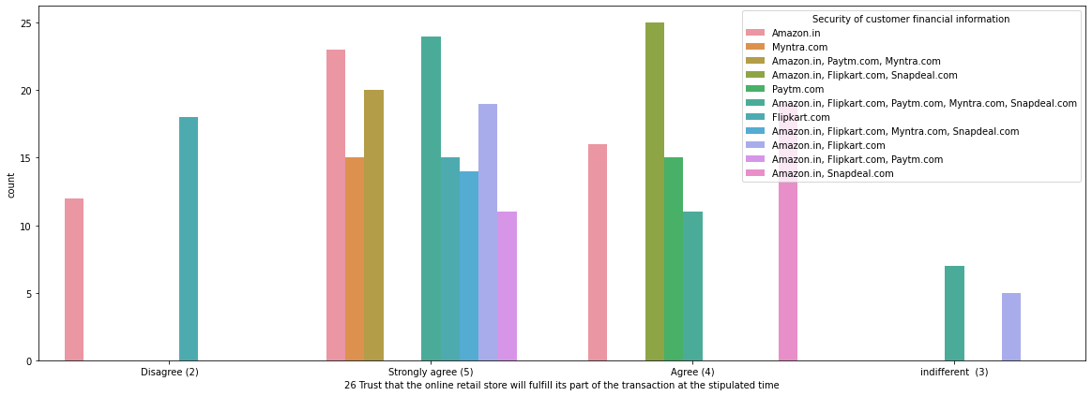

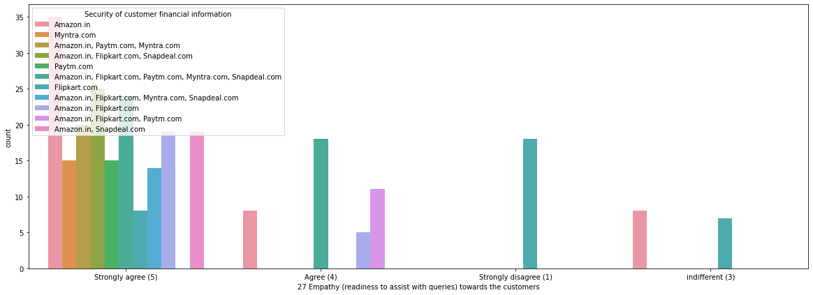

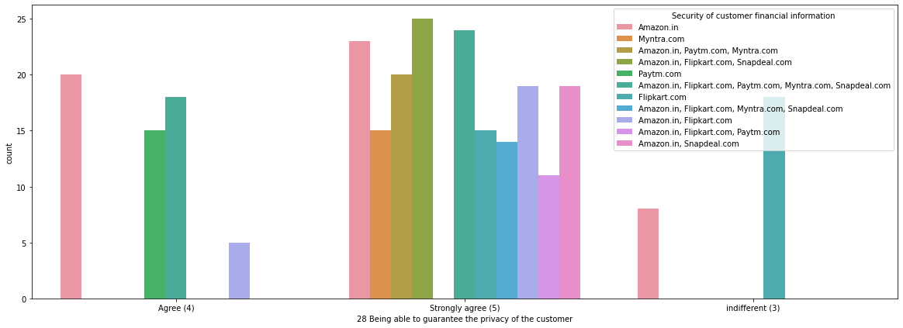

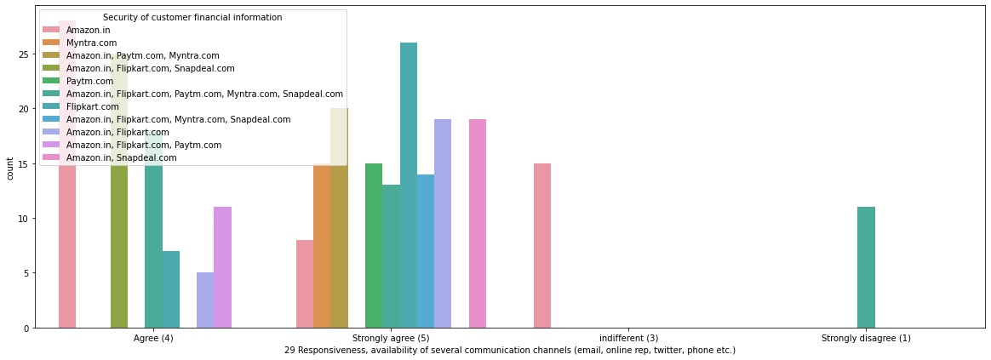

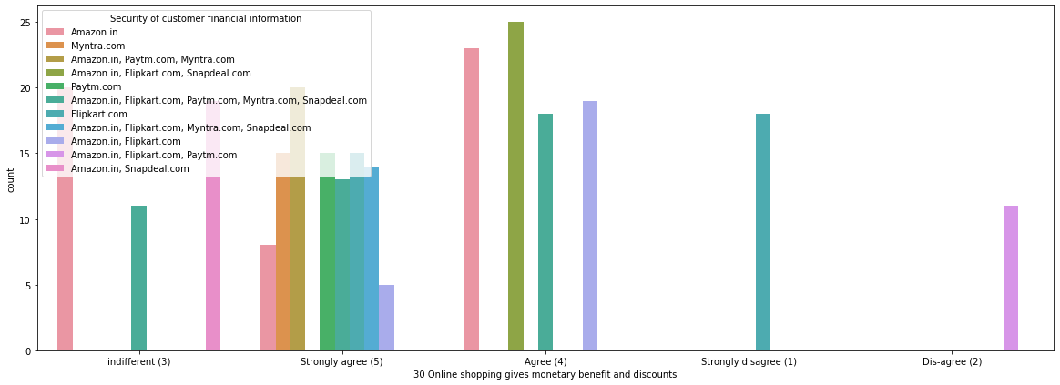

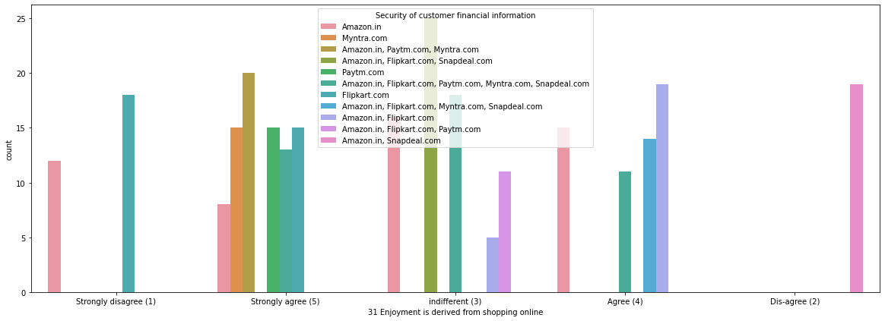

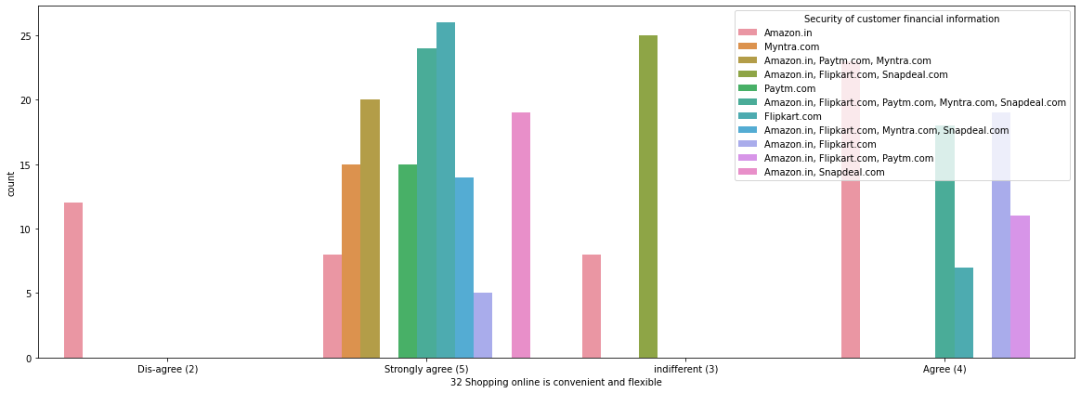

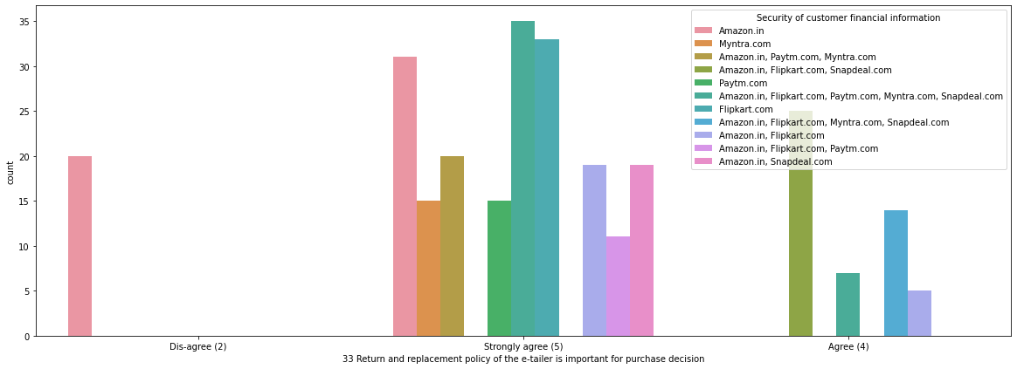

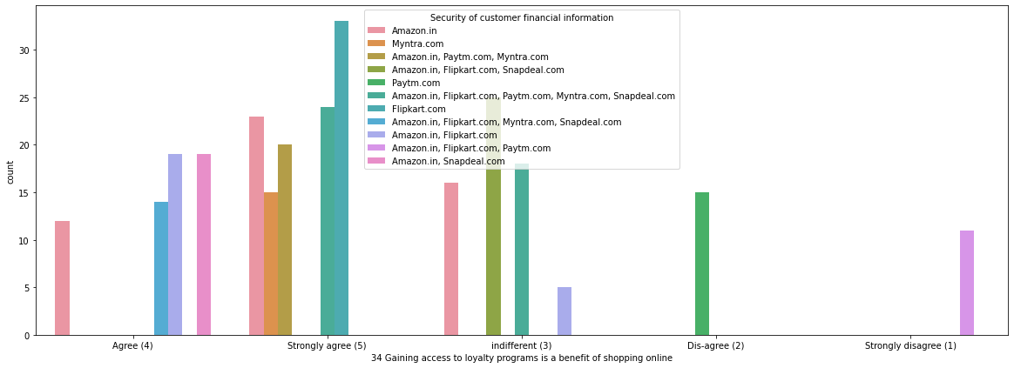

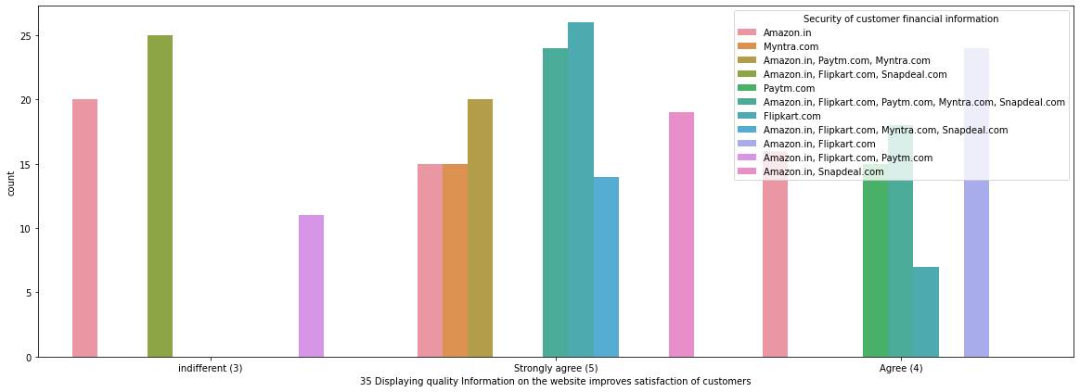

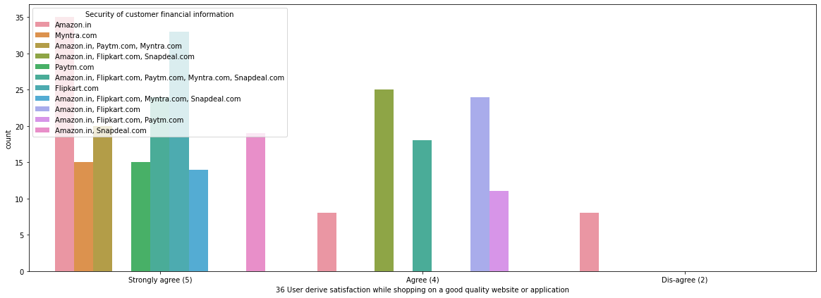

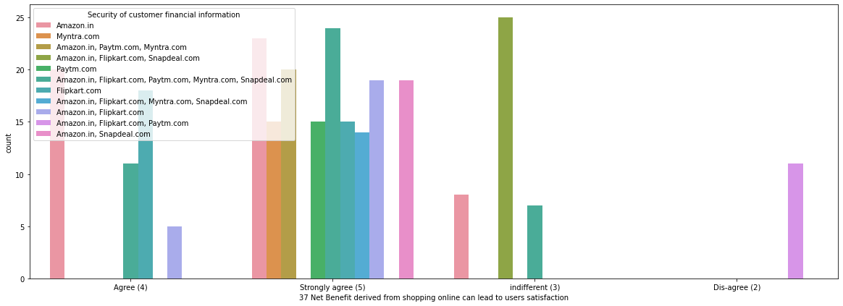

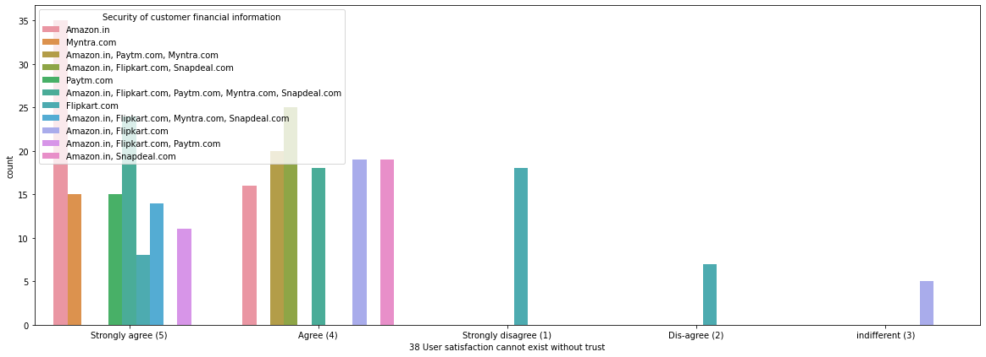

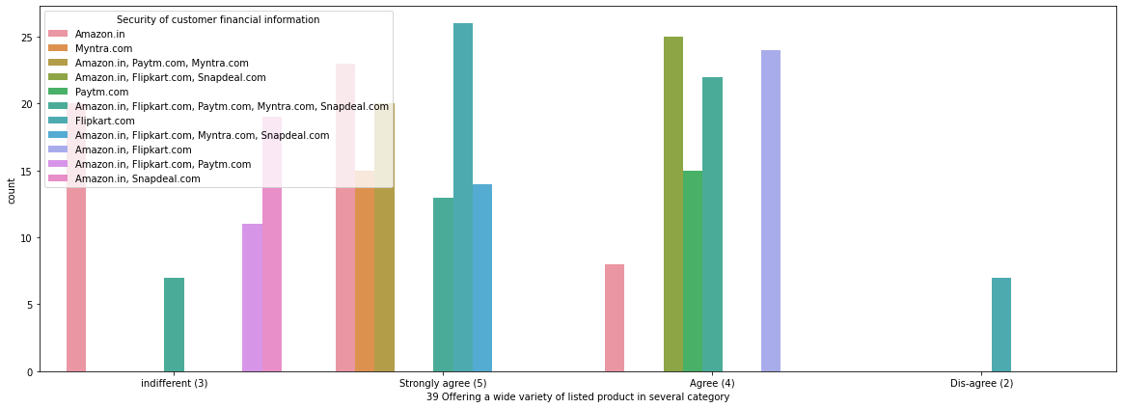

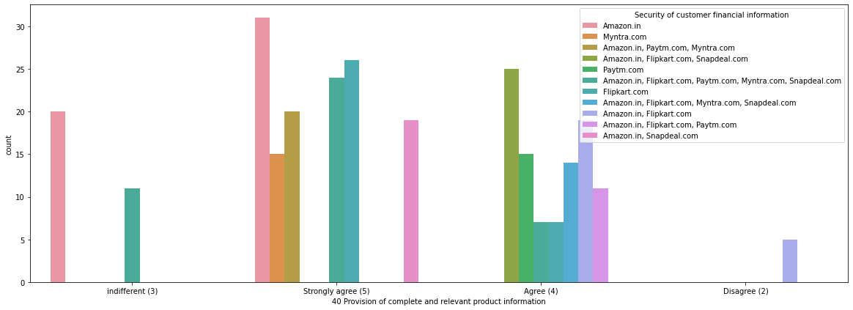

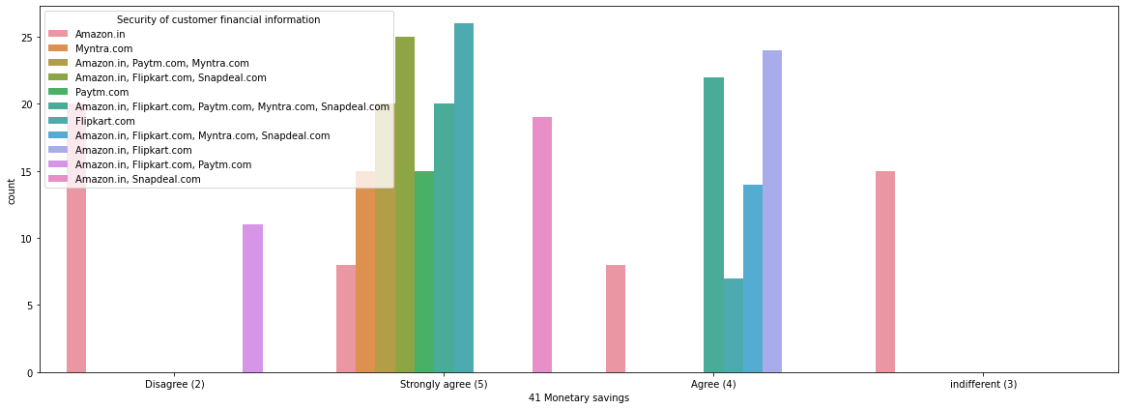

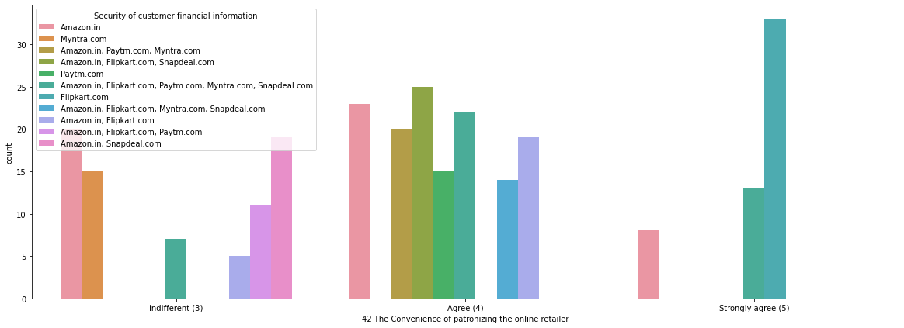

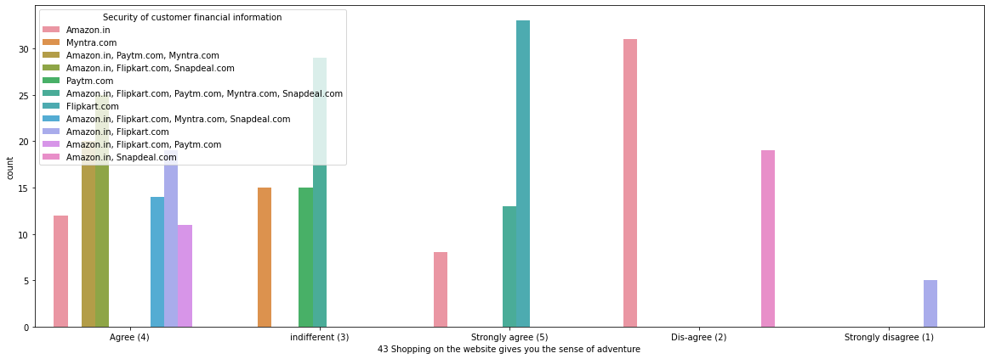

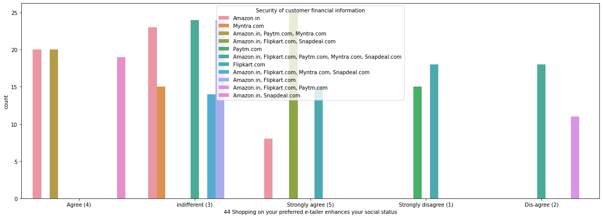

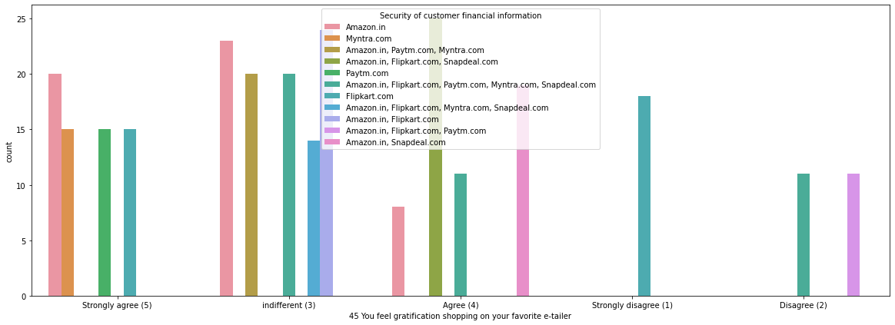

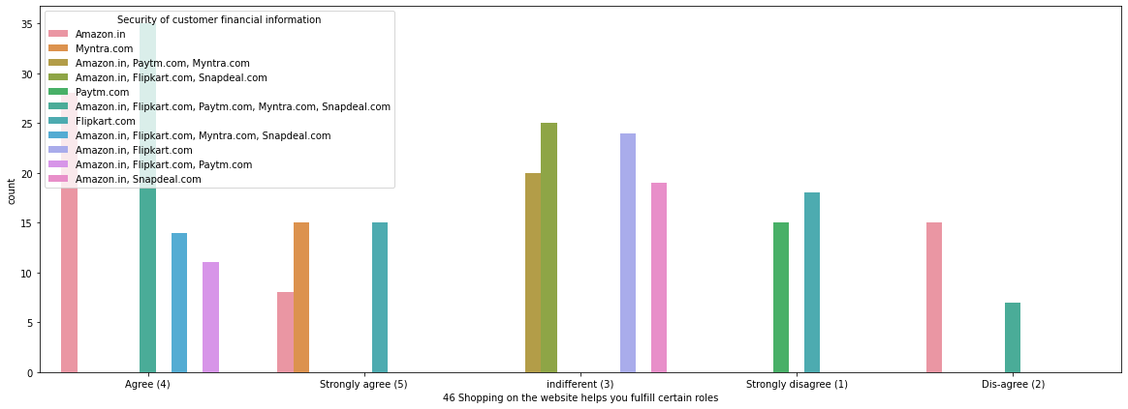

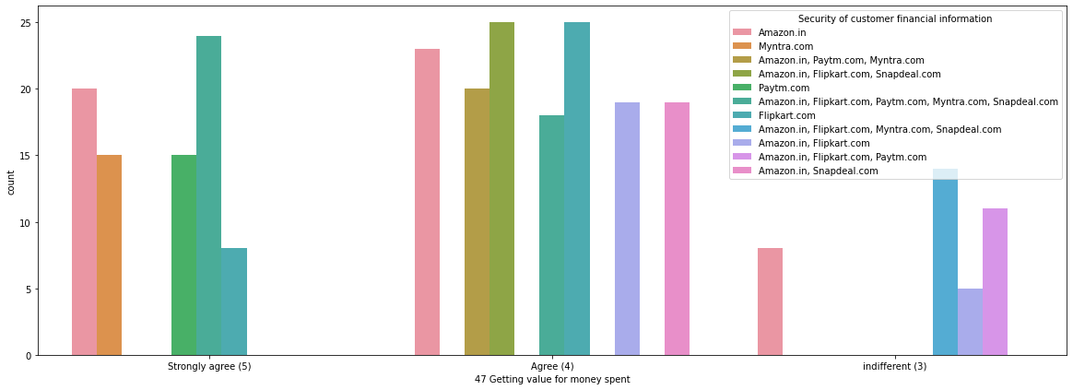

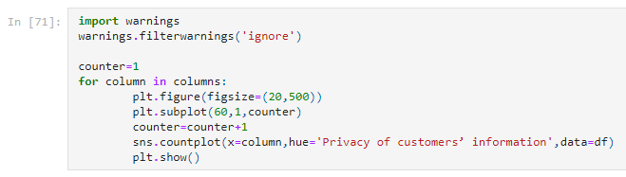

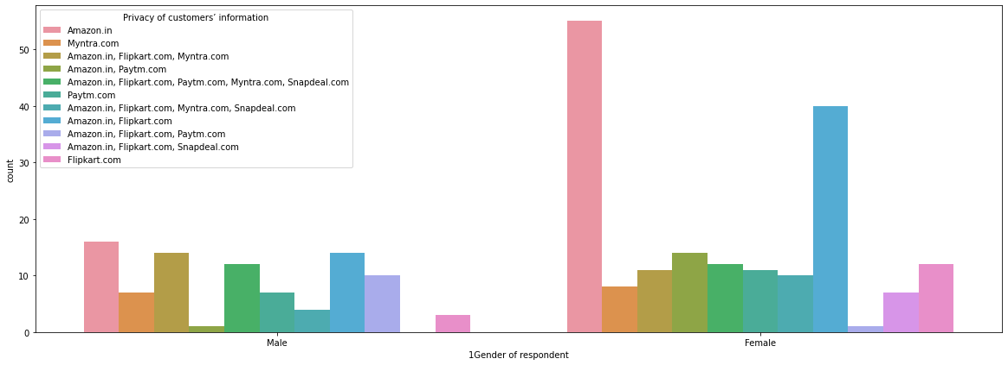

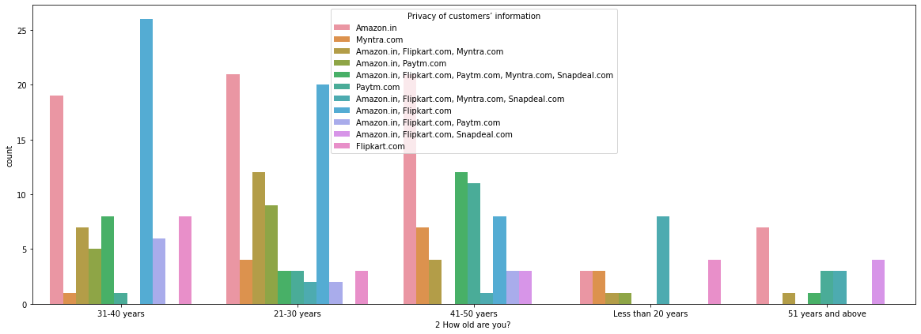

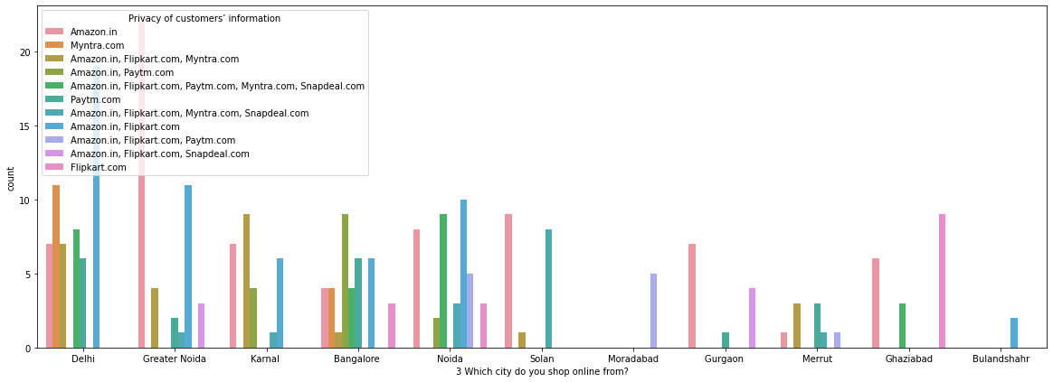

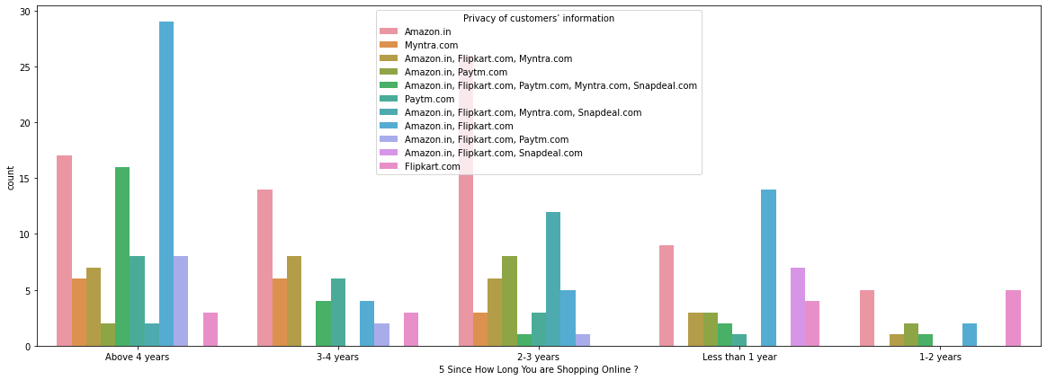

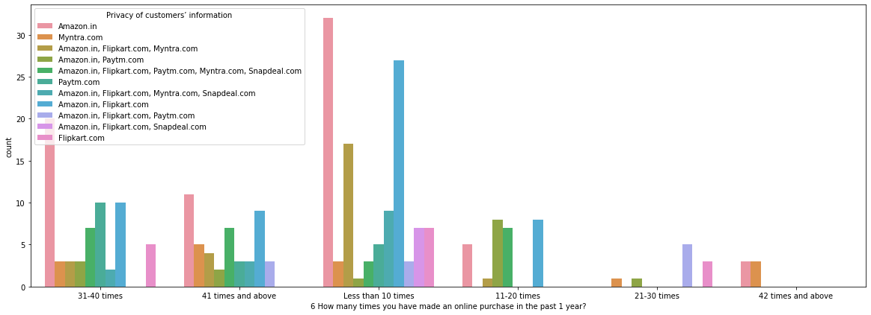

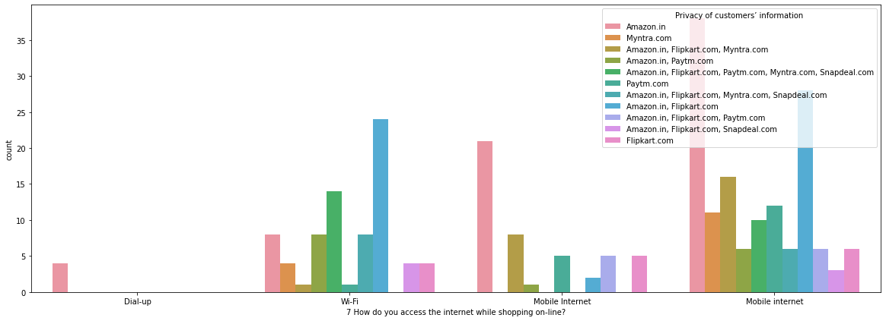

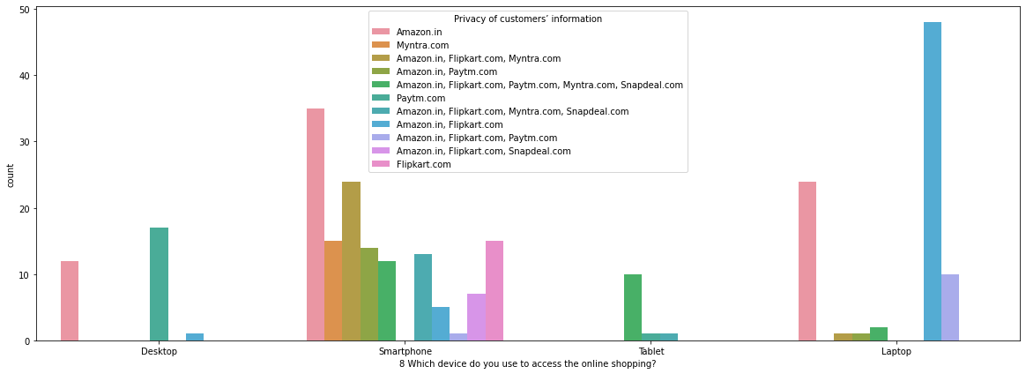

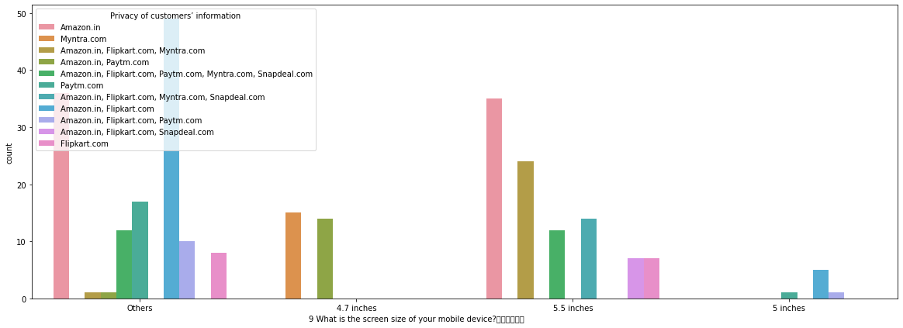

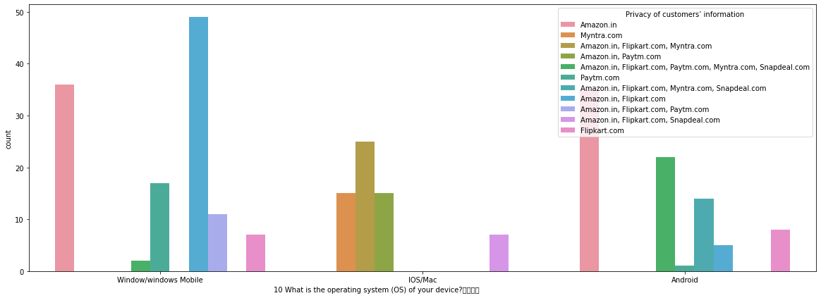

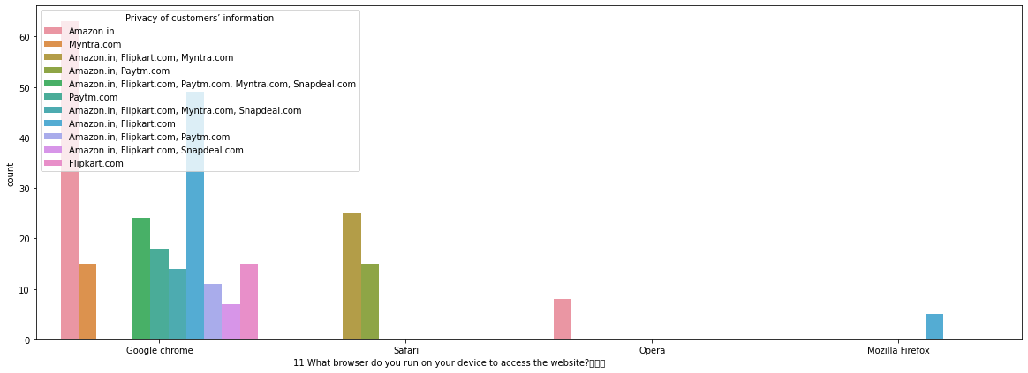

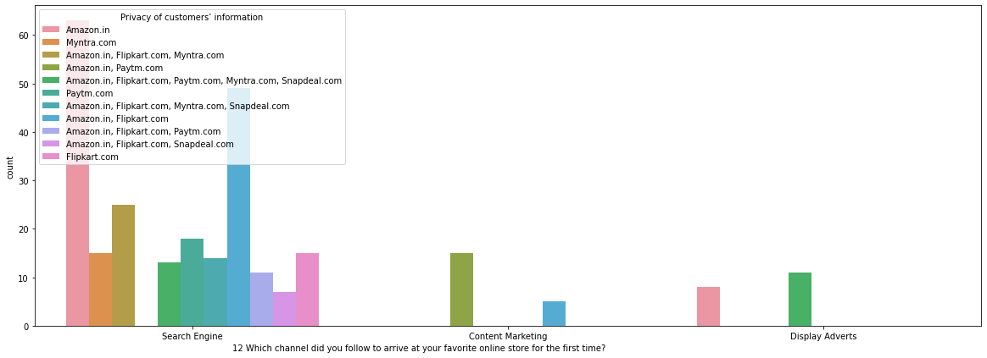

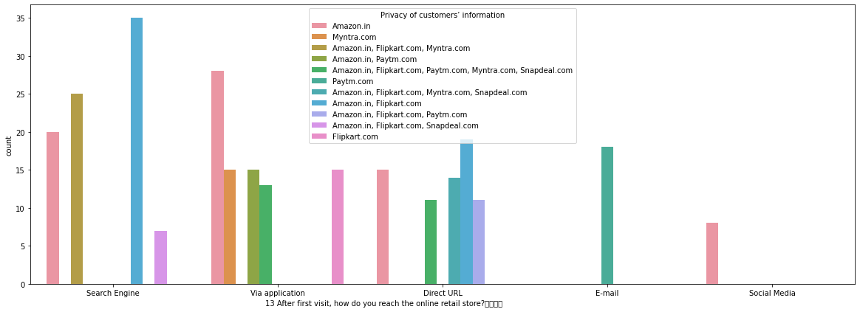

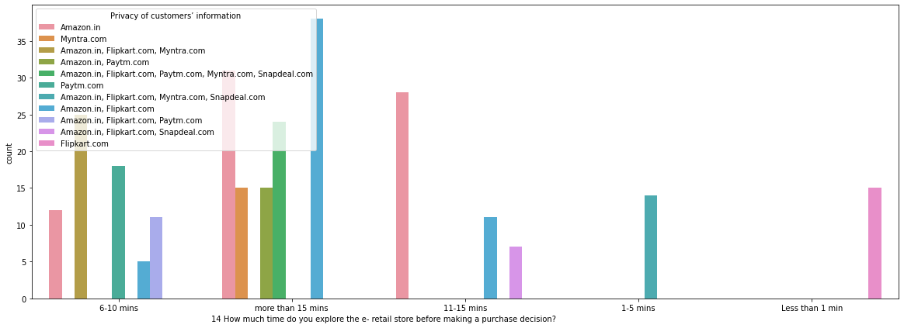

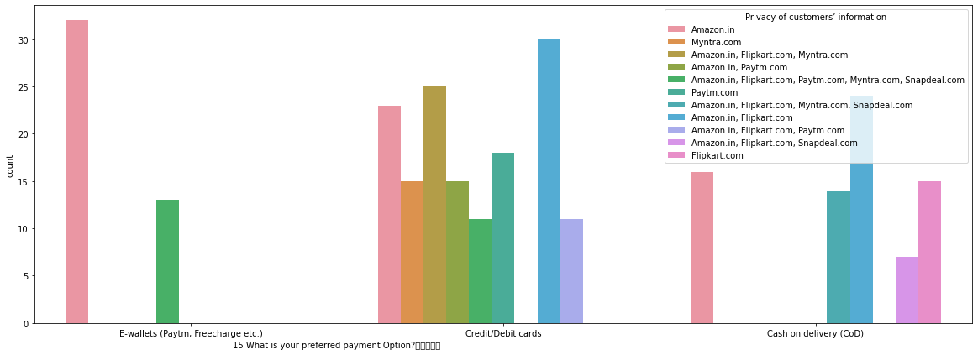

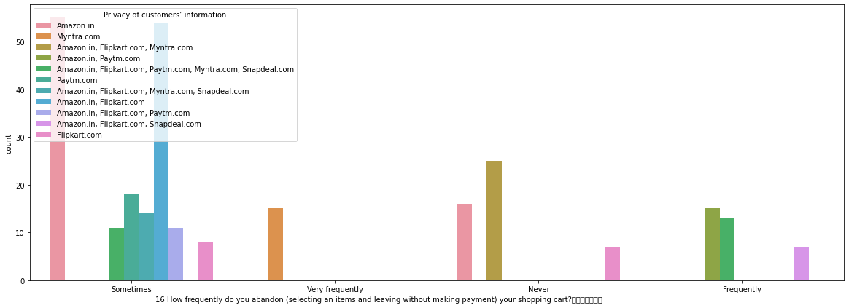

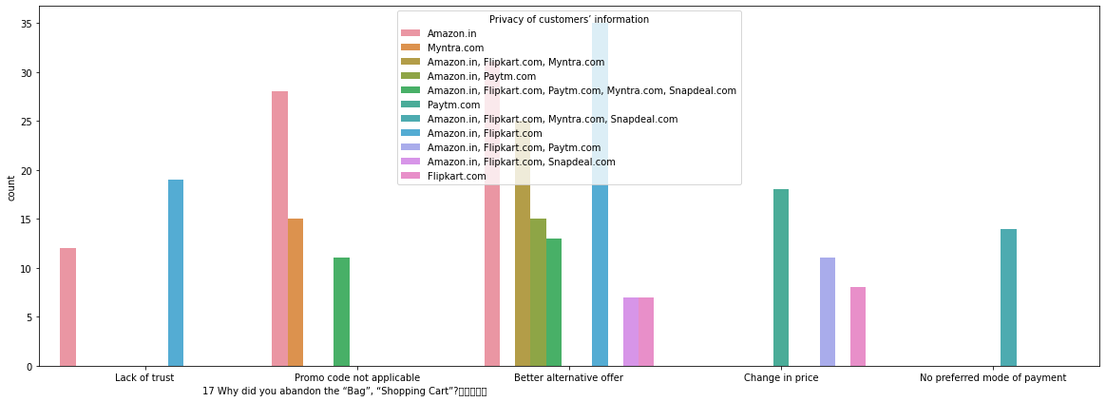

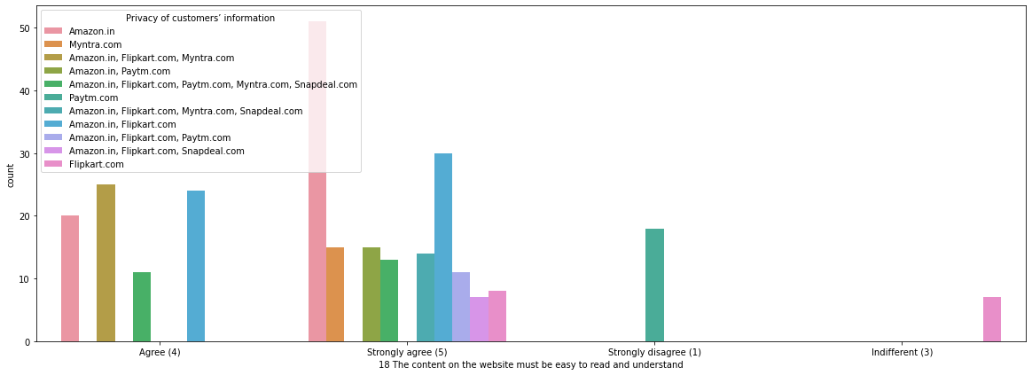

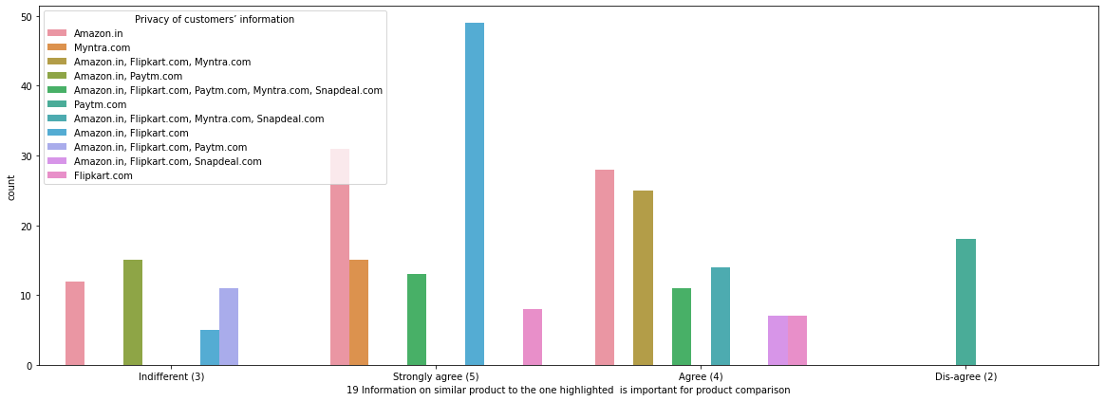

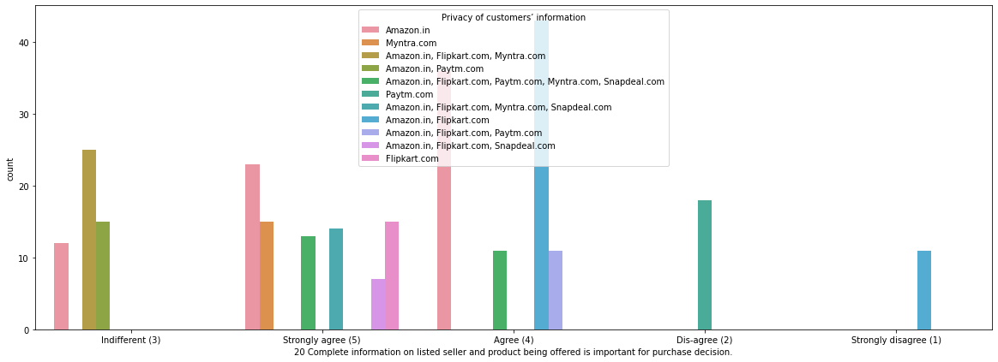

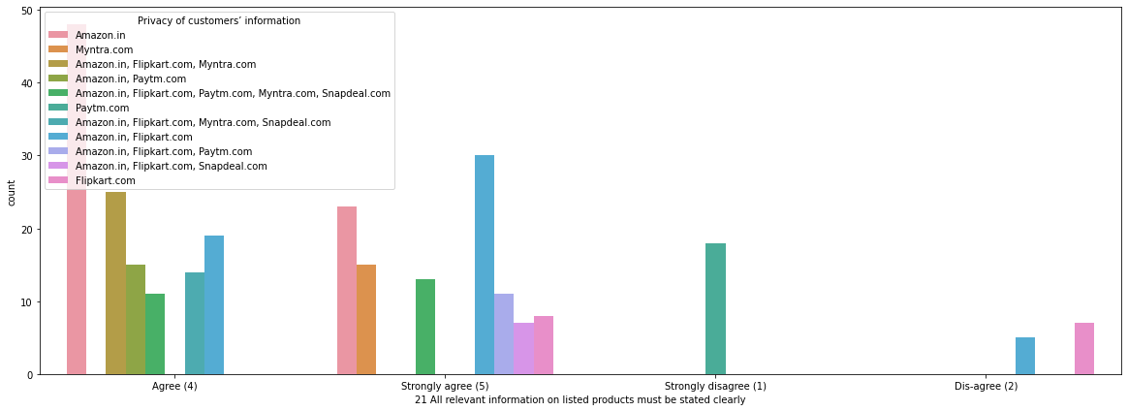

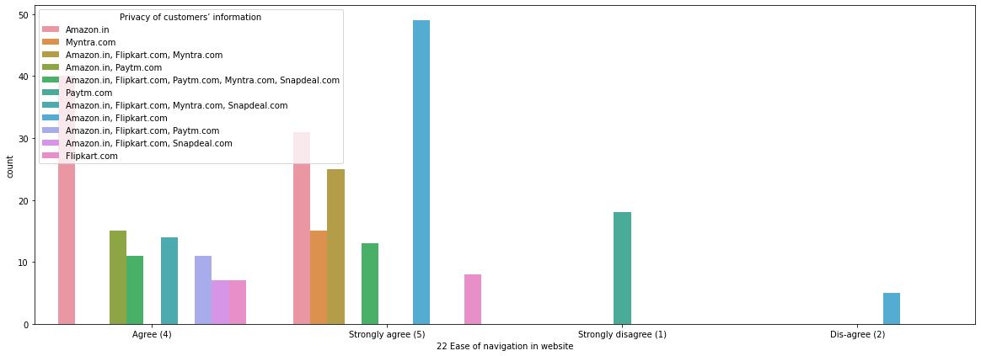

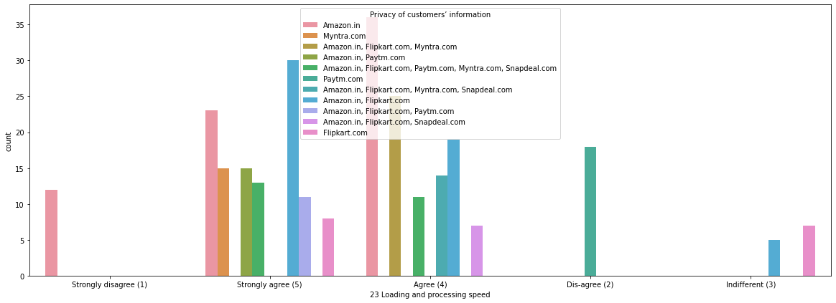

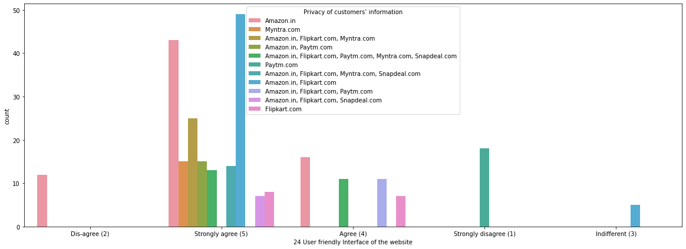

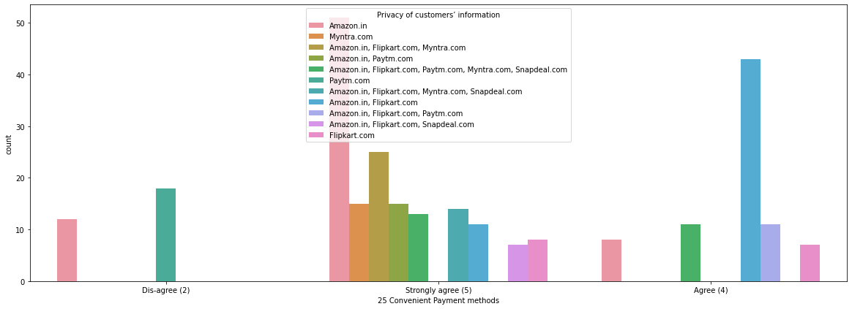

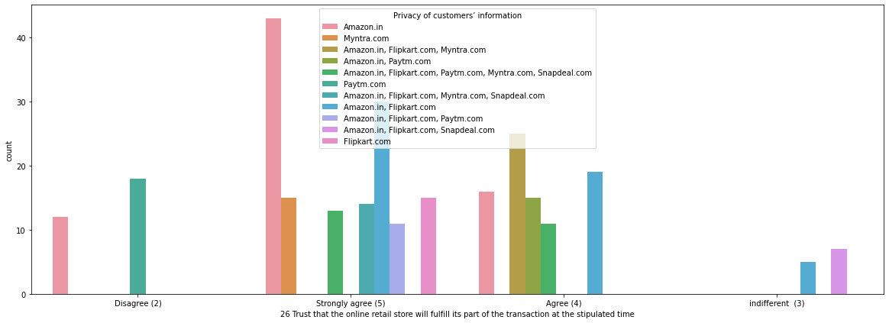

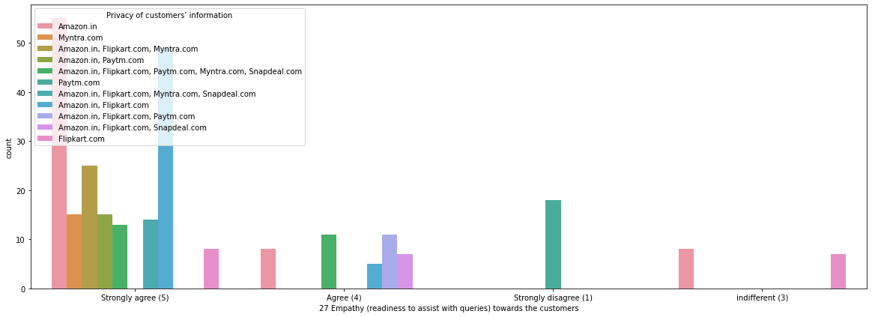

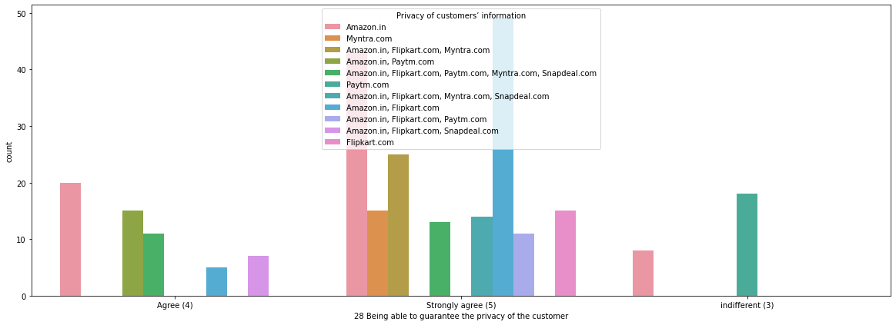

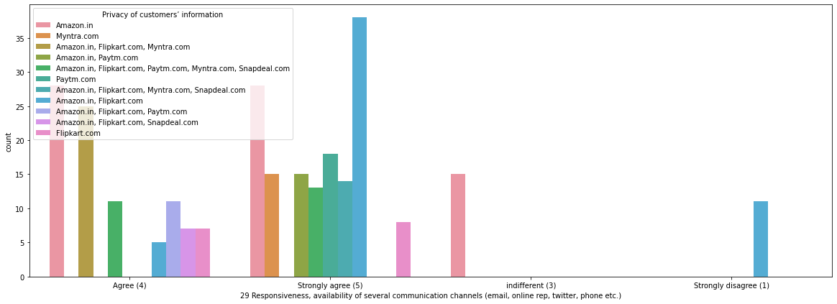

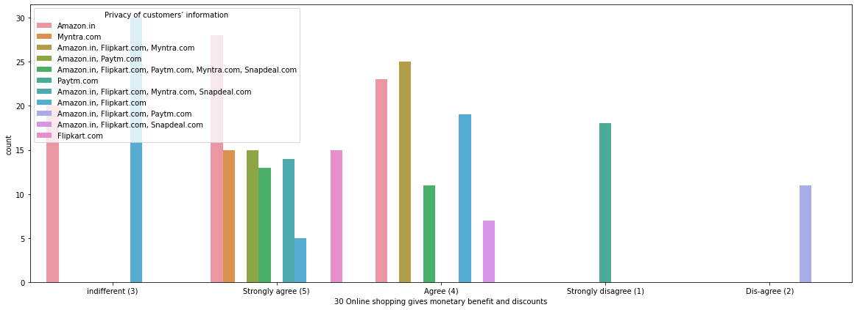

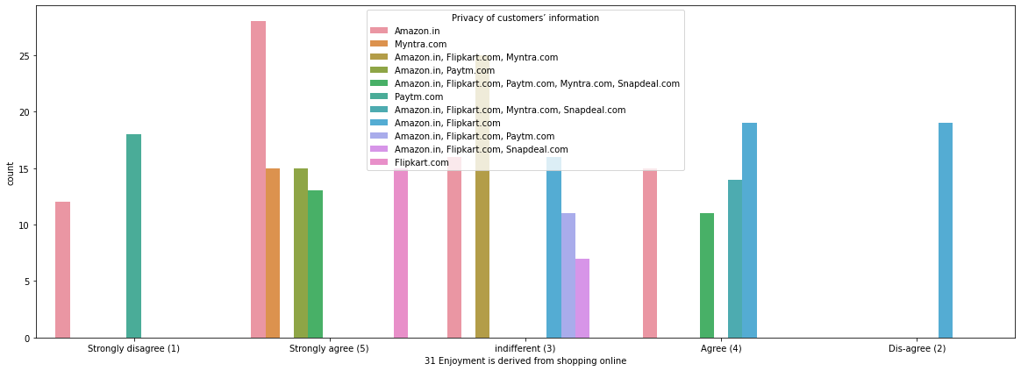

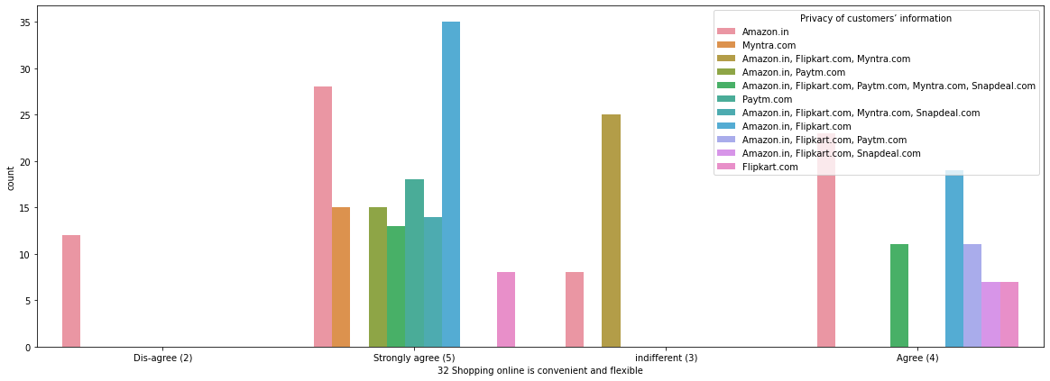

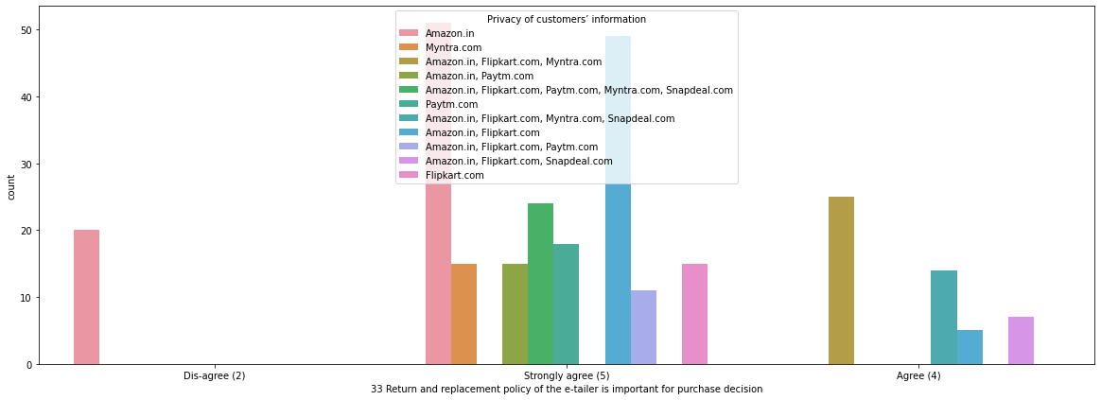

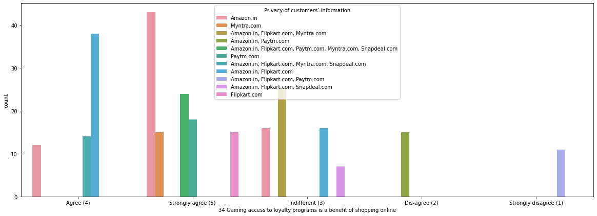

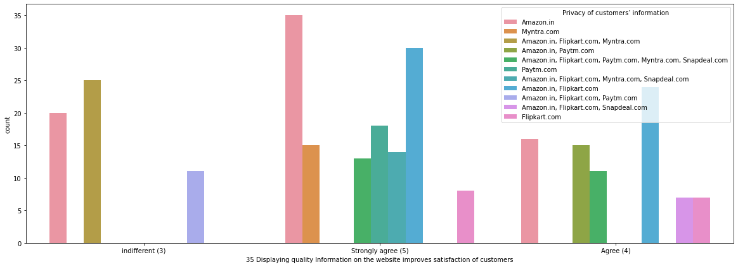

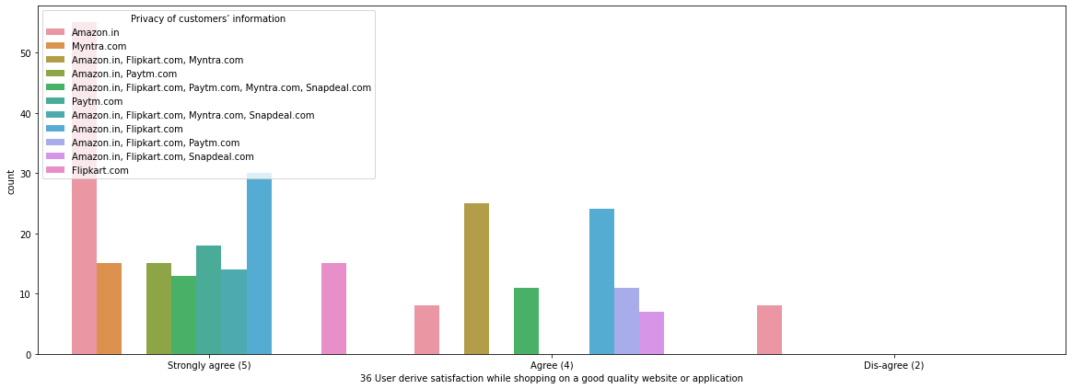

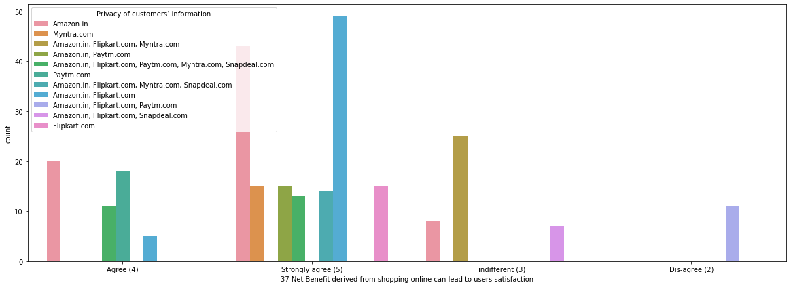

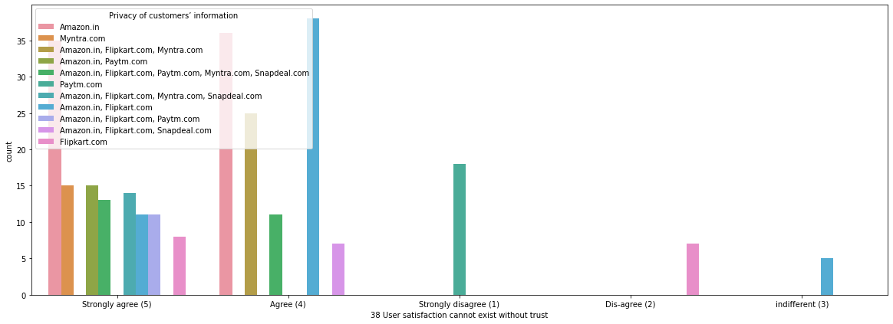

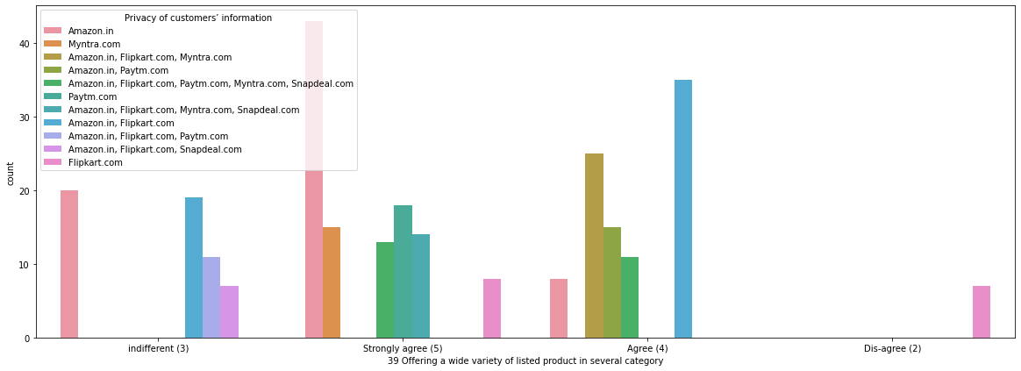

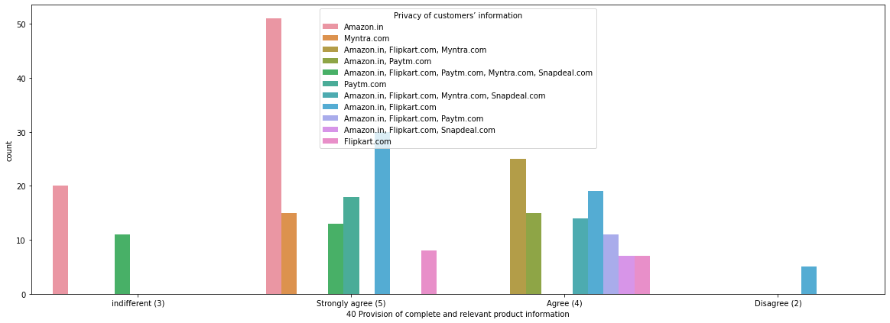

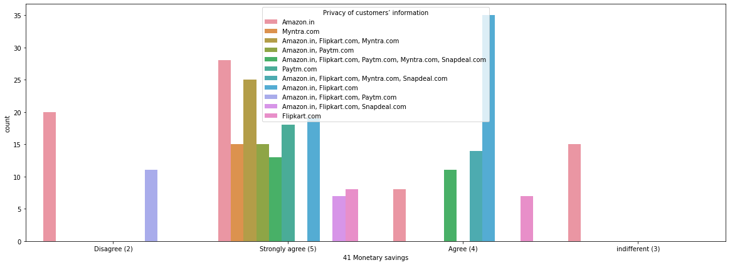

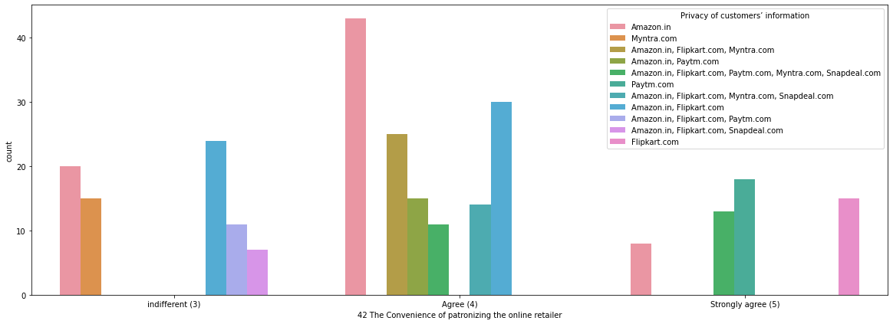

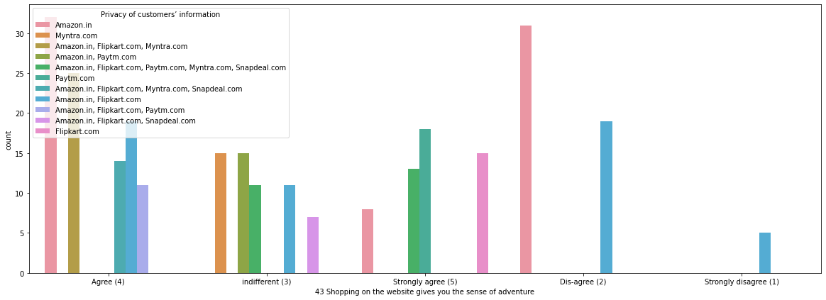

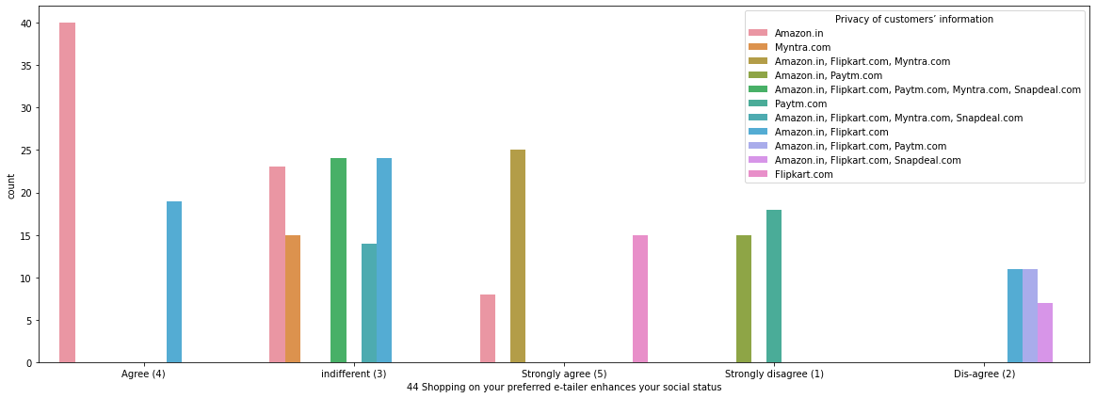

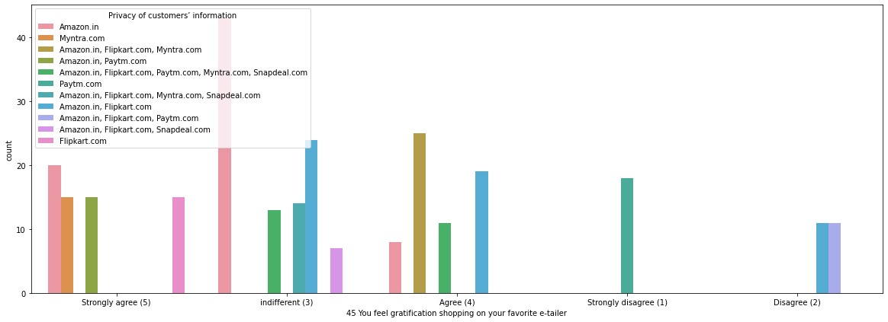

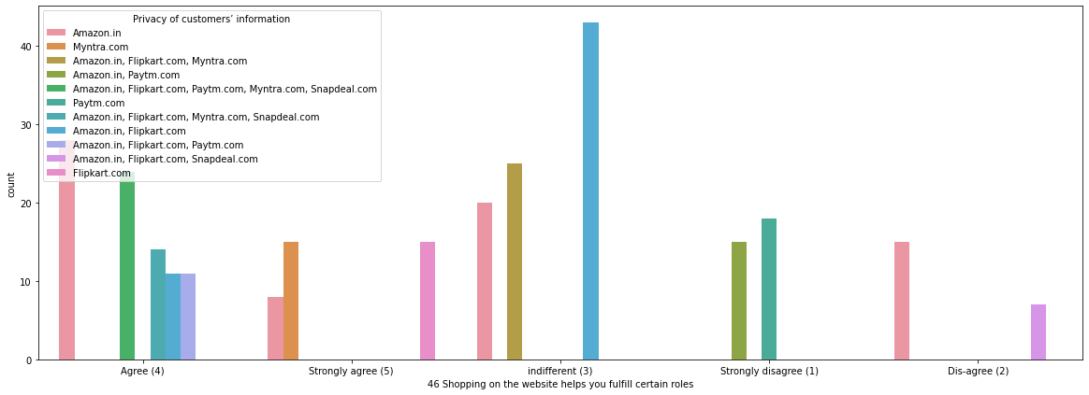

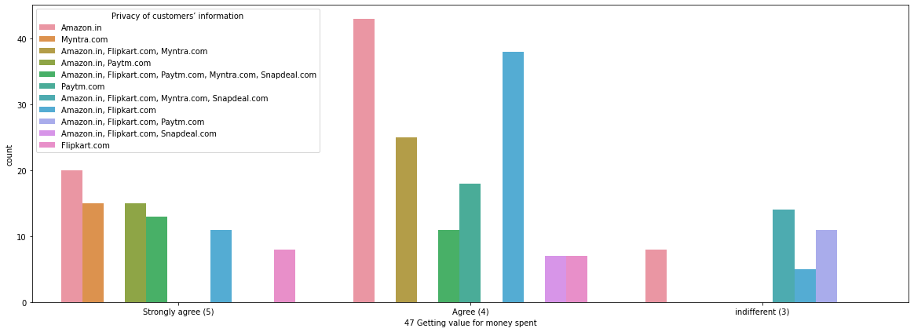

## 

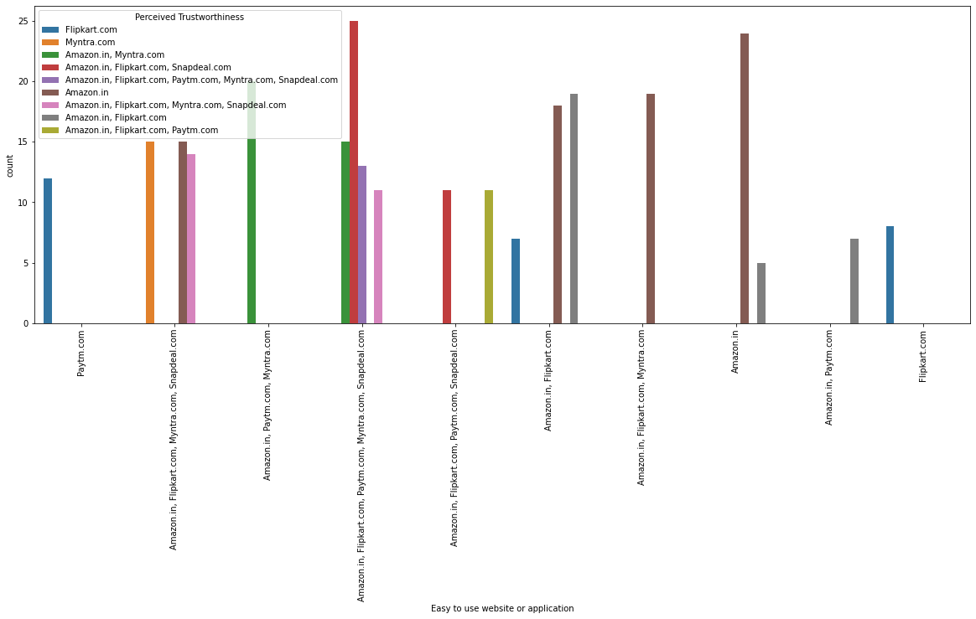

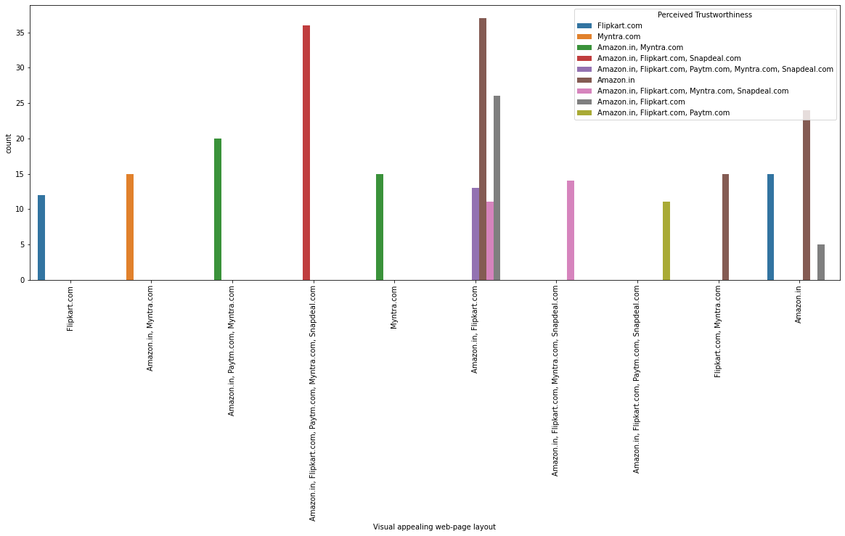

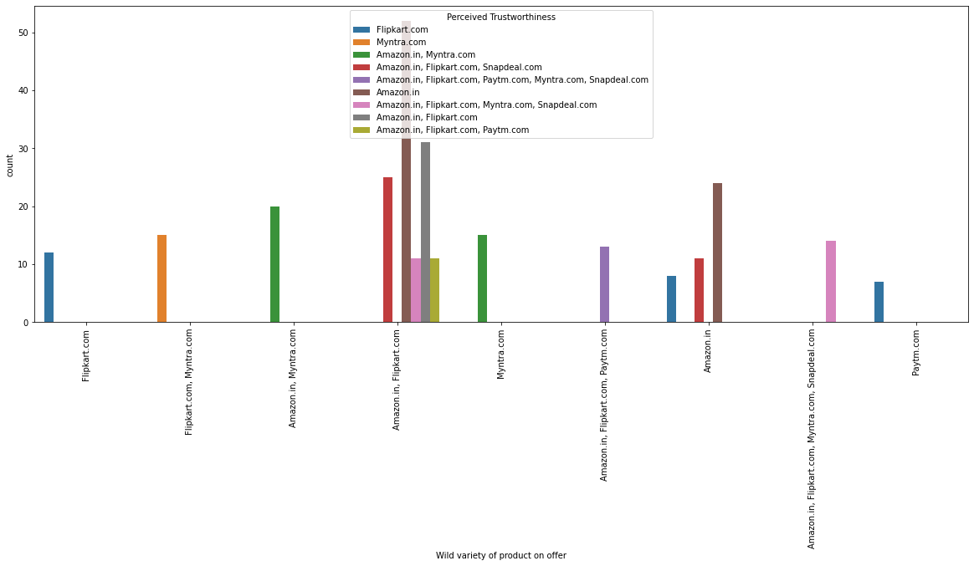

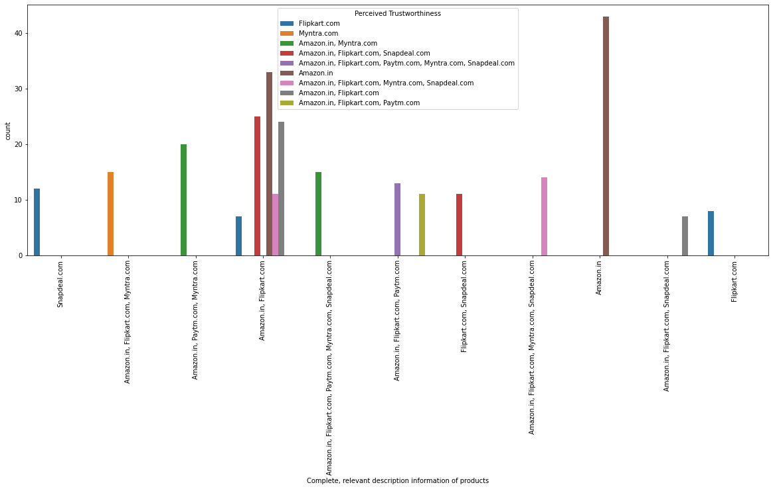

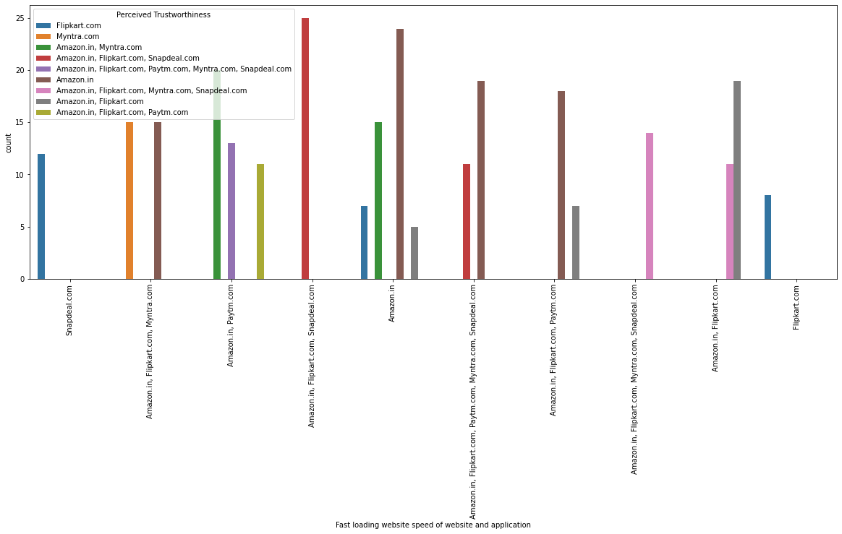

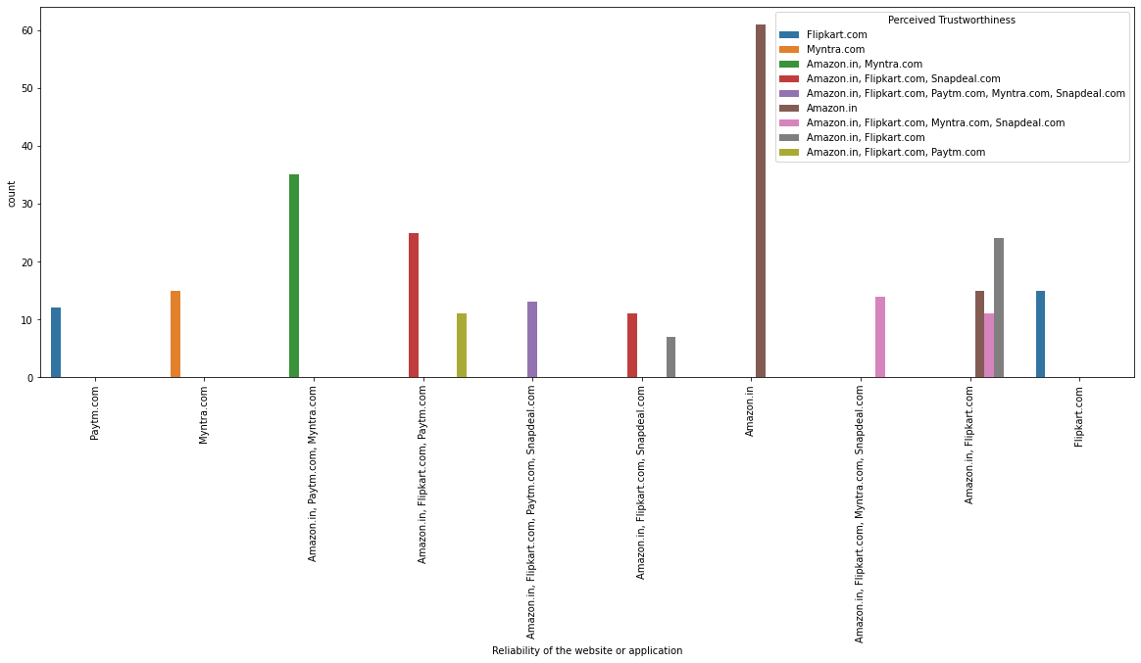

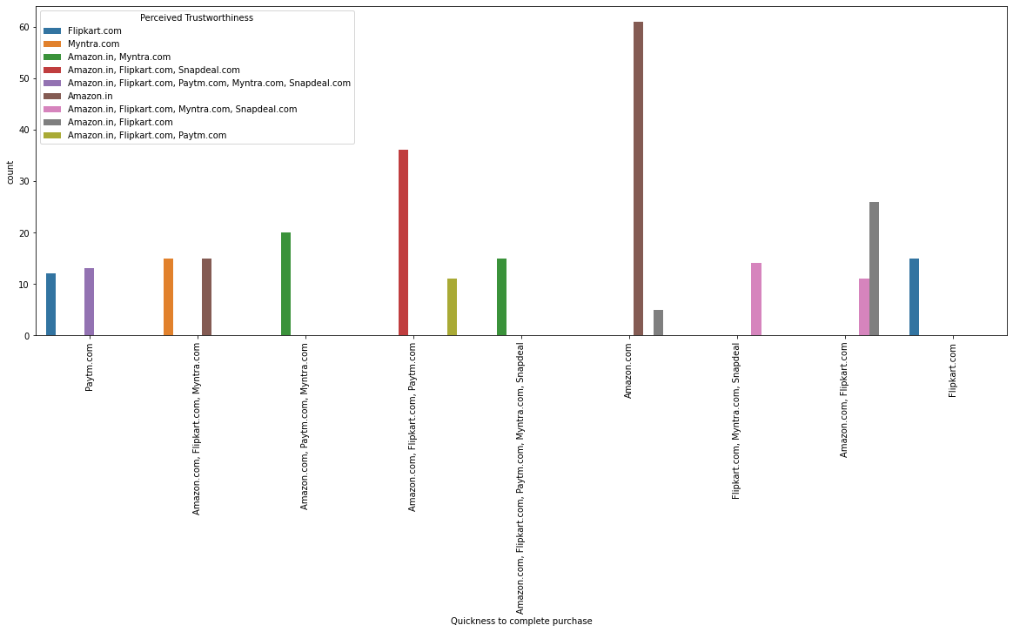

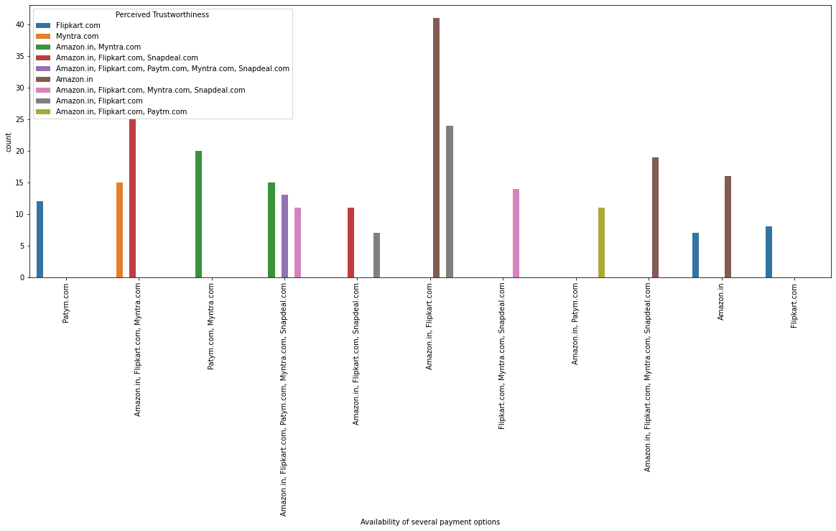

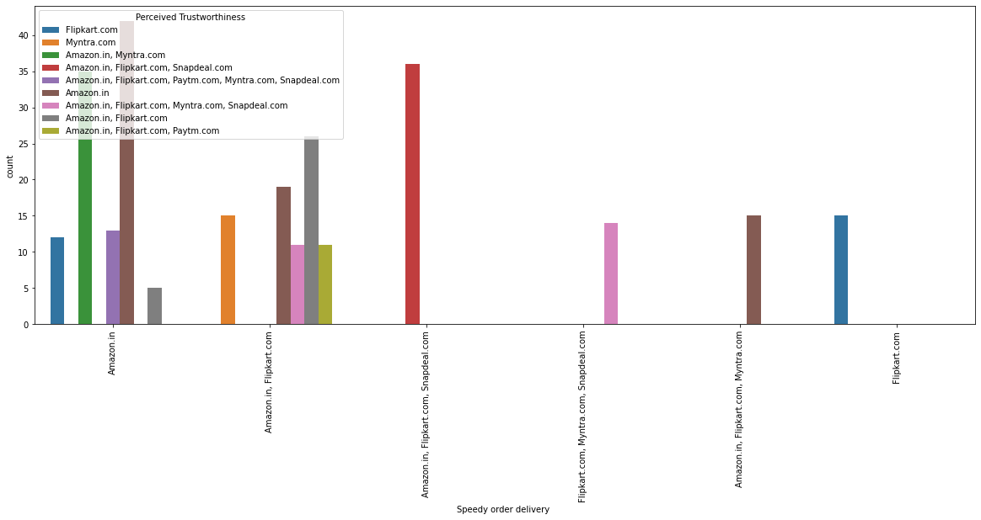

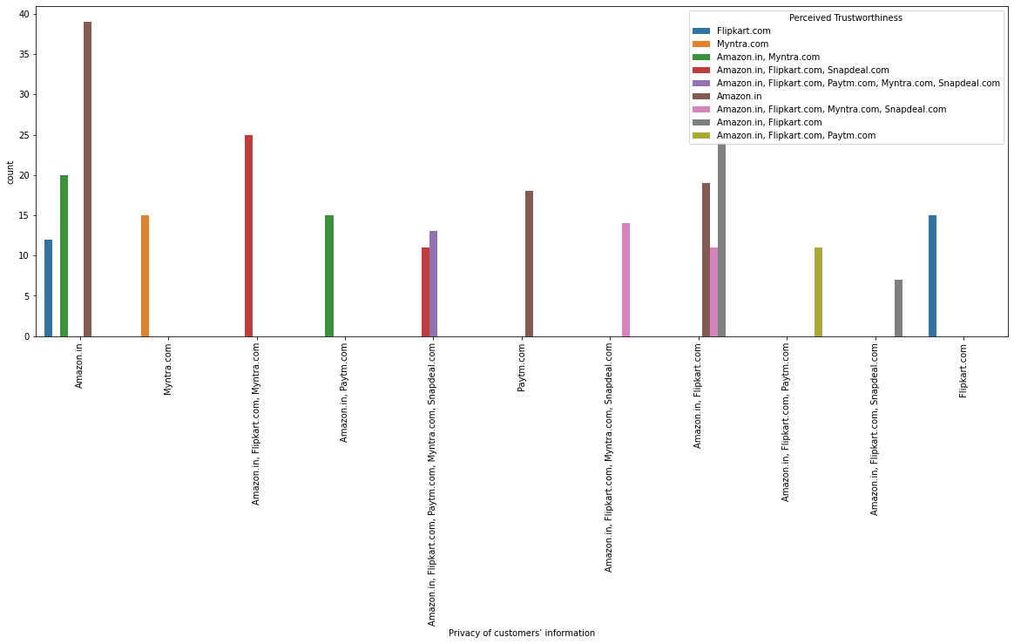

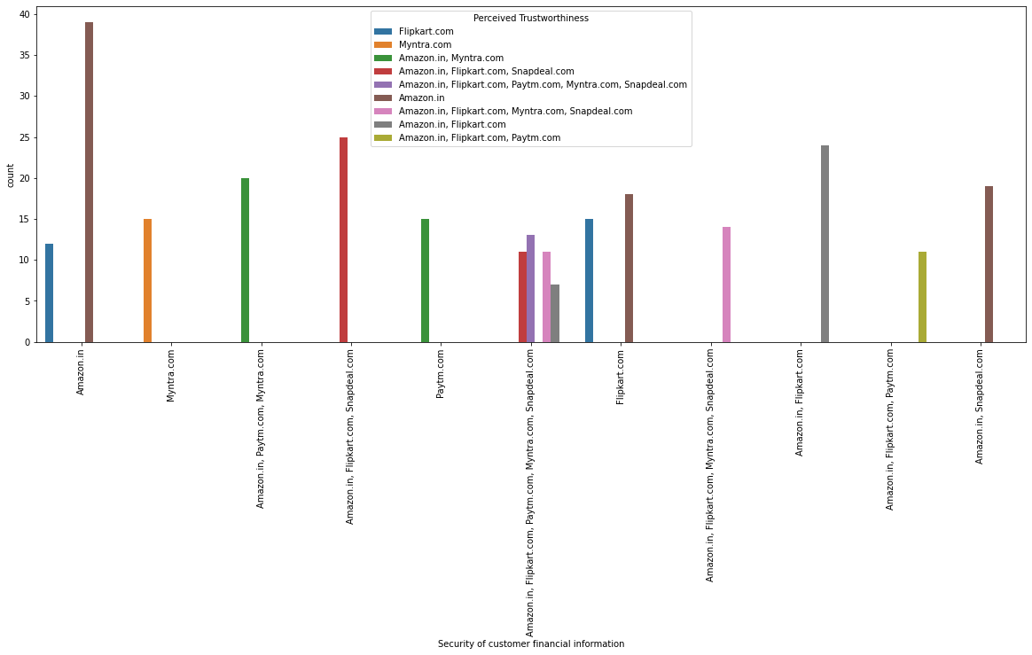

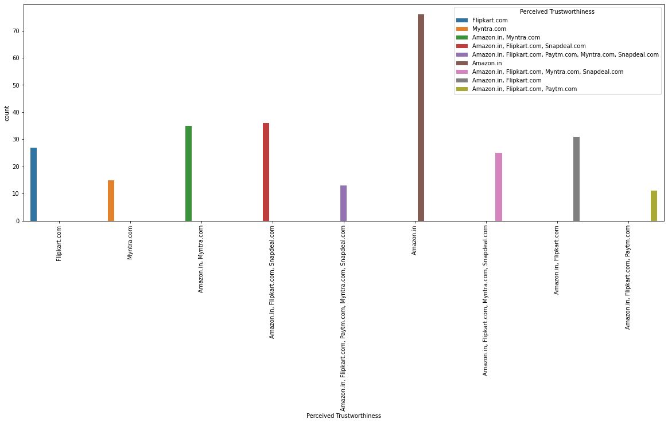

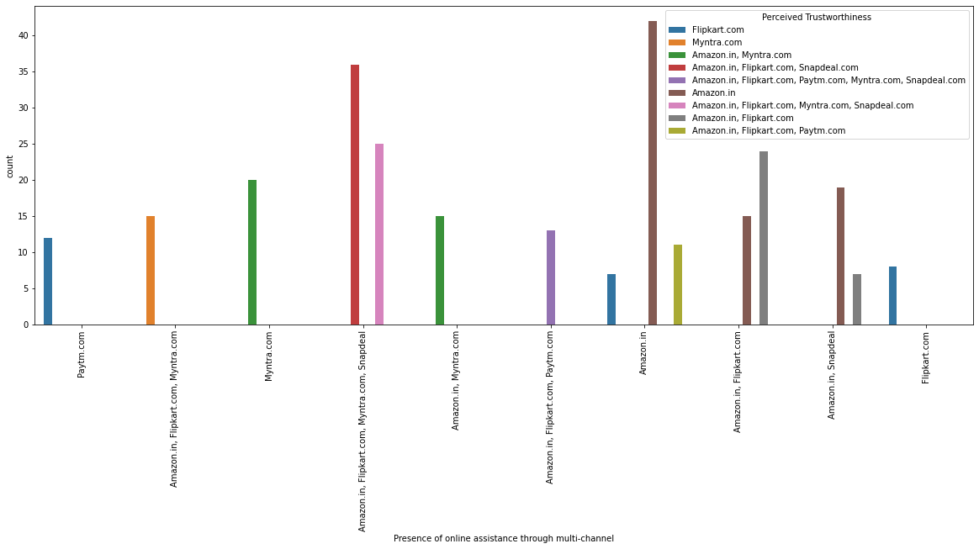

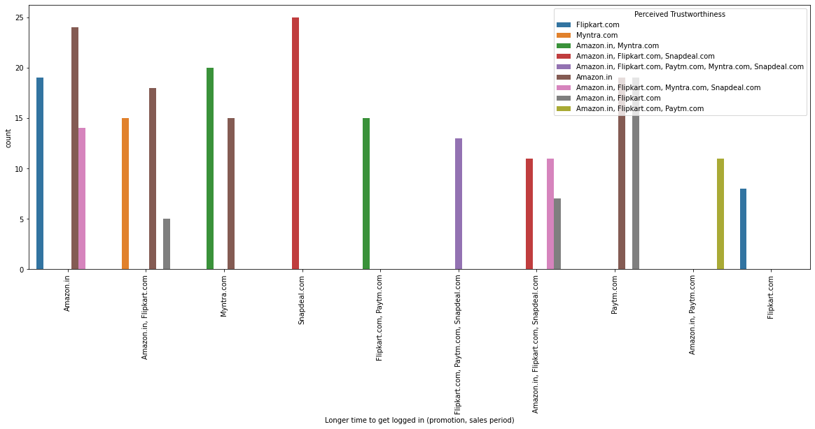

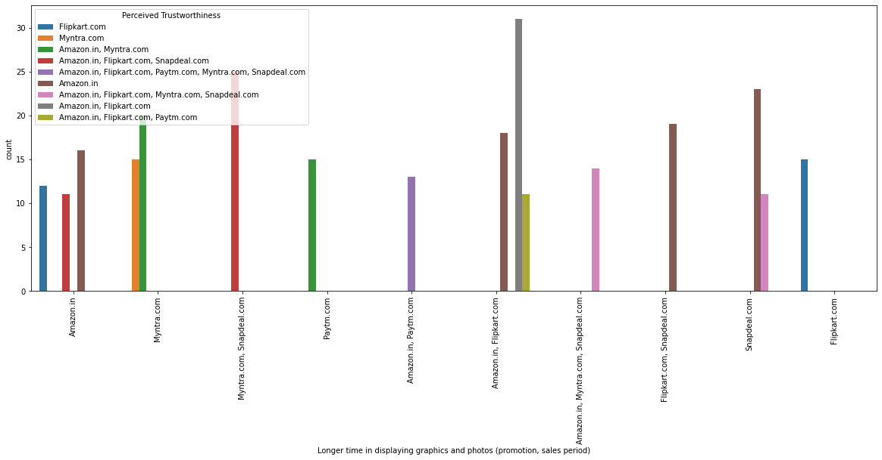

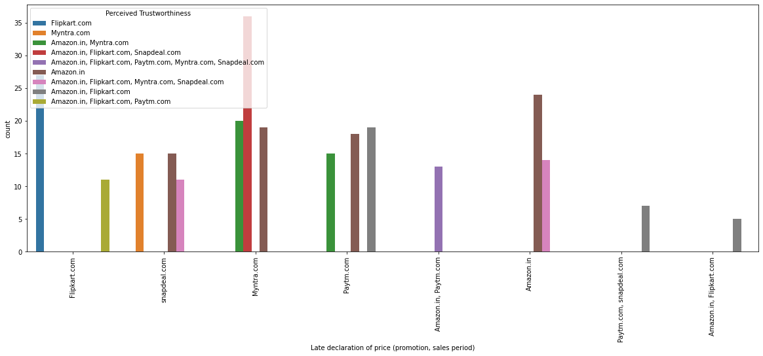

## 

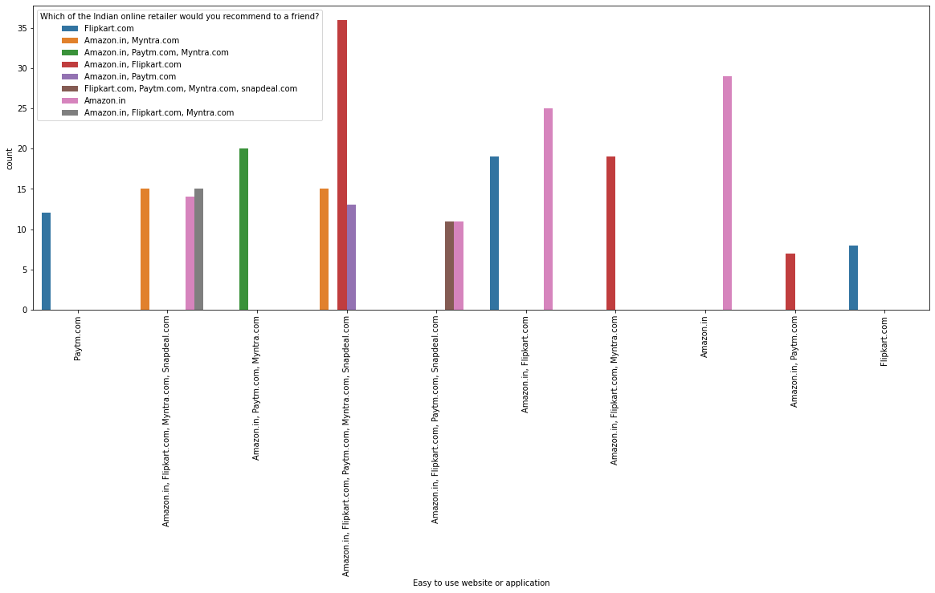

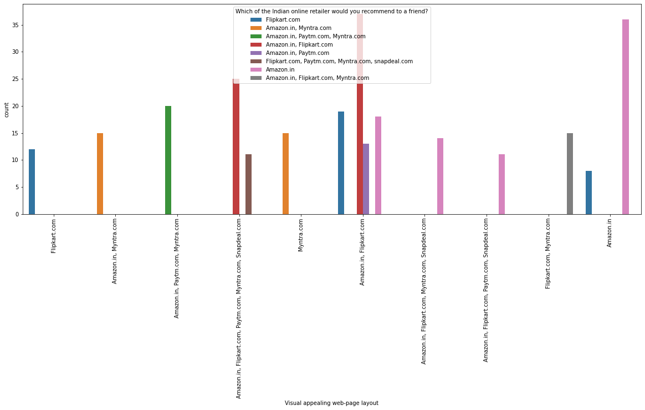

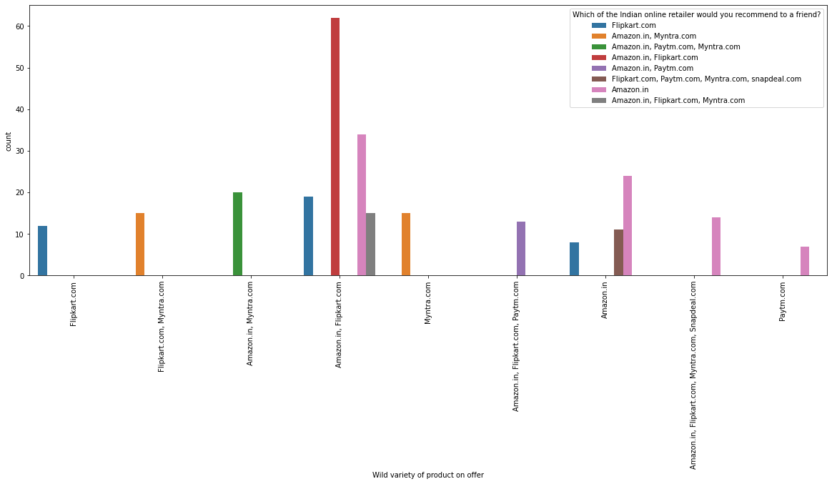

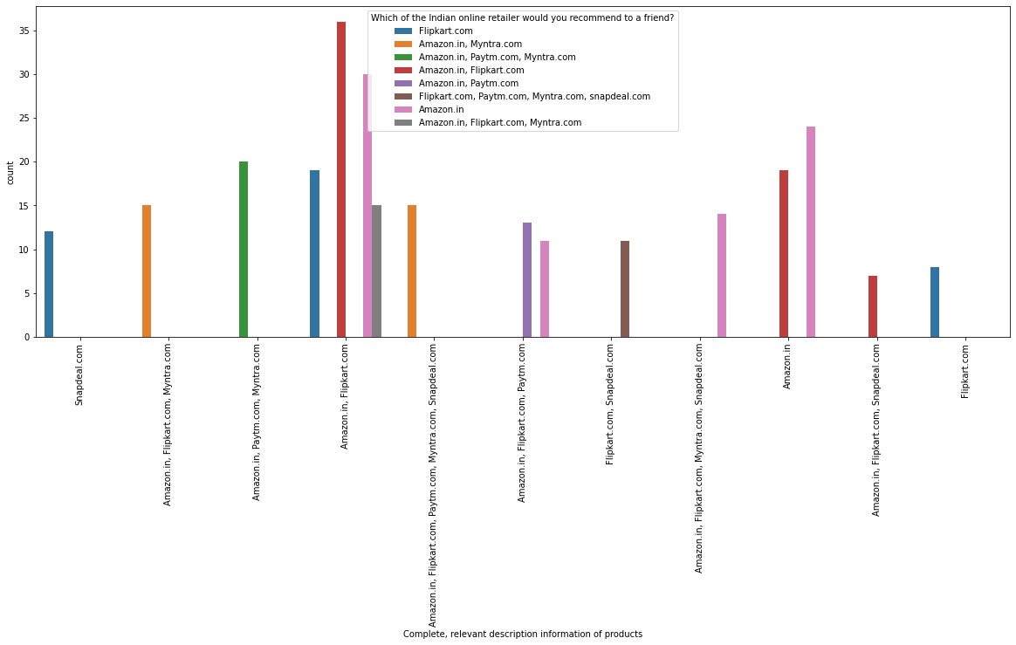

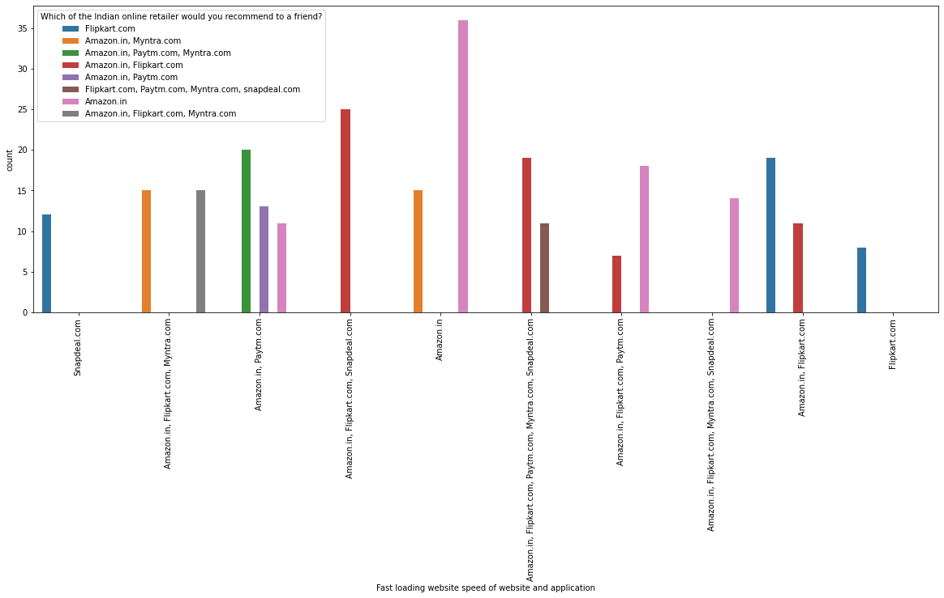

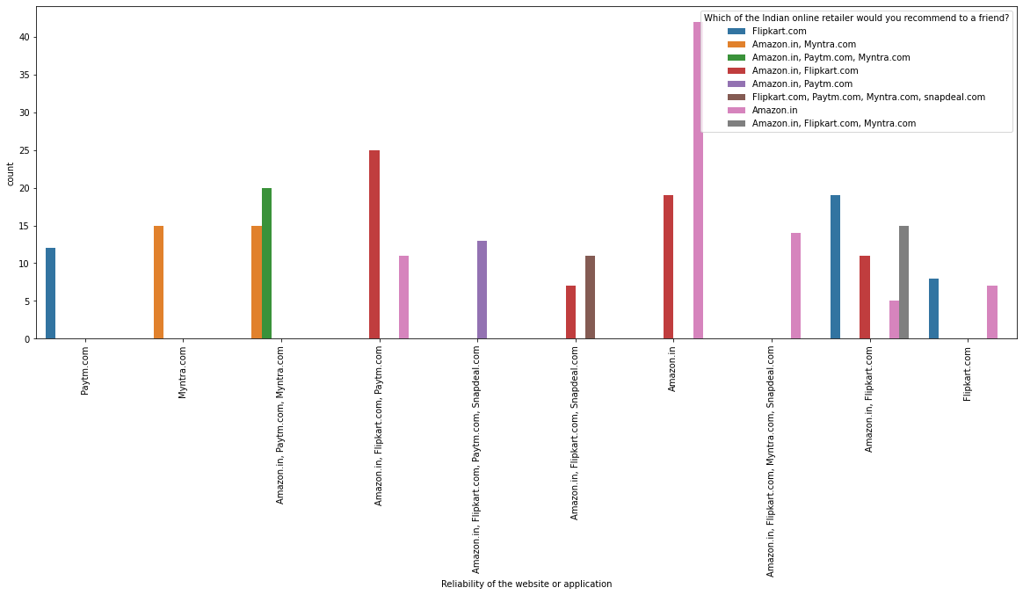

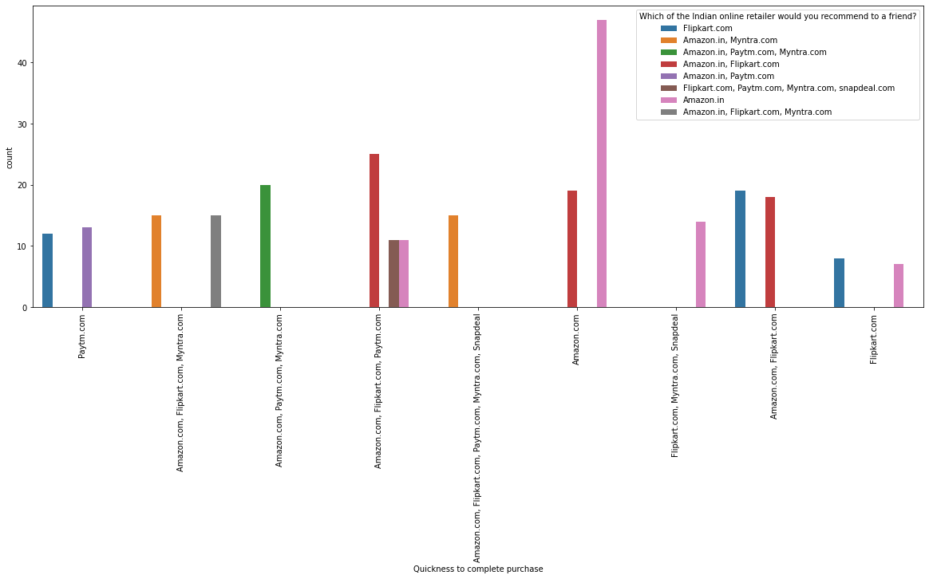

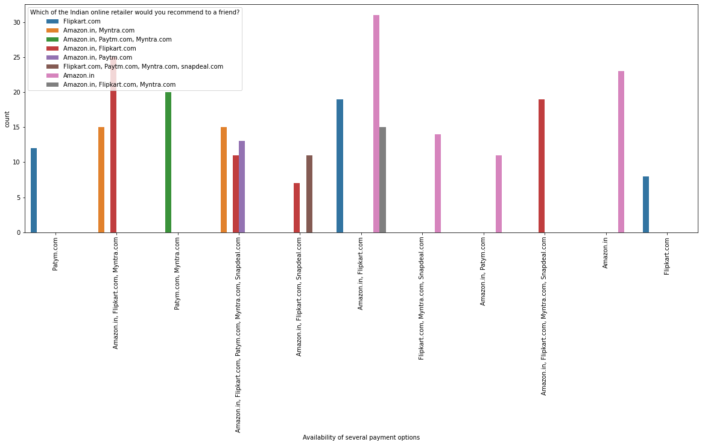

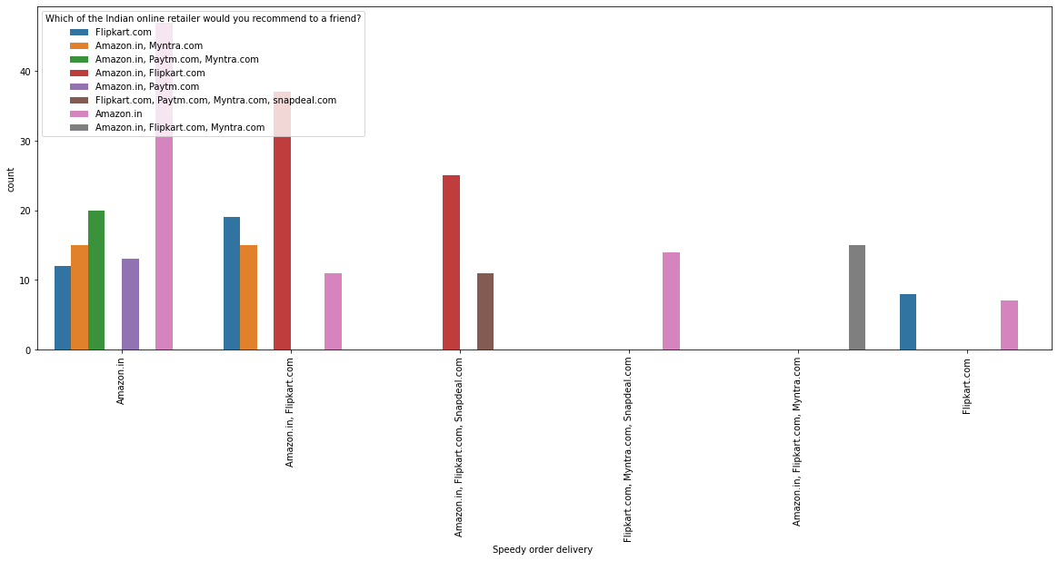

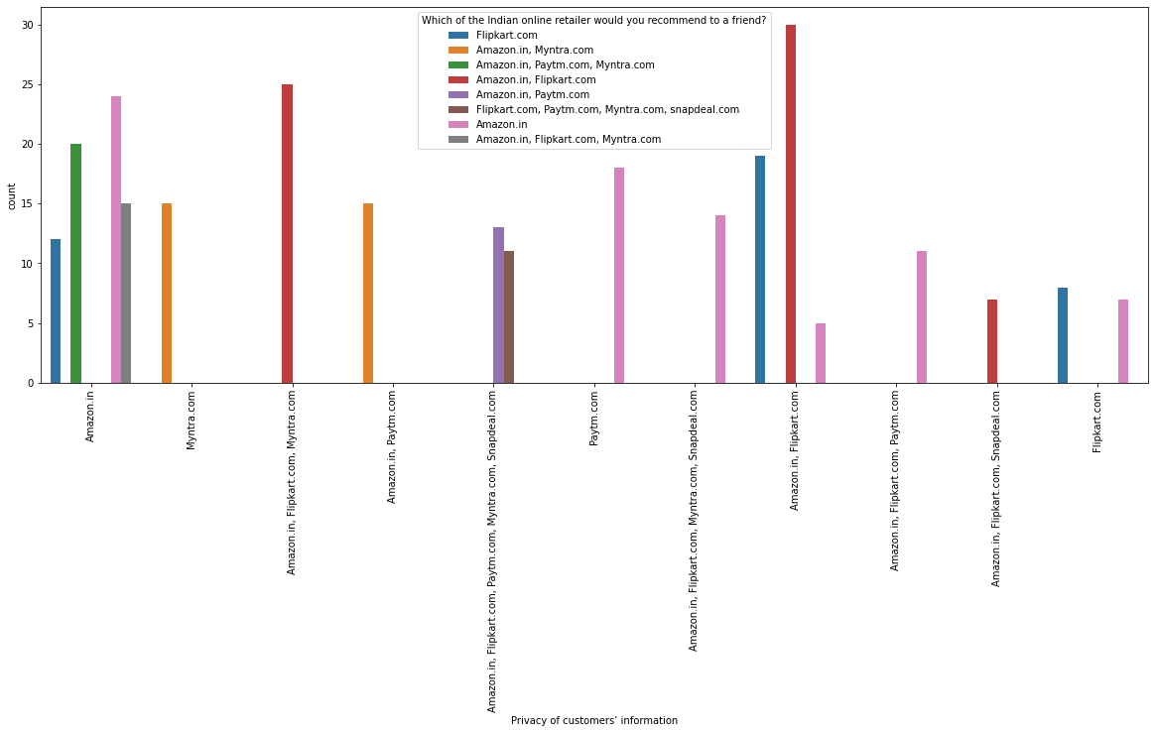

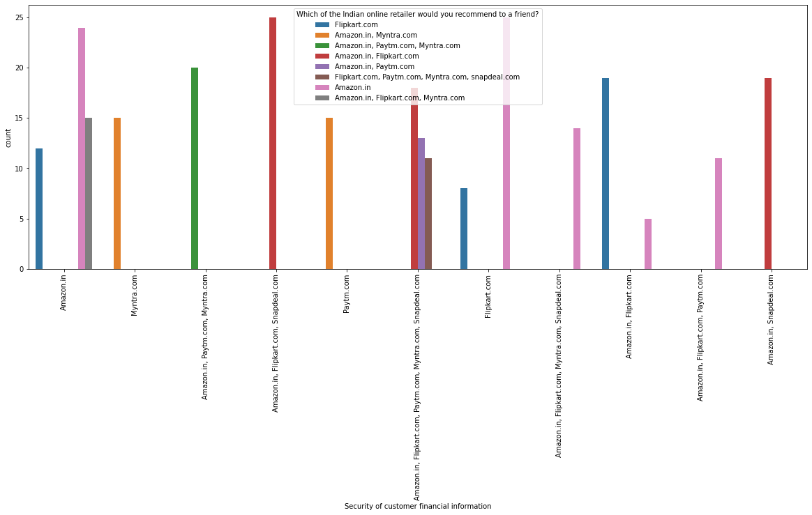

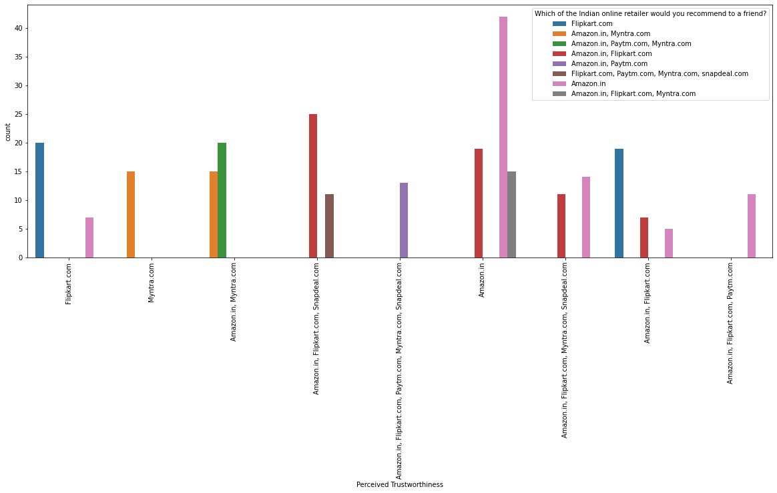

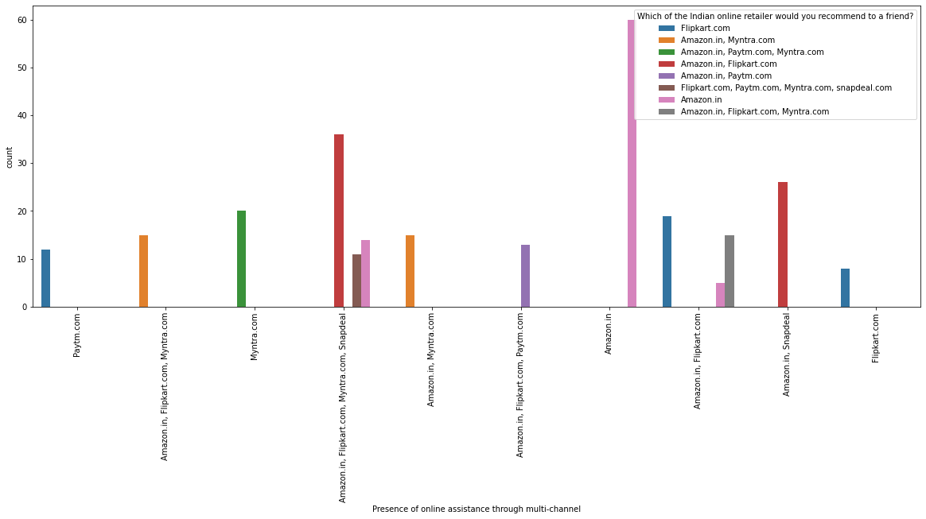

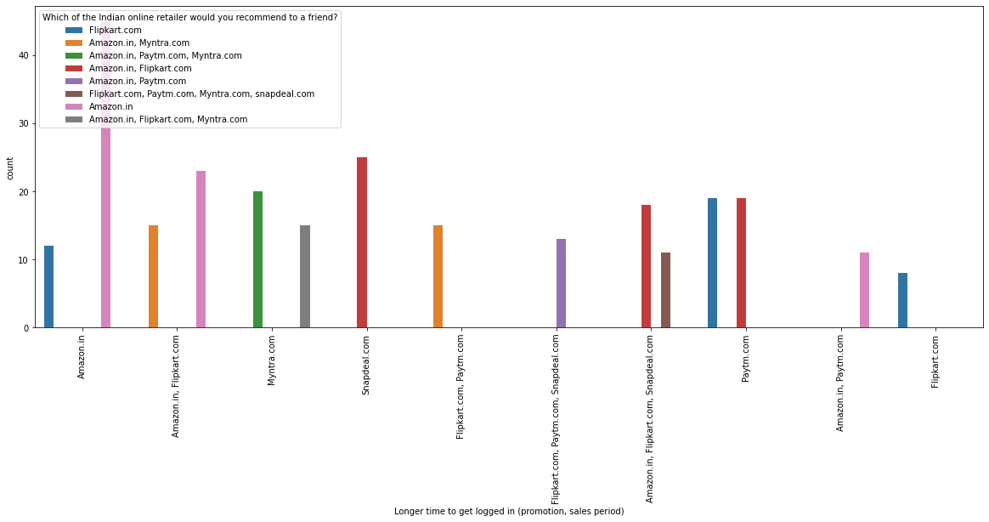

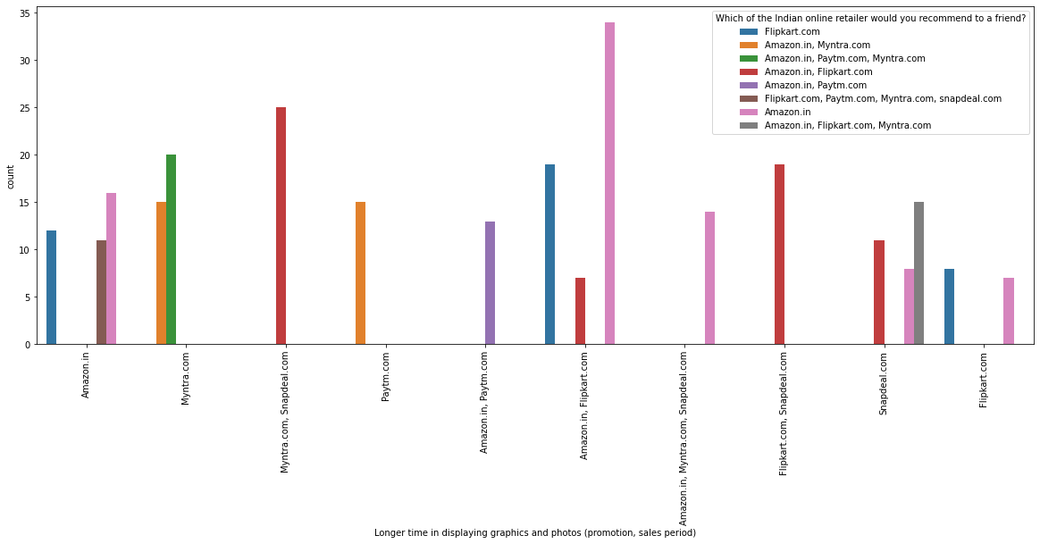

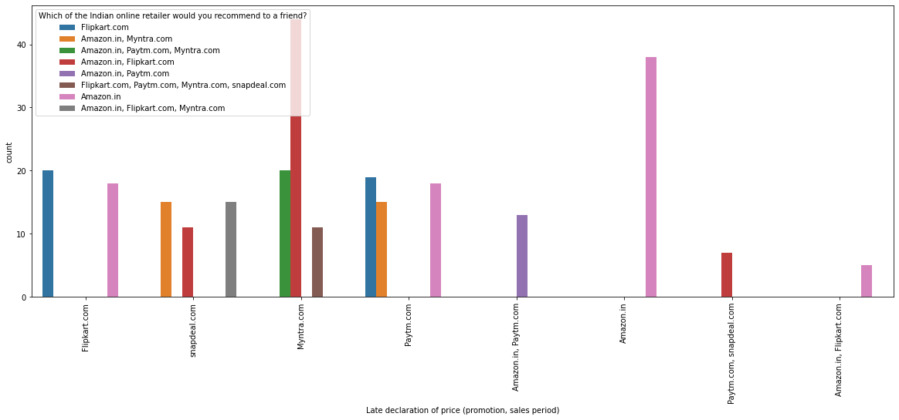

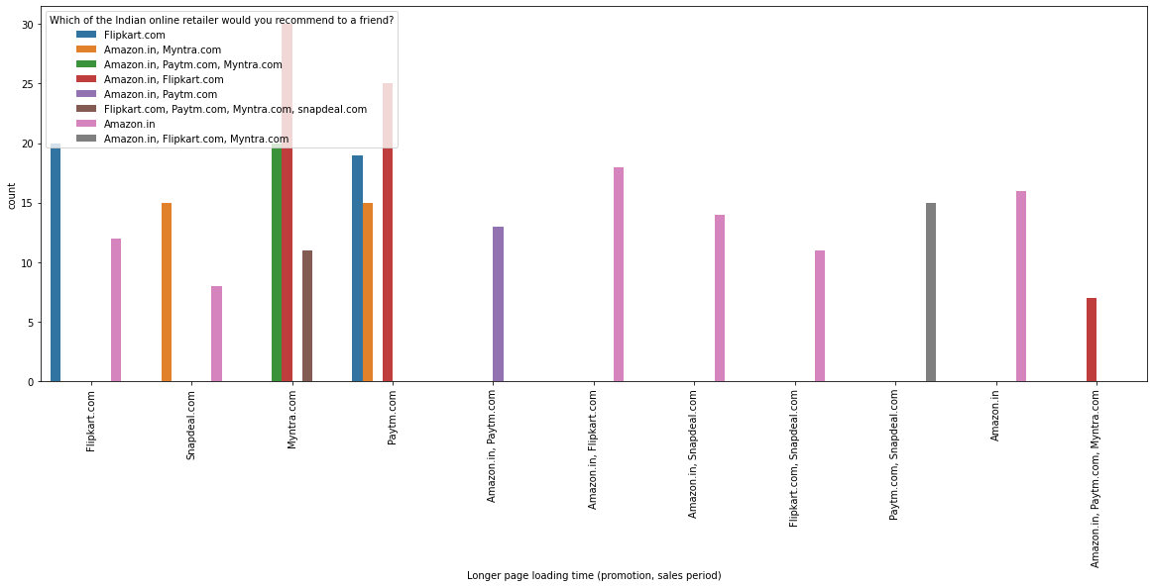

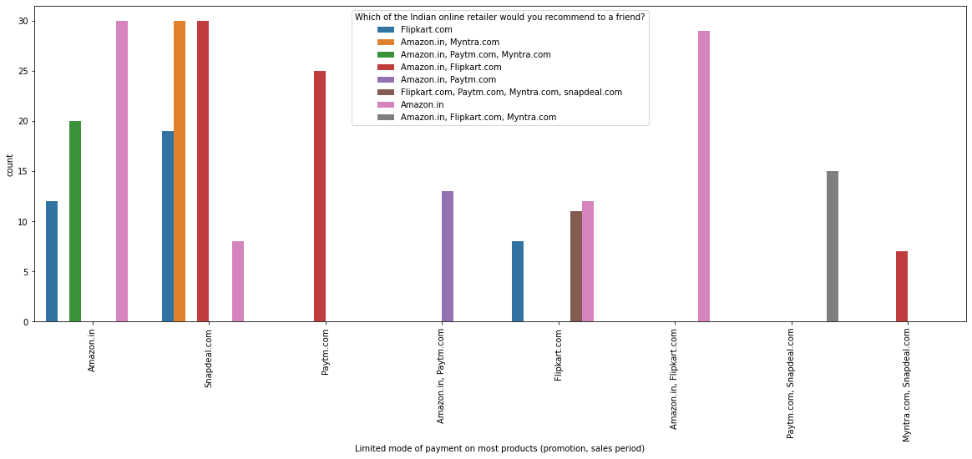

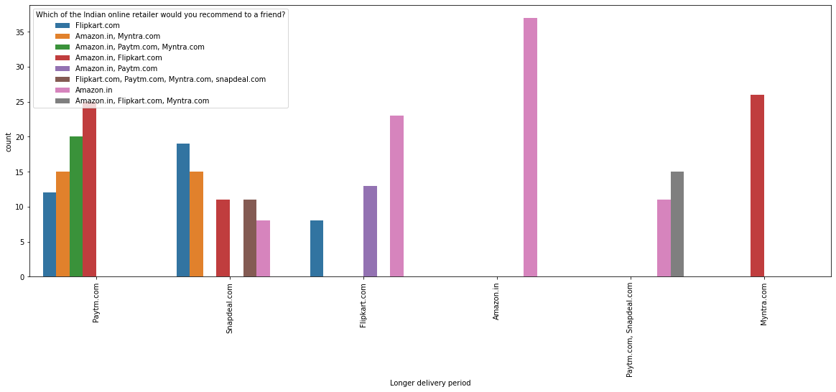

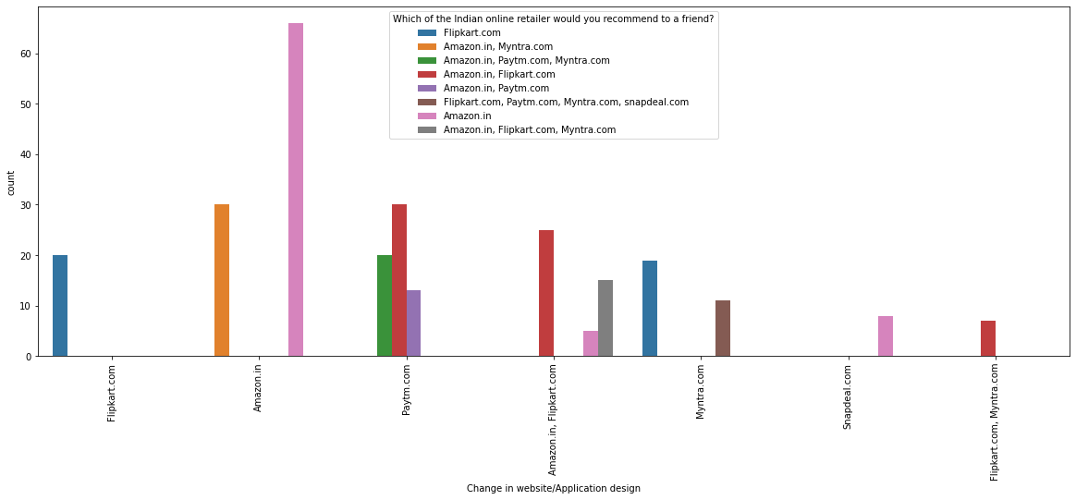

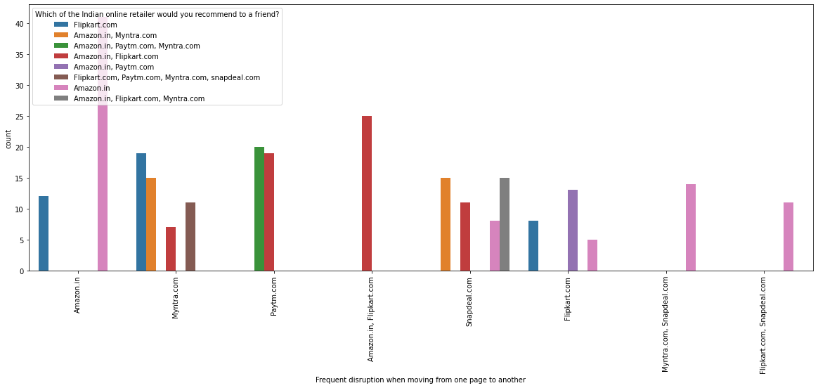

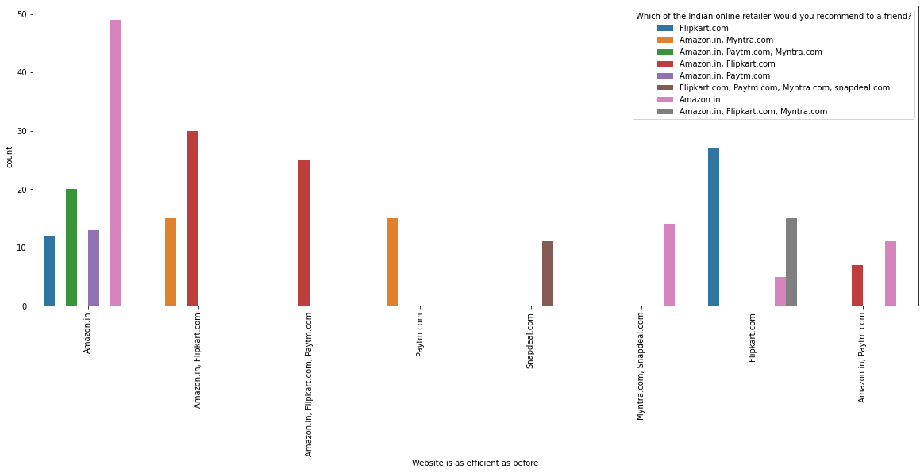

## Interpretation of the Results

Results:

1. No null values or repeated rows are present in dataset
2. Target Variable is highly unbalanced
3. Dataset have outliers in variable
4. Most of the surveys are from Female
5. In data set we have majority of people in 31-40years age group
6. Most of the people are shopping online for above 4 years
7. Most of the people had less than 10 times purchase online for past 1 year
8. Most of the users use Mobile Internet
9. Most of the users use Smartphone to order online
10. Most of the users use Google Chrome Web browser for ordering
11. Most of the users explore for more than 15 min before making purchase
12. Preferred payment option for most users is Credit/Debit cards
13. Most preferred portal is Amazon and flipkart.
14. Most of the Users suggests the portal which is easier to use i.e Amazon and Flipkart
15. Most of the Users suggests the portal which have best visual appeal i.e Amazon and Flipkart
16. Most of the Users suggests the portal which have variety of products i.e Amazon and Flipkart
17. Users recommend those portals which have wide variety of products i.e Amazon and Flipkart
18. Most of the users recommended Amazon by considering one parameter as it is fast loading
19. Most of the users recommended Amazon as it is reliable and quicker to complete the purchase
20. Amazon have the best delivery as per the users
21. Amazon and Flipkart are recommended as the user details are kept confidential and have full privacy

# CONCLUSION

## Key Findings and Conclusions of the Study

We found that to User uses those online portals for shopping online which have better visual interface, Easier to use for all age groups, Ensures the User details privacy and data security. Also, which have large variety of products with proper description. We could observe from our database that Flipkart and Amazon are currently the most preferred and most suggested portals.

## Learning Outcomes of the Study in respect of Data Science

In data science, there are various steps involved during Data analysis and cleaning. With the help of various Visualization tools like plots, Graphs we were able to perform the actions and observe different things. Like for finding the outliers we used Box Plot visualization.

If the data set the target variable is not balanced. So, the challenge will be to balance the variable, one way is to remove the extra data from the target variable but as the data was costly so the loss of data cannot be afforded. so,we can create the Sample data and balance the target variable. we can use the SMOTE technique to balance the data.

## Limitations of this work and Scope for Future Work

Data was unbalanced if data was balanced more accurate and clear picture of the output -> result is dependent on the data

Neural network classifier which are still unexplored & can be taken for future consideration